Influence: Deconstructed
Influence Maximization in Large Networks
with Interchangeable Positive and Negative Influence,

Chapter 1: Introduction 6
1.1 Project Overview 6
1.1.1 Definitions 6
1.1.2 Problem Description 6
1.3. Aim and Objective 7
1.3.1 Main Objectives 7
1.3.2 Subobjectives 7
1.3.3 Research Questions 8
1.3.4 Research Hypotheses 8
1.4. Anticipated Beneficiaries 9
1.5 Assumptions & Limitations 10
1.5.1 Assumptions 10
1.5.2 Limitations 10
Chapter 2: Output Summary 11
Chapter 3: Literature Review 13
3.1 Influence Maximization 13
3.2 Social Network Analysis 14
Chapter 4: Methods 15
4.1 Specifications 15
4.1.1 Objectives and Necessary Components 15
4.2 Methodologies 16
4.2.1 Development Timeline 16
4.2.2 Software Development Lifecycle 16
4.2.3 Research Methodology 16
4.3 Software Used 17
4.3.1 Programming Languages & Libraries 17
4.3.2 Applications 18
4.4 Influence Model (Build #1) 19
4.4.1 Datasets 19
4.4.2 Network Generation 20
4.4.3 Propagation Model (First Build) 21
4.5 Influence Model (Build #2) 22
4.5.1 Refactoring/Modularization (this can be short) 22
4.5.2 Negative Influence (Quality Factor) 23
4.5.3 Weighted Cascade 1 24
4.5.4 Weighted Cascade 2 25
4.6 Network Analysis 26
4.6.1 Probability Analysis and Normalization 26
4.6.2 Network-wide Analysis 27
4.7 Seed Selection Models 28
4.7.1 Models from Past Papers 28
4.7.2 Network-Analysis-based Models 29
4.7.3 Parameter Fine-tuning 30
4.7.4 New Seed Selection Models 30
4.8 Influence Model (Build #3) 31
4.8.1 Switch Factor 31
4.8.2 Time Factor 31
4.8.3 Network Generation (Method #3) 32
4.8.4 Probability Assignment 32
4.9 Testing and Experimentation Plans 33
4.9.1 Functionality Testing and Optimization 33
4.9.2 Experiments 33
Chapter 5: Results 34
5.1 Influence Model (Build #1) 34
5.1.1 Datasets 34
5.1.2 Network Generation 34
5.1.3 Initial Propagation Model 36
5.2 Influence Model (Build #2) 38
5.2.1 Refactoring/Modularization 38
5.2.2 Quality Factor 39
5.2.4 Additional Propagation Models (WC1 & WC2) 40
5.3 Network Analysis 41
5.3.1 Probability Analysis and Normalization 41
5.3.2 Network-wide Analysis 45
5.4 Seed Selection Models 47
5.4.1 Past Models 47
5.4.2 Network-Analysis-based Models 47
5.4.3 Parameter Fine-tuning 48
5.4.4 New Models 50
5.5 Influence Model (Build #3) 50
5.5.1 Switch Factor 50
5.5.2 Time Factor 51
5.5.3 Network Generation 53
5.5.4 Probability Assignment 55
5.6 Seed Selection Model Comparison 56
Past Models 58
NetworkX Models 59
New Models 62
All Models 65
5.7 Propagation Parameter Comparison 69
Chapter 6 Conclusion 76
6.1 Discussion 76
6.2 Objectives Revisited 76
6.3.1 Main Objectives 76
6.3.2 Sub Objectives 76
6.2.1 Research Questions 76
6.2.2 Research Hypotheses 76
6.3 Project Objectives 76
6.4 Future Work 76
References 77
Appendices 80
Appendix A: Project Definition Document 80
Appendix B: Installation Guide 81
Files & Capabilities 81
New Dataset(s) 82
Guide 83
Appendix C: Source Code 84
C.1 cascade_final.py 84
C.2 network_analysis_final.py 100
C.3 seed_selection_final.py 126
Latex Algorithm Code 153
Appendix D: Testing Source Code & Further Results 155
D.1 upgrades.py 155
D.2 Probability Histograms 155
D.3 Network-wide Metric Bar Charts 158
D.4 Seed Selection Parameter Fine-tuning Excel Spreadsheet 160
Appendix E: Executable File & Repo URL 160

Chapter 1: Introduction

1.1 Project Overview
This project explored the problem of influence maximization (IM), analysing previous solutions to gain a better understanding and aid in formulating original solutions. The problem is essentially, where within a social network should original ideas or advertisements be placed to achieve the maximum resultant spread of positive influence, and what actions, models or strategies would best help to find these optimal locations?

1.1.1 Problem Description
Social networks play an increasingly important role in society, through which opinions, ideas and information spreads. IM is an algorithmic extension of social network analysis, considered an optimization problem by computer scientists, that also has wide-reaching applications and implications.
The problem is as follows: how can the spread of influence through a network be best maximised, and what factors are directly correlated. Furthermore, how can simulations represent social networks, and what conclusions could possibly be drawn, if any. More specifically: how can a set of seed nodes of size k be found, to maximise propagation through a network with those nodes.
It was formulated as an approximation problem (Domingos and Richardson, 2001), and has been increasingly common in research since, with opportunities of practical application growing.
It was also proven to be NP-hard (Kempe, Kleinberg and Tardos, 2003), meaning it is suspected to be impossible to solve in polynomial time. This dynamic contributes to it being so interesting and well-studied.
The IM function was also proven to be submodular and monotone (Leskovec et al., 2007), and these properties were used to further optimize approximations. Submodular functions have diminishing returns of additional input values – in this case, extra seed nodes will provide less marginal spread, the bigger the seed set already was. Monotone functions are functions that preserve the given order of input values – in this case, nodes.

1.3. Aim and Objective
The aim of this project is to develop an optimized solution for IM, and in doing so gain a deeper understanding of how influence propagates through a network, what factors affect it most and what insights that reveals into human society and interpersonal interaction.

1.3.1 Main Objectives
- Implement, analyse and experiment with influence-maximizing seed selection models, and develop an original model that outperforms existing models.
- Analyse and evaluate parameters involved with influence propagation, their correlations and the insights they provide, and implement an original parameter to further develop those insights.

1.3.2 Subobjectives
- Implement a general method for generating network graphs from datasets and different models to simulate influence propagation through them.
- Ensure network generation is generalised for reproducibility, and easy extension to other network graphs using other dataset files.
- Analyse propagation parameters and implement some original ones, to better simulate social networks.
- Analyse and implement different seed selection models.
- Perform statistical data analysis on networks, comparing their properties to influence spreads.
- Implement a method of comparing propagation spreads and times with different networks, parameters and seed sets.
- Plot different types of graphs, to analyse and present different propagation models, propagation parameters and seed selection models, in regard to spread and time.
- Using established literature, evaluate and interpret the results, providing insight into social interaction, and discuss accompanying implications.
- Gain a deeper understanding of Python’s research capabilities, and software regarding network graphs, using NetworkX.

1.3.3 Research Questions
- What parameters affect the spread of influence most in simulations and do these translate to real-life?
- What are the best approximation strategies for IM?
- How could propagation models better reflect real social networks, and what limitations restrict them?
- How accurately can simulations reflect real-life networks, and how could irrationality be introduced to a model?

1.3.4 Research Hypotheses
- Networks with more nodes will take longer to perform propagation on, accounting for the spread.
- In a model where positive and negative influences occur and can ‘steal’ influence from the other, the more likely nodes are to switch influence, the influence with the higher general probability will increase.
- New seed selection models based solely on network analysis metrics will outperform existing research models.
A substantial change in how the project was conducted compared to the PDD, was the absence of network visualization. While planning on utilising it throughout, it was decided that it was not the main focus of the research and should not be prioritised, although given more time it would have provided a complementary visual aid.

1.4. Anticipated Beneficiaries
There are a great many different groups of people who are currently interested in IM, with mathematicians and computer scientists studying the problem analytically, advertisers seeking to maximise profits or outreach by way of refined viral marketing campaigns (Richardson and Domingos, 2002), and recently even doctors exploring how research could be applied to pandemics (Blower and Go, 2011), and even maximise vaccine rollouts to the general public.
The scope of people who could potentially benefit from IM research or application in the future is incredibly far-reaching, and only growing with time. Those who could be directly positively affected by IM include:
- Businessowners / advertisers who are particularly short on capital and funds, but have good ideas, products, or services to provide, such as failing small local businesses, entrepreneurs, or start-up companies. Since IM maximises outreach while minimising costs spent, it makes advertising cheaper for everyone – rendering the funds at huge companies’ disposal less significant, effectively levelling the playing field.
- Advertisers looking to reach as many potential customers as possible with limited capital to maximise success.
- Additionally, business owners would benefit from these analyses if advertising their own products or services, maximise profits or reach when advertising products or services. This especially applies to entrepreneurs, start-ups and smaller business owners,
- Brand experts and social media influencers would directly benefit from gaining understanding about the spread through a social network, allowing them to increase or maximise their own gains.
- Individuals looking to research further into the problem of IM for academic purposes – mathematical, computing or otherwise.
- Anybody who is interested in coming to a better understanding of how ideas or influence spreads through a network,

1.5 Assumptions & Limitations

1.5.1 Assumptions
Multiple assumptions were made during research and should be considered when viewing results. Firstly, it is assumed the anonymised datasets acquired from SNAP (more in section 4.3.1) are accurate, as any conclusions hinge on their authenticity.
Furthermore, even assuming their accuracy, an assumption is still made regarding whether connections in these social networks constitute potential for influence. This does not account for a user only being influenced by a handful of their online friends/following/etc. This is especially true on undirected and unweighted graphs, where every node and edge are treated as equally influential, further abstracting the problem away from real human online interactions and relationships. Finally, there is an assumption that all users/nodes in the network are active and does not account for inactive users being documented. This will be particularly impactful if the inactive node in question is in a well-connected position or has strong edge weights to other nodes.

1.5.2 Limitations
A major limitation was, considering the nature of an NP-hard approximation problem to be very computationally expensive (thousands of iterations are desirable), this project was severely limited by the single laptop machine used, as many research papers in the field have access to supercomputers and other machines with high levels of performance.

Chapter 2: Output Summary
Output 2.1: Cascade Program
Program capable of generating network graphs from .csv files, performing various propagation models on them, and analysing propagation parameters with plotted graphs.
Fully functional Python script: 533 lines of code (excluding comments)
Intended for IM researchers or people interested in IM. Facilitates reproduction or further development of my implementation. Produces further results (output 2.8).
Results: sections 5.1, 5.2 and 5.5

Output 2.2: Network Analysis Program
Programs capable of generating network graphs, performing statistical analysis on them, normalizing network properties in various ways and comparing results through graph plotting.
Fully functional Python script: 531 lines of code (excluding comments)
Intended for IM researchers, or anyone interested in social network analysis. Facilitates reproduction or further development of my analysis. Produces further results (outputs 2.4 & 2.5).
Results: section 5.3

Output 2.3: Seed Selection Program
Program capable of generating network graphs, fine-tuning seed selection model parameters, selecting seeds through various models and comparing influence spreads of different models through graph plotting.
Fully functional Python scripts: 1136 lines of code (excluding comments).
Intended for IM researchers or people interested in IM. Facilitates reproduction or further development of my implementation. Produces further results (outputs 2.6 & 2.7).
Results: sections 5.4 and 5.6

Output 2.4: Normalization Technique Comparison Graphs
Histograms and pie charts displaying distributions of degree reciprocals and relational degrees when various normalization techniques are applied.
Plotted pie charts, histograms and line graphs
Intended for myself to analyse the distribution of probabilities and determine which normalization technique best suited the datasets and propagation models and should be applied.
Results: section 5.3.1

Output 2.5: Network-wide Properties Comparison Graphs
Bar charts comparing various network-wide properties of different networks
Plotted bar charts
Intended for developers of project to aid analysis and comparison of networks.
Results: section 5.3.2

Output 2.6: Fine-tuned Seed Selection Parameters
List of values collated in a spreadsheet, denoting different propagation spreads from different sets of values of parameters in NetworkX seed selection models.
Conditionally formatted (colour) Excel spreadsheet (list of values)
Intended for developers of project to determine optimal values for the NetworkX seed selection models, before finalising their implementation.
Results: section 5.4.3

Output 2.7: Seed Selection Model Comparison Graphs
Horizontal bar charts comparing the spreads and (spread/time)s of different seed selection models, on random and real graphs separately.
Plotted horizontal bar charts
Intended for IM researchers, people interested in maximising their own influence or people studying graphing possibilities in Python. Compares results of various seed selection models.
Results: section 5.6

Output 2.4: Propagation Parameter Comparison Graphs
Line graphs comparing influence spreads, varying the model and the propagation parameters used.
Plotted line graphs
Intended for myself or anyone who in future will work on this project. Used to modify NetworkX seed selection models with optimal parameters, improving effectiveness of models.
Results: section 5.7

Chapter 3: Literature Review

3.1 Influence Maximization
Past solutions and variations of the IM problem were studied to develop an understanding of the problem, including seed selection techniques, datasets used and possible variations of the problem through additional parameters to improve insightful conclusions.

Kempe, Kleinberg and Tardos
The first formal solution to the approximation problem of IM that is studied today was formulated by (Kempe, Kleinberg and Tardos, 2003). Building on Domingos and Richardson ((Domingos and Richardson, 2001) and (Richardson and Domingos, 2002)), they developed the greedy solution, which is used as a benchmark for all future solutions. It achieved a high level of approximation but was inefficient and failed to scale well to large networks, as is described in section 4.6.1, due to the nature of its calculations. They also proved the problem to be NP-hard, setting the limits of all future solutions and increasing mathematical and computer-science related interest, as proving NP-hard problems can be solved in polynomial time is of great interest. This paper employed a collaboration graph, arguing that ‘co-authorship networks capture many of the key features of social networks more generally’ – High-energy physics theory section of the e-print arXiv (10,748 nodes, 53,000 edges including parallel edges).

Leskovec et al
One of the earliest significant improvements to Kempe’s greedy approach was the CELF (cost-effective lazy-forward) solution (Leskovec et al., 2007), which proved the submodularity of the problem and used that property to improve efficiency of approximation with no lack of quality guarantee whatsoever.
The lead scientist involved in that paper – Leskovec – also designed SNAP (Stanford Network Analysis Program), a publicly accessible library of large networks for network analysis, from which the datasets in this project are sourced. Specifically, the BitcoinOTC dataset used in this project was created by Leskovec himself through surveys in another paper he proposed, through surveys. Leskovec is a long-time contributor in the field of IM, and his influence on this project cannot be understated.

Chen, Wang and Yang / Chen et al
A further improvement to the greedy and CELF solutions were the improved greedy and heuristic solutions provided in (Chen, Wang and Yang, 2009). The heuristic solution being so significant that it is the last major improvement despite being over a decade ago, improving efficiency by over a factor of 200. The paper used two ‘academic collaboration networks from … two different sections of arXiv … the same source used in the study by Kempe et al (2003)’ – High Energy Physics – Theory (15,233 nodes, 58,891 edges) and the full paper list of the Physics section (37,154 nodes, 231,584 edges)
Chen was also primarily involved in another paper (Chen et al., 2011), where a quality factor was introduced to enable both positive and negative influence, expanding the boundaries of potential conclusive insights. This was directly implemented into this project and was used as inspiration for additional propagation parameters to be added to the model, improving realism and opportunities for practical application. This paper used ‘three real-world networks of increasing sizes’ – The high-energy physics theory section of the e-print arXiv (15,000 nodes, 31,000 edges including parallel edges), The WikiVote Wikipedia voting history network (7,000 nodes, 101,000 edges), and the Epinions product review network. For the latter two, the edges were reversed to represent influence as they interpreted ‘v voting/trusting u as u having an influence on v’, exemplifying excellent dataset preparation to better represent social networks of influence.

3.2 Social Network Analysis
Before the formal definition of IM, social network analysis has long been studied by sociologists, whose social understanding of networks can provide useful insights when discussing results or proposing applications. Analysis of organizational structure (Tichy, Tushman and Fombrun, 1979) or contemporary social science research (Borgatti et al., 2009) are just two examples of the significant overlaps in these fields. Additionally, sociologists have long since used properties such as density and centrality to compare and understand networks, which are still useful metrics of analysis today, and provide an extra level of comparison when researching IM.

Chapter 4: Methods
This chapter outlines the methodologies followed, the necessary requirements and components and every stage of development (including revisited components for optimization/improvements).

4.1 Specifications
This section revisits the objectives and describes the functional requirements and necessary components to achieve them.

4.1.1 Objectives and Necessary Components
- Network graph generation from datasets.
- Propagation models and comparison.
-Network generation and influence propagation program.
- Additional propagation parameters.
- Network data analysis.
-Network analysis program
- Seed selection models and comparisons.
-Parameter fine-tuning and seed selection comparison program
- Graph plotting / presenting of results.
- Evaluation, conclusion & discussion.
-Graph plotting functions

4.2 Methodologies
This section outlines the development timeline and the methodologies followed to develop the software and research.

4.2.1 Development Timeline

4.2.2 Software Development Lifecycle
A sequential development lifecycle was planned to build each component successively. However, due to experiencing unforeseen obstacles (mentioned in section 5.3), as well as the optimization-heavy nature of the task, an iterative approach was followed with multiple components experiencing multiple builds.

4.2.3 Research Methodology
The methodology used to design the study, collect the data and govern the analysis was experimental in design, concerned with the collecting of data in controlled environments to identify cause-and-effect relationships between variables – like influence spread and propagation parameters.
Most of methods used are quantitative, collecting and analysing the measures, proportions and correlations of data rather than the traits or characteristics. Networks are analysed and seed selection models are grouped according to their source, but this is fairly trivial.

4.3 Software Used
This section describes the software used in implementation, their suitability to the task and justifications made.

4.3.1 Programming Languages & Libraries

Python
Most of this project was coded in Python 3.6. Python is a multipurpose language favouring simplistic solutions, which is useful when optimization is key. It has extensive official documentation as well as many useful external libraries. Furthermore, Python’s active community provide discussions about general problems.

NetworkX
NetworkX was chosen as the method of generating and analysing social network graphs, due to scaling well with large networks, many network analysis functions and extensive documentation.
Available alternatives:
- the Pajek program –developed for IM ((Mrvar and Batagelj, 2016)) and regularly updated since.
- statnet – a suite of packages for C and the open-source language of R
- graphViz or gephi – graph visualization tools (which lack network analysis functionality)

Numpy
Numpy is a library of mathematical functions – ideal for manipulating large network graphs, used to generate random numbers, seed randomness and calculate averages. Written in C, Numpy is interpreted by CPython, not compiled, meaning it executes faster than Python, improving efficiency.

Matplotlib
Matplotlib is a versatile library for plotting graphs (essential for research), with in-depth documentation and an active community. It was used to plot graphs during network analysis and experimentation.

Other Packages
- Time.time to optimize code.
- Math.log for log-scaling normalization
- Copy.deepcopy for making deep copies (copies of values, not references – a distinct object) of network graphs.
- Operator.itemgetter for sorting iterable by their second elements.
- Itertools.product for producing every permutation of an iterable of iterables, used in seed selection parameter fine-tuning.

LaTeX
LaTeX is an open-source document preparation system for coding scientific documents. Coding in LaTeX on the website Overleaf enables production of high-quality algorithm visualisations, with clear mathematical symbols.

4.3.2 Applications
This subsection uses the following programming languages and applications used in design and implementation

Jupyter Notebook Web Application
Python scripts were written using the Jupyter Notebook Web Application – it is highly suitable for research due to its language independency, clear visual display and easy-to-manage dashboard.

Microsoft Excel
Excel is a spreadsheet program for data organization, analysis and formatting, used to collate seed selection parameter fine-tuning results with analytical conditional colour formatting.

4.4 Influence Model (Build #1)
Simulating influence propagation through generated networks was the primary stage of development. This chapter outlines the steps taken to build the foundational model – including analysis of datasets and implementation of network generation and influence propagation, as well as preliminary testing for functionality.

4.4.1 Datasets

Analysis
Datasets differ in important ways, such as quantities and arrangements of nodes or edges and whether direction or weight is included. Certain properties were used as criteria to select a range of graphs to provide insightful comparisons:
Preferred Criteria | Larger datasets facilitate comparison with similarly sized datasets from past papers and real large-scale social networks – however, being more computationally expensive, available resources were considered.
Preferred Criteria | Different types of datasets (weightedness, directedness) broaden analysis, resulting in broader conclusions or specific differences in findings.
Necessary Requirements | Public availability and access for reproduction, verification or any further development.
Necessary Requirements | Completely anonymised to protect subjects’ privacy and comply with GDPR.

Design
Datasets sourced from Stanford Network Analysis Platform (SNAP) library (Leskovec and Krevl, 2014):
Name: | Size: | Properties: | Description:
BitcoinOTC: | 5,881 nodes  35,592 edges | Directed  Weighted  Signed | Network of weighted edges (between -10 and 10) indicating trust between users of BitcoinOTC (a platform for trading the cryptocurrency Bitcoin)
Facebook: | 4,039 nodes  88,234 edges | Undirected  Unweighted  Unsigned | Anonymised network of friends lists from Facebook collected from survey participants, first developed by McAuley and Leskovec

Implementation
The datasets needed to be uniformly formatted before being read from files into graphs, with weights indicating influence between nodes. Common format ensures generalised functionality.

4.4.2 Network Generation

Analysis
Generation of network graphs to simulate social networks was implemented first. They can be directed or undirected, weighted or unweighted, and these properties affect their behaviour and subsequent results.

Design
Graphs are implemented as data structures from the NetworkX library read from CSV files. Additionally, smaller, user-defined graphs were created for comparison and debugging purposes.

Implementation
Directed graphs were generated from datasets, for directed or undirected, and weighted or unweighted networks. Additionally, a smaller graph was generated with customised architecture. Its purpose: incremental analysis and debugging, where its small size and simplicity make errors easier to locate. It is here-on referred to as ‘G3’ or the small graph:
5
9
10
4
2
3
1
8
6
7

Figure 1. User-defined graph G3
Figure 1. User-defined graph G3

Testing
Dataset-generated graphs were tested by observing rows from the files and verifying those edges are present.

4.4.3 Propagation Model (First Build)

Analysis
Propagation models share a general underlying framework but determine propagation success differently. Implementing a variety broadens research.

Design
The independent cascade model – propagation determined with a single network-wide variable uniformly applied – was implemented first due to simplicity. It could be viewed as reductive (other models incorporate relationships between probability and network characteristics), or as robust and universal – relationships outlined in other models will not always hold true, as Blower stated: ‘increasing model complexity did not always increase accuracy’ in regards to understanding and predicting epidemics (Blower and Go, 2011).
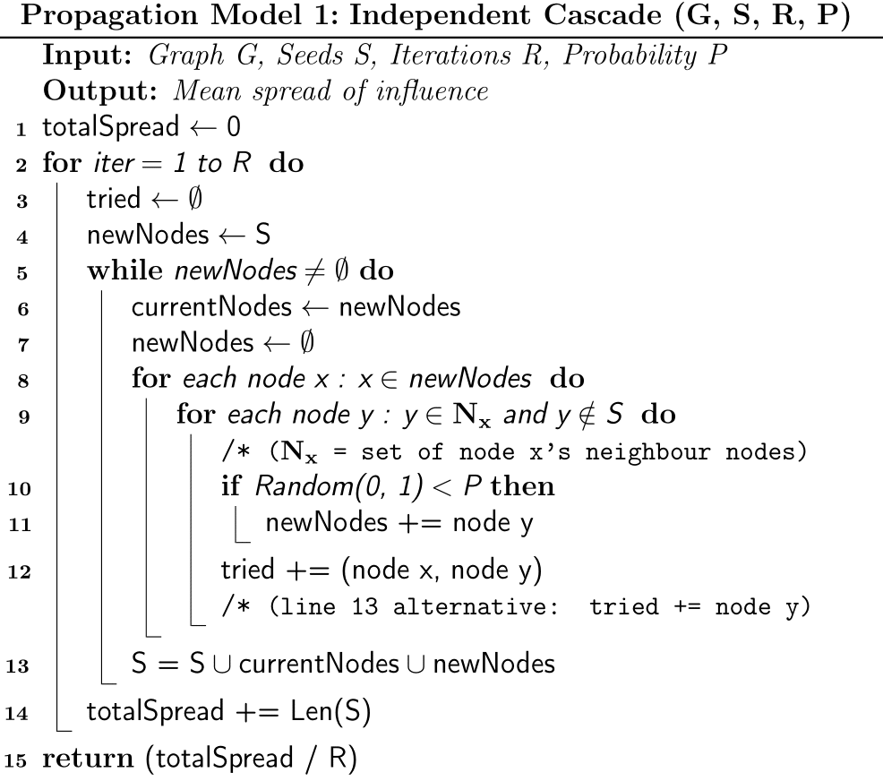
Simpler structure means simpler debugging, introducing complex features after functionality is established. It is also widely used in research, aiding comparison.
Figure 2. Independent Cascade Model Algorithm coded in LaTeX

Implementation and Testing
The model was implemented according to the algorithm above and tested using G3. Testing and results in section 5.2.3.

4.5 Influence Model (Build #2)
This section describes improvements made to the influence model, including refactoring of code for efficiency, modularization for generalization and the introduction of additional propagation parameters.

4.5.1 Refactoring/Modularization (this can be short)

Analysis
Improvements required to improve efficiency and generalization. Some useful community posts discussed relevant topics:
- Best and/or fastest way to create lists in Python (ecampver, 2013)
{https://stackoverflow.com/questions/20816600/best-and-or-fastest-way-to-create-lists-in-python}
- Python Sets vs Lists (Mantas Vidutis, 2010)
{https://stackoverflow.com/questions/2831212/python-sets-vs-lists}

Design
Improvements made were modularization and specialising data structures.

Design and Implementation
Network generation was modularised to generalise the process so all each dataset needed defined was its file-path and some variables (directed, weighted, offset).

Testing
Testing verified the code’s functionality, and measured improvements in efficiency. Tests and results can be found in section 5.3.1.

4.5.2 Negative Influence (Quality Factor)

Analysis
Propagation parameters are introduced to influence models to improve realism, aiding simulation and application. These usually imitate and incorporate a specific property of social networks into simulated models.

Design
A quality factor enabling negative influence, introduced first by Chen et al (2011), was implemented.

Implementation
As in Chen et al (2011): the quality factor qf is implemented negatively for negative influence (1 – qf), and negativity bias is incorporated – people incline to negative opinions and influences. In keeping with this, the order of influence propagation implemented:
- Negative nodes negatively influence (1 – qf)
- Positive nodes positively influence (qf)
- Positive nodes negatively influence (1 – qf)

4.5.3 Weighted Cascade 1

Analysis
Additional propagation models were included to broaden research and complexity. Some models introduce insightful, sociological relationships to improve realism.

Design
The weighted cascade model implies that nodes with more incoming edges (many influences) will be harder to influence.
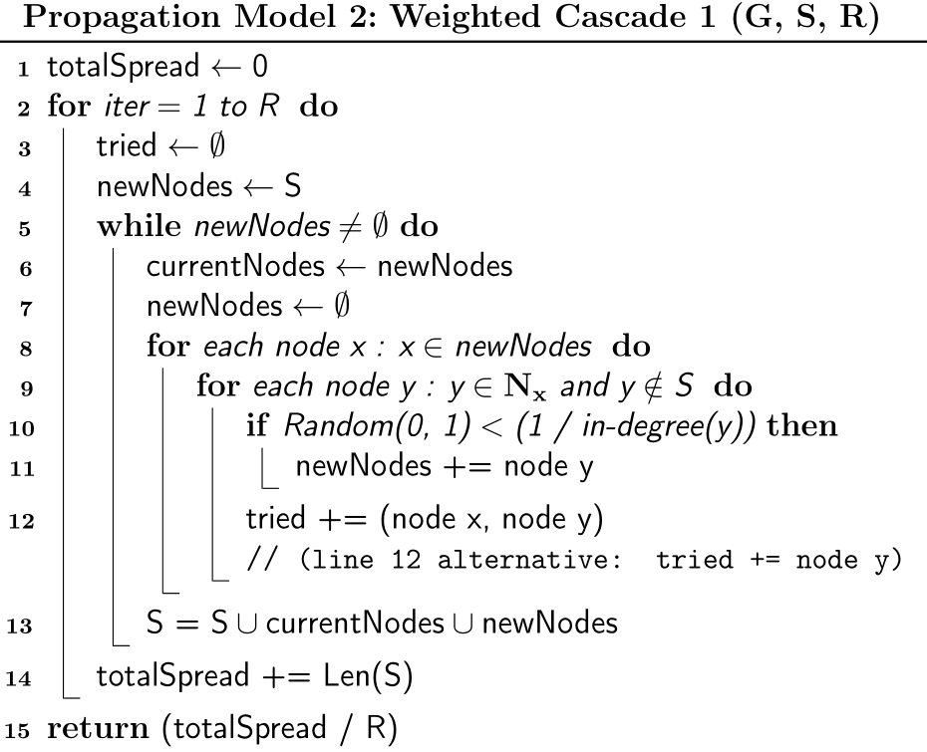
It calculates propagation success using a target node’s degree reciprocal – (1 – its in-degree).
Figure 3. Weighted Cascade 1 Model Algorithm coded in LaTeX
A disadvantage to this model is that it treats all edges equally in terms of calculating probability when some connections will be more significant than others.
It will be from here on referred to as WC1.

4.5.4 Weighted Cascade 2

Analysis
A variation on the weighted cascade model was formulated by Hong and Liu (2019) which considers persuasiveness of popular nodes as well as popular nodes being difficult to influence.

Design
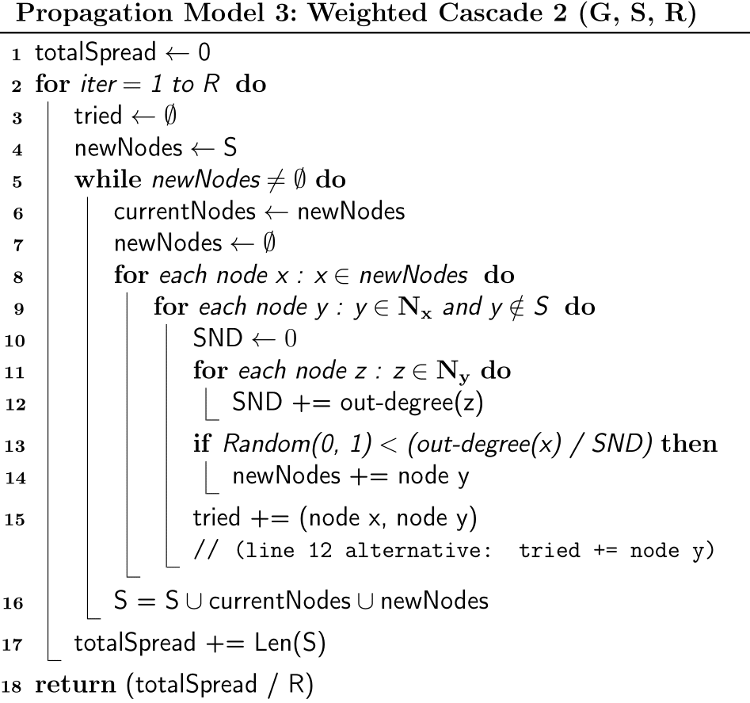
Figure 4. Weighted Cascade 2 Model Algorithm coded in LaTeX
This model determines propagation success using relational degrees: the proportion of the target node’s in-degrees the targeting node’s out-degree comprises.

Testing
New influence models were tested on the BitcoinOTC and Facebook graphs, and influence spreads were compared. For more information, see Section 5.3.4.

4.6 Network Analysis
This section describes network analysis undertaken, involving statistical analysis of degree reciprocals and relational degrees to identify why weighted cascade probabilities were so low and how to rectify them, and comparison of network-wide properties.

4.6.1 Probability Analysis and Normalization

Analysis
Degree reciprocals and relational degrees were calculated and various normalization and scaling techniques were researched and assessed. Useful online resources:
- {https://machinelearningmastery.com/robust-scaler-transforms-for-machine-learning/#:~:text=One%20approach%20to%20standardizing%20input,standardization%20or%20robust%20data%20scaling.} - (Brownlee, 2020)
- {https://developers.google.com/machine-learning/data-prep/transform/normalization.} - (Data Preparation and Feature Engineering for Machine Learning: Normalization, 2020)
- {https://www.codecademy.com/articles/normalization#:~:text=Min%2Dmax%20normalization%20is%20one,decimal%20between%200%20and%201.} - (Normalization, 2020)

Design
The probabilities needed to be between 0 and 1, evenly spread and averaging above 0.2.
Normalization techniques applied:
Technique | Description:
Rooting | All values rooted (square, cube, etc). Values increase, more for lower values.
Min-Max Normalization | For every value: subtract the minimum, divide by the range. Scales values between 0 and 1. Doesn’t handle outliers well. Useful for other techniques that require scaling.
Z-score Normalization | For every value: minus the mean, divide by the standard deviation. Handles outliers well. Requires scaling.
Interquartile Normalization | Normalises using interquartile range. Handles outliers well.
Log-scaling | Every value is logged. Requires scaling.

Implementation and Testing
Normalised probabilities are calculated and compared, and the most ideal technique is incorporated into the propagation models – for more information see section 5.4.2.

4.6.2 Network-wide Analysis

Analysis
Network-wide properties were compared, for supplementary comparison in results.

Design
Metrics compared:
Metric | Description:
Weak components  /  Strong components | Weakly connected components: every node can reach or be reached by every other node.  Strongly connected components: every node can reach every other node.  Number of weak components divided by number of strong components is calculated (undirected graphs = 100%).
Mutuality | Percentage of edges (x -> y) where (y -> x) is also present.
Density | Percentage of possible edges that are present.
Nodes with no incoming edges | Percentage of nodes with no incoming edges.
Nodes with no outgoing edges | Percentage of nodes with no outgoing edges.

Implementation and Testing
Metrics are calculated and compared – see section 5.4.3 for results.

4.7 Seed Selection Models
The next stage was implementing seed selection models; some from previous papers, building some using NetworkX metrics and some new models.

4.7.1 Models from Past Papers
Models explored and implemented from past papers:
Metric: | Description:
Original Greedy  (Kempe, Kleinberg and Tardos, 2003) | Calculates spread of seed set + node for every node in graph, selects highest ranking as a seed. Repeats until seed set full. High level of success, but scales inefficiently due to repeated propagations.
CELF (Cost-effective Lazy-forward)**  (Leskovec et al., 2007) | Optimizes using submodularity of IM (as seed set grows, new seeds improve spread less). Ranks nodes by influence spread. Top node is selected, removed from the list. New top node’s spread recalculated (minus spread from the seed set), list is resorted, and if it remains on top, is selected as a seed and the process repeats. If not, process repeats for the new top node. No seed node will ever outperform their performance of the previous turn.
Improved Greedy  (Chen, Wang and Yang, 2009) | Generates new graph, removing edges with probability (1 – pp). Nodes are selected on their reach within this new graph. Removed the need for repeated propagation, but still inefficient due to generating new graphs every iteration for every seed.
Degree Discount  (Chen, Wang and Yang, 2009) | Heuristic approximation method. Ranks nodes based on degree, and discounts rankings of neighbour nodes of selected seeds, indicating neighbours of seeds are less likely to be good nodes themselves. No iterations required – most efficient approximation method.
**An online implementation was particularly useful and reused/reappropriated into my implementation (King, 2018), which can be found at this link (https://hautahi.com/im_greedycelf)

4.7.2 Network-Analysis-based Models

Analysis and Design
Models were developed using NetworkX metrics, investigating which metrics indicate good seed nodes. Metrics used:
Metric: | Node Description:
Degree Centrality | Fraction of nodes it is connected to.
In-degree Centrality | Fraction of nodes its incoming edges are connected to.
Out-degree Centrality | Fraction of nodes its outgoing edges are connected to.
Closeness Centrality | Reciprocal of the average shortest path distance over all reachable nodes.
Information Centrality | Variant of closeness centrality – incorporates effective resistance between nodes.
Betweenness Centrality | Sum of the fraction of all-pairs shortest paths that pass through it.
Approximate Current-flow Centrality | Approximates betweenness centrality (uses electrical current model) within absolute error of epsilon.
Load Centrality | Fraction of all shortest paths that pass through it.
Eigenvector Centrality | Centrality based on the centrality of its neighbours.
Katz Centrality | Generalization of eigenvector centrality.
Subgraph Centrality | Sum of all weighted walks starting and ending at this node. Weights decrease with path length.
Harmonic Centrality | Sum of the reciprocal of shortest path distances from all other nodes.
VoteRank | Based on a voting scheme. Nodes vote for in-neighbours and node with highest nodes is elected iteratively. Voting ability of out-neighbours decreases subsequently.
PageRank | Based on structure of incoming links. Designed to rank web pages.
HITS Hubs | Value based on outgoing links.
HITS Authorities | Value based on incoming links.

4.7.3 Parameter Fine-tuning

Analysis
Some NetworkX-based models can take parameters – to enhance effectiveness, the parameters were investigated to determine ideal values.

Design
For each parameter, a range of values was compiled for comparison.

Implementation
Every permutation of parameters is calculated, and the seed set obtained with each has its influence spread measured.

Testing and Results
Influence spreads and selection times are compared. Results were stored in a conditionally formatted spreadsheet for staggered entry due to long processing times, enabling easy analysis and comparison. For more information see section 5.4.3.

Evaluation
Once collection was complete, the optimal parameters were set as defaults in their respective seed selection functions.

4.7.4 New Seed Selection Models

Analysis
To accomplish the main objective (1), new seed selection models were developed to rival past models.

Design and Implementation
Some were developed through combining existing strategies, and others extended or generalised characteristics of existing models.

4.8 Influence Model (Build #3)
Final improvements and additional propagation parameters.

4.8.1 Switch Factor

Analysis and Design
Negative influence presents opportunities for nodes to switch sign of influence, representing people changing their mind about something. To incorporate this insight a ‘switch factor’ was implemented.

Implementation
Enables nodes to switch sign of influence with a defined penalty in probability.

Testing
Effects of switch factor were assessed, holding other propagation parameters constant – for more information see section 5.5.

4.8.2 Time Factor

Analysis
How recent something is affecting its influence is an insight included in multiple papers (Liu et al., 2014), referencing how as time goes on (as products/opinions age), influence probabilities decrease.

Design and Implementation
Propagation success is multiplied by a variable decreasing by the time factor each turn of propagation.

Testing
Effects of time factor were assessed, holding other propagation parameters constant – for more information see section 5.5.

4.8.3 Network Generation (Method #3)

Analysis
Generalising network generation to enable seamless extension to further datasets is important in ensuring reproducibility and aiding extension of the model.

Design
The requirement is that anyone can add their own network dataset and use my propagation models or my network analysis tools on it, simply.

Implementation
This consisted of storing information about datasets (name, weighted, directed, file-path) in a dictionary, and completely refashioning the network generation function.

Testing
Functionality testing is performed – efficiency testing against old method unnecessary, as the extra functionality is prioritised. However, iteration methods within the function are optimized through testing.

4.8.4 Probability Assignment

Analysis
Degree reciprocals and their normalizations do not change during the program, so to improve efficiency a method was implemented to

Design

Implementation
Probabilities for the weighted cascade models (1 and 2) are calculated, the collection of them normalised and added to a dictionary for easy access during propagation.

Testing
Iteration methods tested for efficiency, and entire function tested for functionality against previous method.

4.9 Testing and Experimentation Plans
To conclude the project and finalise the main objectives, two phases of experiments are performed – comparison of seed selection models’ performances in time and IM, and analysis of propagation parameters and their effects on influence spread.

4.9.1 Functionality Testing and Optimization
Throughout development, components were improved and optimized. Functionality testing verified that improved components still function the same, and efficiency tests evaluate if they optimize code.

4.9.2 Experiments

Analysis
Seed selection models are compared on time taken to select seeds and their resulting spreads, and propagation parameters are compared on their effects on influence spread.

Design
Different graphs are plotted for different experiments – line graphs for propagation parameters and horizontal bar charts for seed selection models.

Implementation
For seed selection models, every model is executed, with their returned seed sets and time elapsed measured. Bar charts are plotted for the real graphs and the random graphs for the slower models to be compared.
For propagation parameters, propagation is performed varying one parameter (pp¸ qf, sf, tf) and line graphs are plotted to analyse its effect on influence spread.

Chapter 5: Results
This chapter outlines important parts of underlying software and all results from Methods, including functionality and efficiency testing and experimentation.

5.1 Influence Model (Build #1)

5.1.1 Datasets

Implementation
Datasets were formatted into 2 or 3 columns – node, node, weight (if present) – each row representing an edge of the graph (new nodes added automatically). Weights on edges represent the likelihood of propagation between them, scaled between 0 and 1.
The BitcoinOTC dataset was in .csv (comma-separated-values) format, while the Facebook file was in .txt (elements separated by spaces). Preliminary formatting involved replacing every space in the Facebook file with a comma (Ctrl-f -> Advanced -> Replace all) and saving the file in .csv format. An optional step is to delete any values from column 4 onwards, as they won’t be used and may decrease efficiency in very large dataset files.

5.1.2 Network Generation

Design
Directed graphs were used for all networks, keeping the data structure uniform aiding universality – some NetworkX functions are exclusive to directed graphs.
For different types of graphs, Boolean variables indicate directedness and weightedness. Unweighted graphs will be assigned a weight of 1 to all edges; for undirected graphs, every edge will be added in parallel. Also, edges are reversed when added, as discussed in (Chen et al., 2011) to represent influence – an edge indicating node x trusts node y shows node y has influence over node x.
1
2
1
2
1
2

Dataset
Directed graph
Undirected graph
Figure 5. Edge formatting diagram

Implementation
Network generation was manual and done individually for each graph. This way, their parallel edges (if undirected), weight values (if weighted) could be adjusted accordingly. The BitcoinOTC dataset needed its weight values scaled from between -10 and 10 to between 0 and 1. Also, nodes in BitcoinOTC began at 1, and in Facebook at 0. So, BitcoinOTC node keys (numbers) had 1 subtracted for uniformity.
BitcoinOTC example (Facebook graph follows same format, with different file-path):
#Initliaise directed graph
G1 = nx.DiGraph(Graph = "BitcoinOTC")
#Open files from path
with open(r"D:\Sully\Documents\Computer Science BSc\Year 3\Term 2\Individual Project\datasets\soc-sign-bitcoinotc.csv") as csvfile1:
#read file and separate items by comma
# (file is in format: X, Y, W
# indicating an edge from node X to node Y with weight W)
readFile = csv.reader(csvfile1, delimiter=',')
#for every row in the file...
for row in readFile:
#add the edge listed to the graph
#edges are reversed to indicate influence
G1.add_edge((int(row[1])-1), (int(row[0])-1), trust=(int(row[2])+10)/20)

G3 example:
#Small, custom directed, unweighted graph
G3 = nx.DiGraph()
testedges = [(1,2), (2,4), (2,5), (2,6), (3,5), (4,5), (5,9), (5,10), (6,8),
(7,8), (8,9)]
G3.add_edges_from(testedges)
nx.set_edge_attributes(G3, 1, 'trust')

Testing
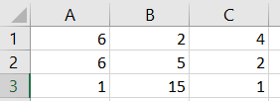
Manual testing if edges are present:
for test in [(1,5), (4,5), (14,0)]:
present = (test in G1.edges)
print(str(test) + ": " + str(present))

Results
Edge: | Present in BitcoinOTC Graph:
1 -> 5  (6 -> 2 in dataset) | True
4 -> 5  (6 -> 4 in dataset) | True
14 -> 0  (1 -> 15 in dataset) | True

Evaluation
Testing was successful: multiple rows from the .csv files were present in the networks, proving functionality of network generation.

5.1.3 Initial Propagation Model

Implementation
The initial implementation was developed as a foundational model – focusing on functionality, with optimization and additional features being secondary concerns. As such, the coding was non-optimized and quite inefficient.
(See appendix D.1 for variations in propagation model)
The model used lists and nested for loops extensively, avoiding other features for the time being to simplify debugging and develop a functional build. It would later be optimized and modularised.

Testing
Propagation was tested on G3, with a seed set of [1, 2] and one of two propagation probabilities over 100 iterations:
print(IndependentCascade(G3, [1,2], 100, 0.1))
print(IndependentCascade(G3, [1,2], 100, 0.8))

Results
Propagation Probability (pp) | Influence Spread | Time elapsed
0.1 | 1.42 | 0.001
0.8 | 4.56 | 0.003

Evaluation
Testing was successful, indicating the model functioned as intended and could be expanded to include additional features. However, propagation on either the BitcoinOTC or Facebook graphs was too inefficient to run, necessitating optimization.

5.2 Influence Model (Build #2)

5.2.1 Refactoring/Modularization

Implementation
Improvements were made, using relevant community posts (listed in section 4.4.1) as a broad guide.
The influence model was modularised into three functions – iteration, propagation and success.
Refactoring consisted of removing unnecessary loops and specializing data structures. Sets are quicker than lists when searching for an element. Sets cannot contain duplicates, however, so the model was restructured without ‘targets’ lists.
Network generation was also modularised and semi-generalised:
(see Appendix D.1 for variations in network generation method)
Network generation from datasets:
# Generate network graph from soc-BitcoinOTC dataset (5881 nodes, 35592 edges)
# (directed, weighted, signed)
G1 = generateNetwork("BitcoinOTC Network", True, True, 1, r"D:\Sully\Documents\Computer Science BSc\Year 3\Term 2\Individual Project\datasets\soc-sign-bitcoinotc.csv")

# Generate network from ego-Facebook dataset (4039 nodes, 88234 edges)
# (undirected, unweighted, unsigned, no parallel edges)
G2 = generateNetwork("Facebook Network", False, False, 0, r"D:\Sully\Documents\Computer Science BSc\Year 3\Term 2\Individual Project\datasets\facebook.csv")

Testing
Modularised network generation functionality testing:
test = [(G11, G21, G31), (G12, G22, G32)]
for gc in range(3):
for graphlist in test:
print(graphlist[gc].size())
print(str(len(graphlist[gc])) + "\n")

Results
Network generation method 2 results:
Network Generation Method: | Graph 1 Size (edges), Length (nodes) | Graph 2 Size (edges), Length (nodes) | Graph 3 Size (edges), Length (nodes)
Method 1 (manual) | 35587, 5875 | 176468, 4039 | 11, 10
Method 2 (semi-modularised) | 35587, 5875 | 176468, 4039 | 11, 10

Evaluation
Testing was successful, indicating modularized network generation was functionally identical to the previous method.

5.2.2 Quality Factor

Implementation
The quality factor was implemented in the success function, with qf being applied to probability for positive influence and (1 – qf) for negative influence:
q = qf
#Modify quality factor for negative influence
if not sign:
q = (1-q)
return q

Data required restructuring to allow for negative nodes and newly negative nodes, avoiding interference with positive nodes.
Quality factor was tested along with new propagation models.

5.2.4 Additional Propagation Models (WC1 & WC2)

Implementation
New propagation models were introduced:
def successWC1(sign, g, target, targeting, pp, qf):
recip = 1 / g.in_degree(target)
return np.random.uniform(0,1) < (recip*successVars2(sign, qf)*g[targeting][target]['trust'])

def successWC2(sign, g, target, targeting, pp, qf):
snd = 0
for neighbour in g.predecessors(target):
snd += 1
reldeg = g.out_degree(targeting) / snd
return np.random.uniform(0,1) < (reldeg*successVars2(sign, qf)*g[targeting][target]['trust'])

Testing
#Testing the change in quality factor for every model, for every graph
for model in ['IC', 'WC1', 'WC2']:
for gc, g in enumerate([G1, G2]):
for pp in [0.2]:
for qf in [0.2, 0.8]:
print("G" + str(gc+1) + ":\n" + model + " Vars Testing\nPP = "
+ str(pp) + ". QF = " + str(qf) + "\n" +
str(iteration2(g, [1], 50, pp, qf, model)) + "\n")

Results
Graph: | Model (Build #2): | Propagation Probability (pp): | Quality Factor (qf): | Spread: | Time elapsed (50 iterations):
BitcoinOTC | Independent Cascade | 0.2 | 0.2 | 7.32 | 5.458 secs
BitcoinOTC | Independent Cascade | 0.2 | 0.8 | 759.1 | 7.438 secs
BitcoinOTC | Weighted Cascade 1 | 0.2 | 0.2 | 5.68 | 0.524
BitcoinOTC | Weighted Cascade 1 | 0.2 | 0.8 | 27.8 | 0.2777 secs
BitcoinOTC | Weighted Cascade 2 | 0.2 | 0.2 | 353.44 | 19.153 secs
BitcoinOTC | Weighted Cascade 2 | 0.2 | 0.8 | 3593.74 | 20.76 secs
Facebook | Independent Cascade | 0.2 | 0.2 | 0.88 | 45.028 secs
Facebook | Independent Cascade | 0.2 | 0.8 | 1560.36 | 37.475 secs
Facebook | Weighted Cascade 1 | 0.2 | 0.2 | 1.28 | 0.039 secs
Facebook | Weighted Cascade 1 | 0.2 | 0.8 | 2.68 | 0.032
Facebook | Weighted Cascade 2 | 0.2 | 0.2 | 0.0 | 0.368 secs
Facebook | Weighted Cascade 2 | 0.2 | 0.8 | 1696.64 | 98.8408

Evaluation
Results verified that the quality factor increased influence when high and decreased influence when low – further analysis in section 5.8.
However, WC1 and WC2 models had noticeably low spreads with a low quality factor (orange), and WC1 even with a high quality factor (red). This indicated probabilities based on degree reciprocals or relational degrees were too low. These models comprised much of the planned experimentation, and the spreads needed to be sufficiently high to enable comparison with other models. This led to in-depth statistical analysis of probabilities and normalization techniques.

5.3 Network Analysis

5.3.1 Probability Analysis and Normalization

Analysis
As previously mentioned, probabilities based on degree reciprocals (WC1) or relational degrees (WC2) were too low, especially in the Facebook graph, necessitating investigation into normalization techniques. Network-wide analysis was also performed for network comparison.

Implementation
Degree reciprocals and relational degrees are calculated and compiled into lists, various normalization techniques are applied and histograms of results are plotted. Normalization is intended to achieve probabilities with a mean between 0.3 and 0.7 and an even spread of values. Example functions are included below, different variations are included in appendices (REFERENCE).
Relational degree calculation function:
#Calculate and return the relational-degrees for all edges in a graph (WC2):
def calcRelDegs(g, weighted=False):
relDegs = []
for target in g:
if not g.in_degree(target):
continue
#sum of target's neighbours' out_degrees
snd = 0
for neighbour in g.predecessors(target):
snd += g.out_degree(neighbour)
#relational degrees calculated
for targeting in g.predecessors(target):
if weighted:
relDegs.append((g.out_degree(targeting)/snd)*g[targeting][target]['trust'])
else:
relDegs.append(g.out_degree(targeting)/snd)
return relDegs

Example normalization function (square rooting):
#Convert all elements in a list to a given root
def rootList(lis, root):
return list(map(lambda x : x**root, lis))

rooted = []
for g in graphs:
rooted.append(rootList(calcRelDegs(graphs[g], (1/2))))

See appendix C.2 for plot histogram functions

Results
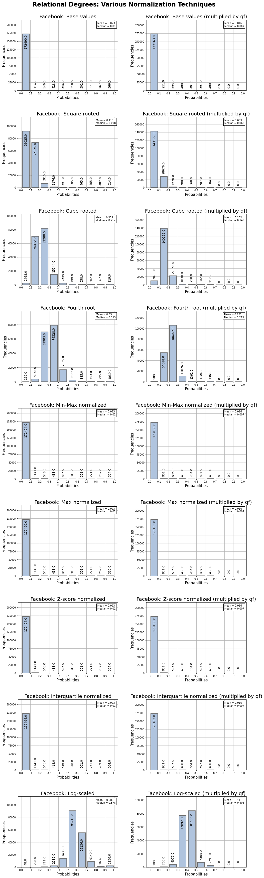
Example histograms for Facebook graph relational degrees:
The complete collection of histograms can be found in appendix D.2.

Evaluation
Reviewing the histograms, log-scaling was chosen as it results in sufficient probabilities for both graphs and has an even spread. Despite increasing probabilities, relationships still hold due to all values being normalized.

5.3.2 Network-wide Analysis

Implementation
Different metrics are calculated for each network, compiled into lists and plotted in bar charts. Example functions are included below, different variations can be found in appendices (REFERENCE).
Example metric calculation function (mutuality):
#Returns the mutuality-percentage of a given graph
#(how many of the edges are parallel/bi-directional)
def mutuality(g):
edgeSet = set(g.edges)
count = 0
for (u,v) in edgeSet:
if (v,u) in edgeSet:
count += 1
return round((count/g.size())*100, 5)

(see appendix C.2 for network metric bar chart plotting functions)

Results
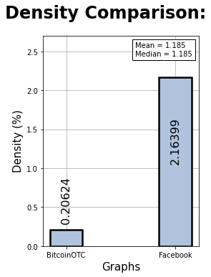
BitcoinOTC and Facebook – mutuality and density:

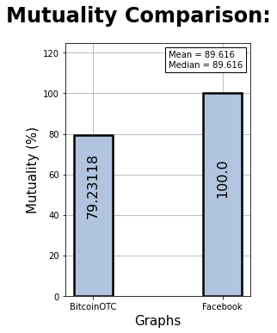
Evaluation
Analysing network-wide properties was successful. Evaluating the density bar chart shows the Facebook graph to be significantly higher than the BitcoinOTC graph, with a density of ~2.2% compared to ~0.2%. This explains why the Facebook graph is slower to propagate through – as more edges per nodes, means more edges must be attempted before propagation is completed.

5.4 Seed Selection Models

5.4.1 Past Models

Analysis and Design
Recreating past models involved studying algorithms from relevant papers and implementing them in Python.

Implementation
Example of past models: (original greedy)
#Original Greedy from Kempe et al 2003
#Calculates spread for every node not in the seed set, and adds the
# highest to the seed set. Repeat until seed set is full.
def ogGreedySeeds(g, qty, its, propFunc='IC'):
S = set()
for _ in range(qty):
inf = {node: cascade(g, S.union({node}), its, model=propFunc)
for node in g if node not in S}
S.add(max(inf, key=inf.get))
return S
The rest of the models can be found in appendix C.3.

5.4.2 Network-Analysis-based Models

Design
All models follow a similar framework: sort all nodes by the given metric using the appropriate built-in NetworkX function, and extract the k top nodes, where k is the seed set size.

Implementation
Two examples of NetworkX-based models:
#Closeness-centrality
def ccSeeds(g, qty):
ccs = nx.closeness_centrality(g, wf_improved=True)
return sorted(ccs, key=ccs.get, reverse=True)[:qty]

#VoteRank
def voteRankSeeds(g, qty):
return set(nx.voterank(nx.to_undirected(g), qty))

5.4.3 Parameter Fine-tuning

Design
Range of values used in fine-tuning:
Closeness Centrality | Wasserman-Faust improvement
Closeness Centrality | True |  |  | False
Betweenness Centrality | Node samples for estimation |  |  |  |  |  | Randomness seed
Betweenness Centrality | 25 | 50 |  | 100 |  | 200 | 10 |  |  | None
Approx. Current-flow Betweenness Centrality | Maximum number of sample node pairs
Approx. Current-flow Betweenness Centrality | 10000 | 500 |  | *-50 |  | *-200
Load Centrality | Cut-off length
Load Centrality | 1 | 2 |  | 3 |  | 4
Eigenvector Centrality | Max iterations |  |  |  |  |  | Error tolerance
Eigenvector Centrality | 100 |  | 500 |  | 1000 |  | 0.001 |  | 0.0025 |  | 0.005
Katz Centrality | Beta (neighbourhood weight) |  |  |  |  |  | Alpha (attenuation factor)
Katz Centrality | 0.75 | 1 |  | 1.25 |  | 1.5 | 0.05 | 0.1 |  | 0.15 |  | 0.2
Harmonic Centrality | Distance edge attribute
Harmonic Centrality | None |  |  | Trust
PageRank | Alpha (damping parameter)
PageRank | 0.65 | 0.75 |  | 0.85 |  | 0.95
*Negative values indicate the parameter will be the graph’s size divided by this value.

Implementation
Each seed selection model was run with every possible permutation of values with functions defined with variable parameters:
Example variable parameter function:
#Eigenvector-centrality w/ variable parameters
def evCSeedsTune(g, qty, mi, t, w=None):
evcs = nx.eigenvector_centrality(g, weight=w, tol=t, max_iter=mi)
return sorted(evcs, key=evcs.get, reverse=True)[:qty]

A function obtained seeds using every permutation for every seed selection model, ran propagation with those seeds and printed the results. The function ‘paramFineTune’ can be found in appendix C.3:
It also tracked which seeds had been propagated to prevent propagation using any previously tried seed sets as it would return the same result and waste time.

Testing
#Seed selection models to be fine-tuned, with tuples
# for each parameter containing every value to be tried.
sModsTune = [(btwnCSeedsTune, "BetweennessCentrality", ((25,50,100,200), (10, None))),
(approxCfBtwnCSeedsTune, "ApproxCF-BetweennessCentrality", [(10000,500,-50,-200)]),
(loadCSeedsTune, "LoadCentrality", [(1,2,3,4)]),
(evCSeedsTune, "EigenvectorCentrality", ((100,500,1000), (0.001,0.0025,0.005))),
(kCSeedsTune, "KatzCentrality", ((0.75,1,1.25,1.5), (0.05,0.1,0.15,0.2))),
(harmCSeedsTune, "HarmonicCentrality", ([(None, 'trust')])),
(pageRankSeedsTune, "PageRank", [(0.65,0.75,0.85,0.95)]),
(ccSeedsTune, "ClosenessCentrality", [(True, False)])]
#Parameter fine-tuning
paramFineTune(graphs, 8, 25, sModsTune)

Results
Results were compiled into a formatted excel spread sheet, an excerpt of which is shown here:
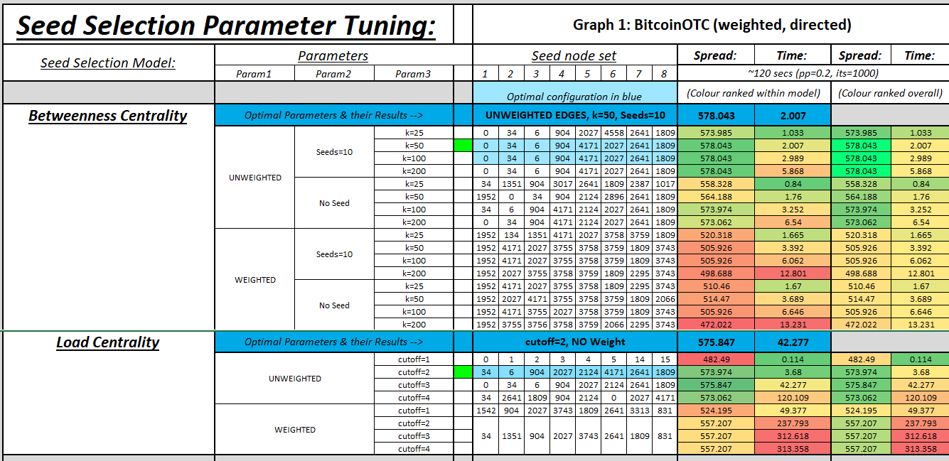
(The complete file can be found in appendix D.4, and values may have changed before the final version due to further tweaks in the cascade implementation, but the rankings will be consistent).
The conditional formatting modified the colours of cells depending on their rank (by spread or time), once per model and once overall. There were also formulas to calculate averages and display the maximum spread (or minimum time) overall.
This was repeated for both the Bitcoin and Facebook graphs, and the optimal parameters were hard-coded into the seed selection models.

5.4.4 New Models
The first new model implemented, the ‘MixedGreedy’, was theorised but not detailed in Efficient Influence Maximization in Social Networks (Chen, Wang and Yang, 2009). It uses the improved greedy technique to generate a modified graph, removing edges by probability, and uses the CELF technique to continuously re-rank and choose the best seed nodes (both described in section 4.6.1). Four variations of this model were implemented.
The next model implemented was a heuristic strategy closely based on the degree discount model and another heuristic solution described broadly by (Hong and Liu, 2019) which ranks nodes by degree and discounts rankings of seed node’s neighbours.
The final model implemented, ‘Disconnect’ model, removes nodes reached by seed nodes from the graph iteratively, however this model was not successfully implemented and was never developed to working order.

5.5 Influence Model (Build #3)

5.5.1 Switch Factor

Implementation
If an already influenced node is being influenced with the opposite sign of influence (positive/negative) a factor of (1 – sf) where sf is the switch factor is applied to the probability. If the node is uninfluenced, no switch factor is applied.
success(successMod, False, (neighbour in pos)#...
#...other code...#
def success(successModel, sign, switch,#...
if successModel == 'IC':
succ = (pp*successVars(sign, switch, qf, sf)
#...other code...#
def successVars(sign, switch, qf, sf):
if not sign:
qf = (1-qf)
if not switch:
sf = 0
return qf*(1-sf)

Testing
#switch factor testing for every model in BitcoinOTC graph
g = graphs['BitcoinOTC']
for model in propMods:
print(model[1] + ":\n")
for test in [0, 0.3, 0.6, 0.9]:
measureTime2("Switch factor: " + str(test), cascade, g,
[1], 50, model[0], 1, False, 0.2, 0.6, test)
print("")

Results
Switch factor testing on BitcoinOTC graph:
Propagation Model | Switch Factor (sf): | Influence Spread | Time elapsed
Independent Cascade | 0 | 847 | 8.51 secs
Independent Cascade | 0.3 | 845.36 | 8.12 secs
Independent Cascade | 0.6 | 902.18 | 8.13 secs
Independent Cascade | 0.9 | 975.56 | 8.35 secs
Weighted Cascade 1 | 0 | 1561.02 | 9.58 secs
Weighted Cascade 1 | 0.3 | 1628.18 | 9.67 secs
Weighted Cascade 1 | 0.6 | 1695.58 | 10.06 secs
Weighted Cascade 1 | 0.9 | 1867.92 | 11.1 secs
Weighted Cascade 2 | 0 | 1937.3 | 10.09 secs
Weighted Cascade 2 | 0.3 | 1978.8 | 9.74 secs
Weighted Cascade 2 | 0.6 | 2097.32 | 9.97 secs
Weighted Cascade 2 | 0.9 | 2295.3 | 10.91 secs

Evaluation
The switch factor results are opposite to what was initially expected, as a higher switch factor was expected to reduce influence. The only possible explanation is that due to the incorporation of negativity bias, it reduces negative influence more than it reduces positive influence, resulting in an overall increase in positive influence. An unexpected, but insightful result.

Further Testing
Due to the switch factor producing unexpected results, it was thought it may be due to the positive quality factor – referring to research hypothesis (2) – and if quality factor was negative, switch factor would have an inverse effect. So further testing was carried out.
for q in [0.2, 0.8]:
for sw in [0, 0.2, 0.4, 0.6, 0.8, 1]:
print("QualityFactor = " + str(q) + "\nSwitch factor = " + str(sw))
print(cascade(graphs['BitcoinOTC'], [1], 25, qf=q, sf=sw))
print("")

Results
Quality Factor (qf): | Switch Factor (sf): | Positive influence | Negative influence
0.2 | 0 | 14.6 | 2245.52
0.2 | 0.2 | 14.84 | 2249.68
0.2 | 0.4 | 18.32 | 2243.64
0.2 | 0.6 | 20.0 | 2239.04
0.2 | 0.8 | 24.6 | 2229.84
0.2 | 1 | 37.24 | 2218.96
0.8 | 0 | 1854.56 | 416.16
0.8 | 0.2 | 1865.32 | 404.52
0.8 | 0.4 | 1868.28 | 389.92
0.8 | 0.6 | 1874.72 | 381.92
0.8 | 0.8 | 1892.92 | 375.24
0.8 | 1 | 1903.64 | 359.6

Evaluation
It seems regardless of what value the quality factor is, a higher switch factor always benefits positive influence over negative influence. The logical explanation is that it counteracts the negativity bias implicit in the model.

5.5.2 Time Factor

Implementation
A time variable is initialised at 1. Every turn of propagation, the time factor is subtracted from the time variable, and is multiplied during propagation probability.
E.g., time factor = 0.02:
First turn: prob = 1 x prob. Second turn: prob = 0.98 x prob Third turn prob = 0.96 x prob
timeFactor = 1
#while there are newly influenced nodes from last turn...
while posNew or negNew:
#...other code...#
#Time delay is taken away from the time factor
if timeFactor < 0:
timeFactor = 0
else:
timeFactor -= tf

Testing
#switch factor testing for every model in BitcoinOTC graph
g = graphs['BitcoinOTC']
for model in propMods:
print(model[1] + ":\n")
for test in [0, 0.05, 0.1, 0.5]:
measureTime2("Time factor: " + str(test), cascade, g,
[1], 50, model[0], 1, False, 0.2, 0.6, 0.5, test)
print("")

Results
Time factor testing on BitcoinOTC graph:
Propagation Model | Time Factor (tf): | Influence Spread | Time elapsed
Independent Cascade | 0 | 929.36 | 8.69 secs
Independent Cascade | 0.05 | 869.84 | 8.88 secs
Independent Cascade | 0.1 | 770.34 | 8.44 secs
Independent Cascade | 0.5 | 111.76 | 2.71 secs
Weighted Cascade 1 | 0 | 1679.78 | 9.9 secs
Weighted Cascade 1 | 0.05 | 1648.88 | 10.59 secs
Weighted Cascade 1 | 0.1 | 1579.5 | 10.44 secs
Weighted Cascade 1 | 0.5 | 297.6 | 5.08 secs
Weighted Cascade 2 | 0 | 2105.56 | 10.697 secs
Weighted Cascade 2 | 0.05 | 2028.0 | 10.25 secs
Weighted Cascade 2 | 0.1 | 1926.14 | 10.67 secs
Weighted Cascade 2 | 0.5 | 427.88 | 7.56 secs

Evaluation
The results show that time factor works exactly as expected: as it increases, influence spread decreases. This is due to less propagation turns being possible each iteration, as the delay made to the time delay variable is greater.

5.5.3 Network Generation

Implementation
Completely generalized network generation method is implemented using a dictionary to store information about datasets and the network graphs themselves. This enables new datasets to be added to the program requiring only two lines of code – add file-path to datasets dictionary and list whether it is weighted and/or directed.
Adding new datasets is explained in full detail in appendix B.
(unconnected function can be found in appendix C.1, C.2, C.3 or D.1)
(final network generation function can be found in appendix C.1, or D.1)

Dataset dictionary and example network generation:
#Title : directed, weighted, offset, filepath to .csv file
datasets = {
#BitcoinOTC dataset (5881 nodes, 35592 edges)
#(directed, weighted, signed)
"BitcoinOTC": (True, True,
r"D:\Sully\Documents\Computer Science BSc\Year 3\Term 2\Individual Project\datasets\soc-sign-bitcoinotc.csv"),
#Facebook dataset (4039 nodes, 88234 edges)
#(undirected, unweighted, unsigned)
"Facebook": (False, False,
r"D:\Sully\Documents\Computer Science BSc\Year 3\Term 2\Individual Project\datasets\facebook.csv")
}

#Generate graphs from real datasets using the datasets dictionary
for g in datasets:
realGraph = generateNetwork((g + " Network"),
datasets[g][0], datasets[g][1],
datasets[g][2])
graphs[g], diGraphs[g], allGraphs[g] = realGraph, realGraph, realGraph

#Generate various mock graphs for testing and debugging:

#Custom, small directed, unweighted graph
mockG, name = nx.DiGraph(), "mock1: Custom, small"
testedges = [(1,2), (2,4), (2,5), (2,6), (3,5), (4,5), (5,9), (5,10), (6,8),
(7,8), (8,9)]
mockG.add_edges_from(testedges)
nx.set_edge_attributes(mockG, 1, 'trust')
mockGraphs[name], diGraphs[name] = mockG, mockG

Testing and Results
There were various iteration methods available in Pandas to iterate through the rows of the .csv files, so they were tested for efficiency:
(code for iteration method efficiency testing can be found in appendix D.1)
Pandas Row Iteration Model: | Time elapsed: (10 iterations)
index | 38.35 secs
loc | 45.99 secs
iloc | 130.19 secs
itertuples | 5.54 secs
iterrows | 95.22 secs

Secondly, the new method is functionally tested, against the old method, to ensure they work identically.
Network Generation Method: | Graph: | Size (# of edges): | Length (# of nodes):
Method 2 (Semi-generalised function with manual dataset parameter entry) | G1: BitcoinOTC | 35587 | 5875
 | G2: Facebook | 176468 | 4039
 | G3: Custom | 11 | 10
Method 3 (Fully generalised function with dataset parameter dictionary) | G1: BitcoinOTC | 35587 | 5875
 | G2: Facebook | 176468 | 4039
 | G3: Custom | 11 | 10

Evaluation
The itertuples iteration method was the most efficient and was implemented in network generation method 3. Method 3 and method 2 are seen to be functionally identical, so the new network generation method was a success.

5.5.4 Probability Assignment

Implementation
Assign functions were implemented to calculate all degree reciprocals (WC1) or relational degrees (WC2), depending on the model, normalise them and assign them as node (degree reciprocal) or edge (relational degree) attributes. The downside to this approach was that the normalization method had to be manually predetermined.
This was then improved with a more generalised method, where the cascade function had an additional parameter assign which would specify which normalization method should be used in the case of WC1 or WC2. Furthermore, if assign was set to 0, no assigning would occur and any calculations for degree reciprocal or relational degree were done in the success function, as required. This final feature meant that comparative testing could take place.

Testing and Results
Optimization and functionality tests were run to confirm it still functioned identically and compare performance. The tests were run on the BitcoinOTC graph with the parameters: Seed set = [1], 75 iterations, propagation probability = 0.5, quality factor = 0.7, switch factor = 0.7, time factor = 0.04:
(testing can be found in appendix D.1)
The initial results can be seen below:
Assign Model: | Description: | Spread: | Time elapsed:
Assign = 0  (Manual log-scaling) | Calculate log-scale of probability every time it’s needed, during the success function. | 1.427 | 0.368 secs
Assign = 3  (Log-scaling and assigning method) | Calculate and normalise all Relational Degrees initally and assign them as edge attributes | 888.773 | 77.491 secs
As they are not equal, there was a problem in implementation. Upon inspection it is clear there was a mistyped line in the AllRelDegs function (used to calculate all the relational degrees, to obtain maximums and minimums, which are used for normalization when manually calculating for Assign = 0), and further running of the tests were carried out:
Assign Model: | Description: | Spread: | Time elapsed:
Assign = 0  (Manual log-scaling) | Calculate log-scale of probability every time it’s needed, during the success function. | 1188.533 | 328.085
Assign = 3  (Log-scaling and assigning method) | Calculate and normalise all Relational Degrees initially and assign them as edge attributes | 1188.533 | 13.405
It is clear from these results, that the two methods are functionally identical and the newer assigning method improves efficiency by a factor of over 20.

5.6 Seed Selection Model Comparison

Design
Bar charts were used to compare the seed selection models, as each model is its own distinct entity, and as such they form discrete variables. The random user-defined graph was used initially, due to the past models being too inefficient to feasibly run on the BitcoinOTC or Facebook graph (even running the original greedy with 1 iteration on the Facebook graph would take over 15 minutes).

Implementation
After collecting and compiling all the fine-tuning results, bar charts were plotted to better compare the different models, using different preparation and plotting functions:
The function ‘prepareBar’ used to prepare the data, given seed selection models and their labels can be found in appendix C.3.
Function to plot horizontal bar charts with the prepared data, comparing different seed selection models:
def horzBar(lis, vals, msg, topGap):
#return nothing if lists aren't same size
if len(lis[1]) != len(vals[1]) != len(vals[2]):
print("Error, not the same size")
return
lis[1], vals[1], vals[2] = lis[1][::-1], vals[1][::-1], vals[2][::-1]
#subplot set up, gridlines drawn, max value calculated and y-limits set
fig, ax = plt.subplots(2, 1, figsize=(12,2*len(vals[1])))
for g in range(2):
ax[g].grid(zorder=0)
height, pos = 0.4, np.arange(len(vals[1]))
#bar chart plotted
ax[g].barh(lis[1], vals[g+1], height=height,
facecolor='lightsteelblue', edgecolor='black',
linewidth=2.5, zorder=3)
#Subtitle, x-labels & y-labels are set for each axis
ax[g].set_ylabel(lis[0], fontsize=20)
ax[g].tick_params(axis='both', labelsize=15)
ax[g].set_xlabel(vals[0][g], fontsize=20)
#Titles are set and the layout (incl. padding/gaps) is set and adjusted
fig.tight_layout(pad=5)
fig.suptitle(msg + " Comparison:", fontsize=24, fontweight='bold')
fig.subplots_adjust(top=topGap)

Results
Each model has bar charts plotted for spreads and for spreads divided by a tenth of the seed selection time. Past models are compared using the random graphs, as they take too long to run on the BitcoinOTC and Facebook graphs, and the others are compared on random and real graphs. Finally, all models are compared on the random graphs – once comparing spread, and once comparing spread divided by a tenth of the seed selection time (to compare effectiveness in regards to efficiency).

Past Models

Results
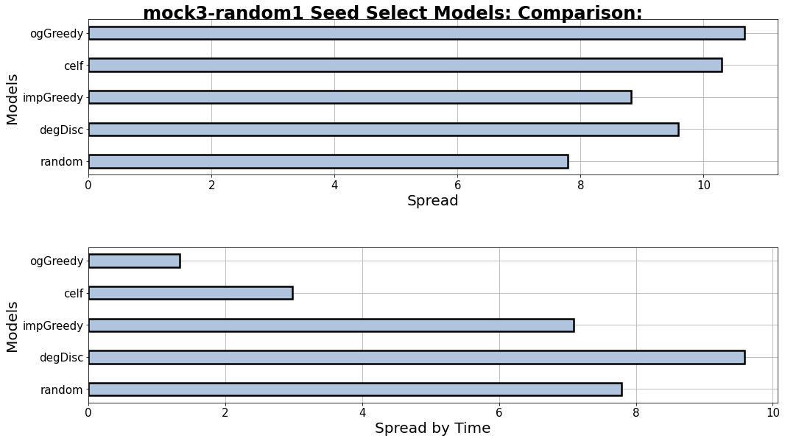
Past models – random graph with uniform trust values:

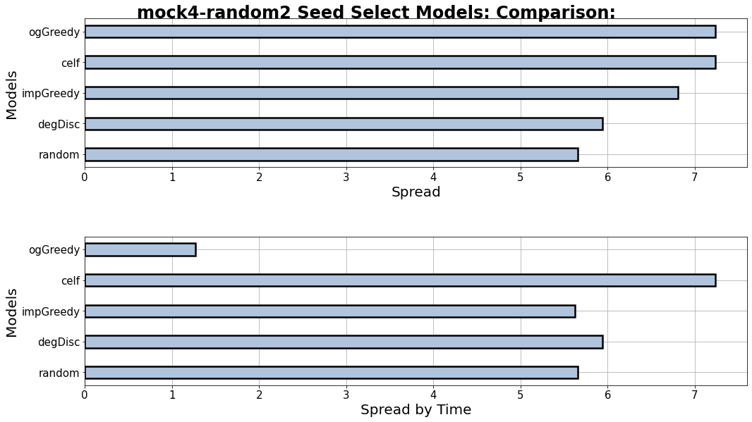
Past models – random graph with randomised trust values:

Evaluation
On the first random graph, original greedy, CELF and degree discount provide the best spread, but only degree discount retains its high ranking when time is considered. In the second graph, however, degree discount does not perform as well, with CELF retaining a very high spread.

NetworkX Models

Results
NetworkX models – random graph with uniform trust values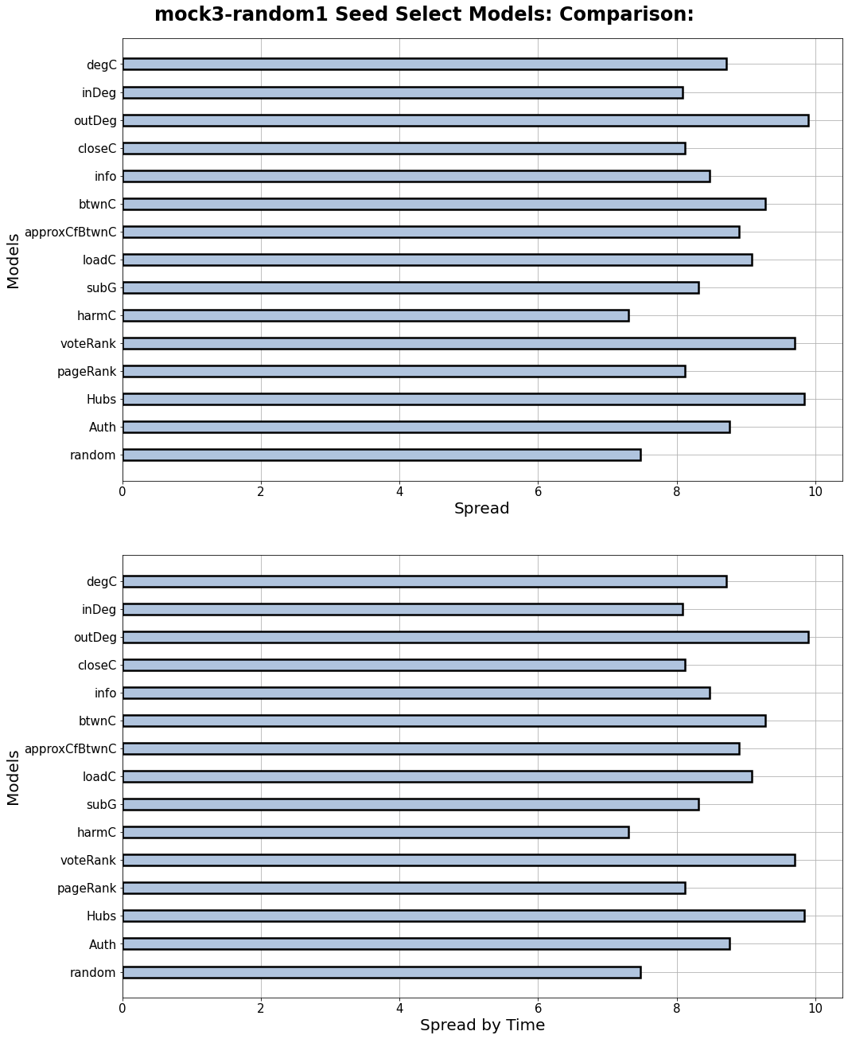m

NetworkX models – random graph with randomised trust values:
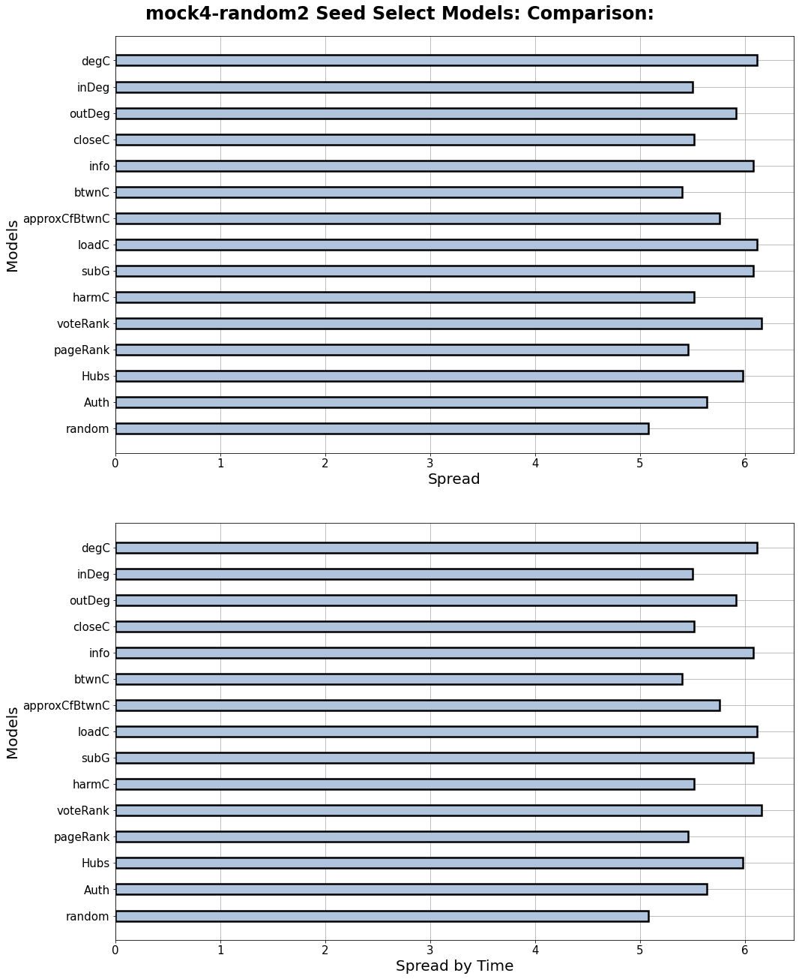

NetworkX models – BitcoinOTC graph:
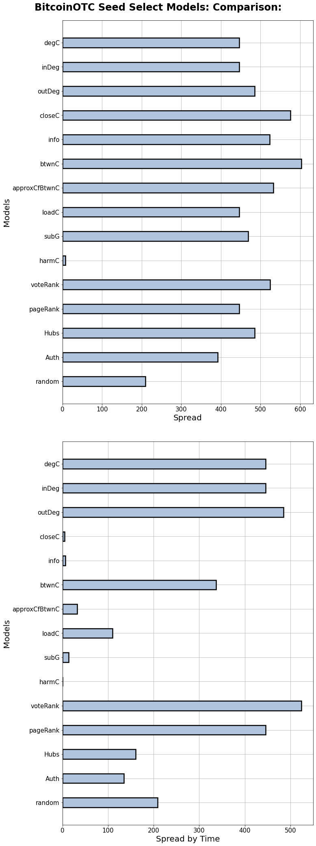

Evaluation
In both random graphs, considering time had no effect on spreads achieved, implying that all models selected seeds in a reasonable time. In the first graph, out degree centrality, vote rank and page rank were the best performing, and in the second graph, degree centrality, info centrality, load centrality, subgraph centrality and vote rank all perform the best.
However, considering time has a much more tangible effect on the Bitcoin graph. Closeness centrality and betweenness centrality performed the best on spread alone, but out degree centrality and vote rank were the best by far when considering time also, with closeness centrality severely dropping down the rankings.

New Models

Results
New models – random graph with uniform trust values:
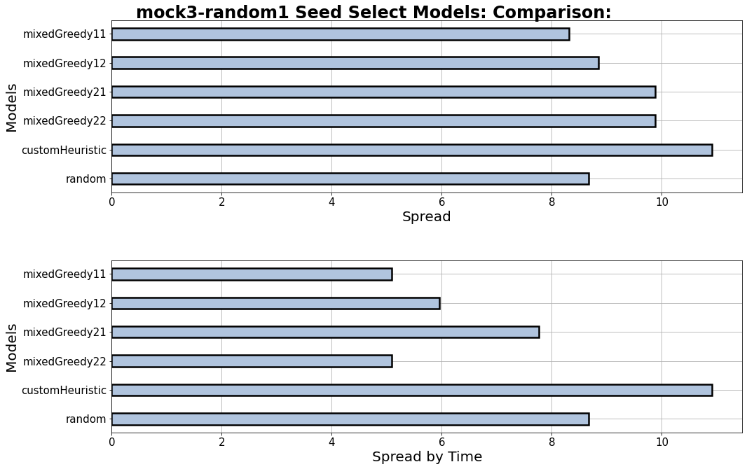

New models – random graph with randomized trust values:
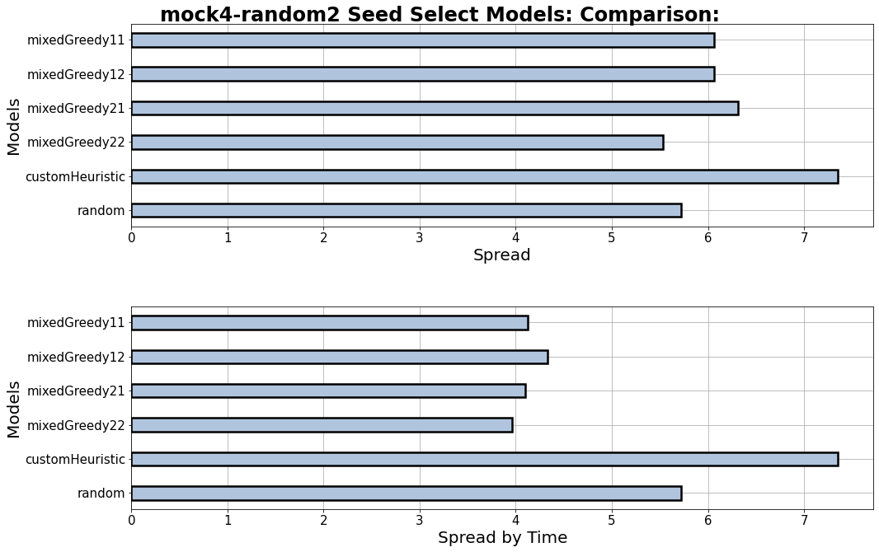
New models – BitcoinOTC graph:
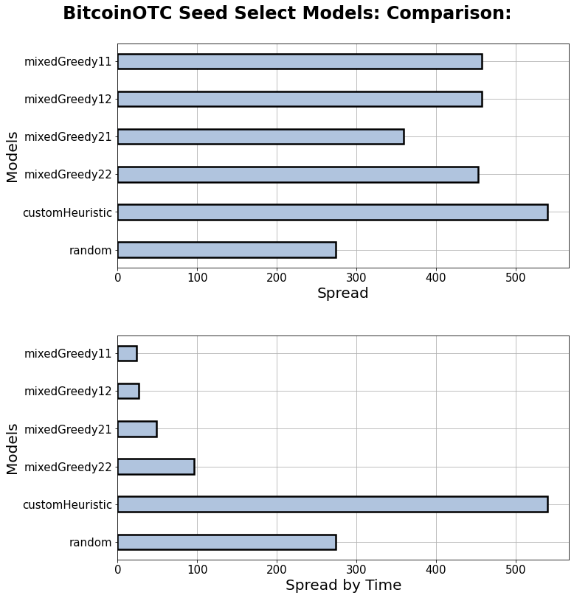

New models – Facebook graph:
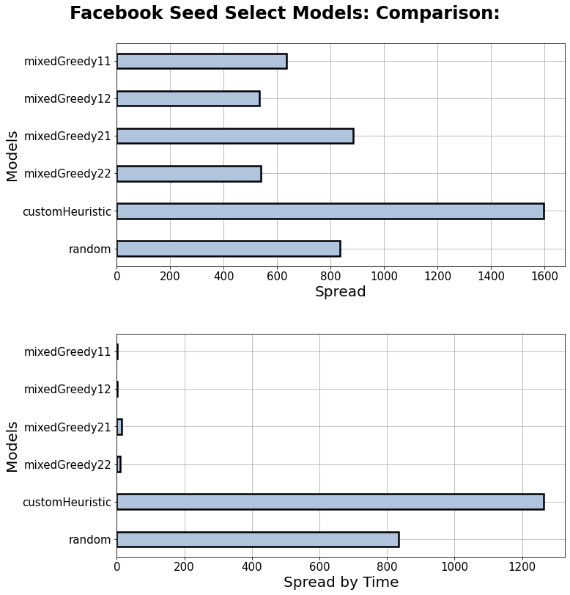

Evaluation
On both random graphs, custom heuristic performed the best, and the mixed greedy models had reasonable spreads until time was considered.
On the BitcoinOTC and Facebook graphs this was even more pronounced, with custom heuristic still being the best performing, but with the mixed greedy models dropping off even more steeply.

All Models

Results
All models – random graph with uniform trust values
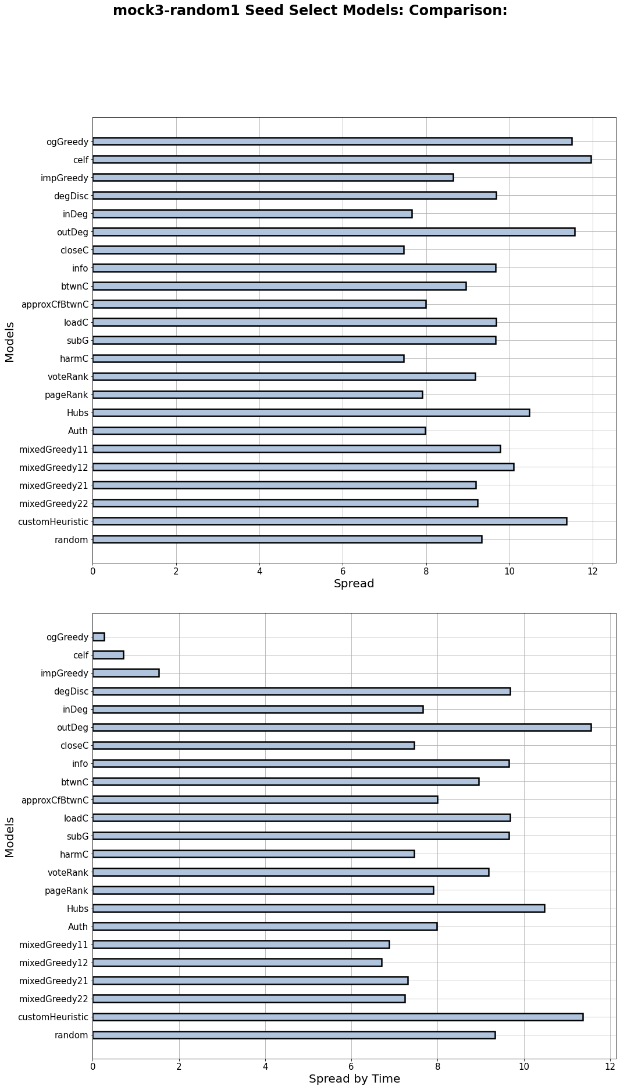
All models – random graph with randomized trust values
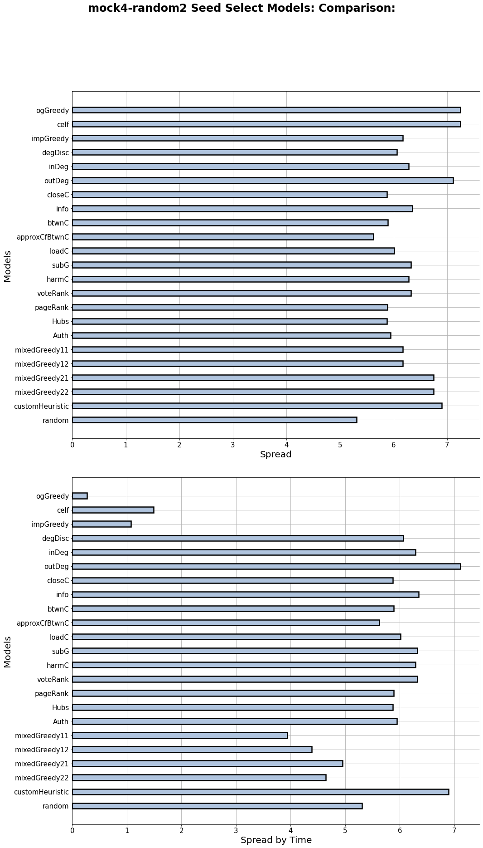

Some models (efficient enough to run) – BitcoinOTC graph
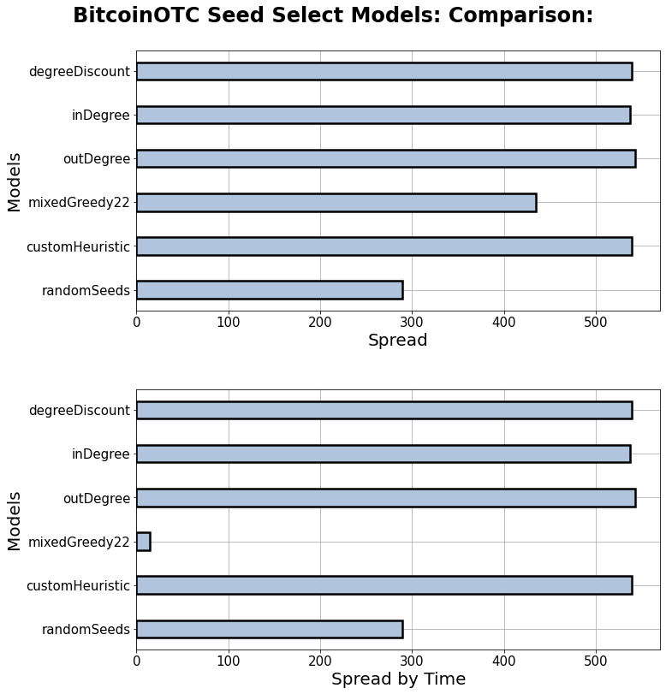

Some models (efficient enough to run) – Facebook graph
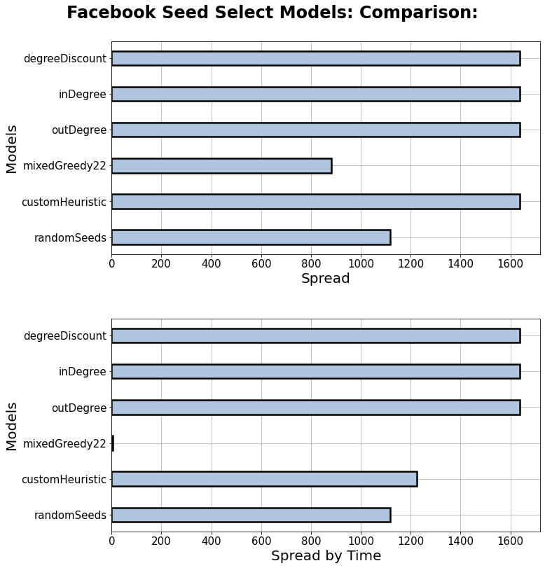

Evaluation
On the random graphs, CELF, original greedy, out degree centrality and custom heuristic performed the best by spread, and when time was considered CELF and original greedy went from some of the best to some of the worst.
On the real graphs, degree discount, in-degree centrality and out-degree centrality were consistently the best models, with custom heuristic performing much better on the BitcoinOTC graph than the Facebook graph.
Overall, the best models seem to be out-degree centrality, degree discount and custom heuristic.

5.7 Propagation Parameter Comparison

Design
Line graphs were plotted to indicate the effects of the parameters across a continuous range – 0 to 1 (0 to 0.1 for time factor).
A range of parameter values had to be used to illustrate the changes and correlations:
- Propagation probability = {0, 0.1, 0.2, 0.3, 0.4, 0.5, 0.6, 0.7, 0.8, 0.9, 1}
- Quality factor = {0, 0.1, 0.2, 0.3, 0.4, 0.5, 0.6, 0.7, 0.8, 0.9, 1}
- Switch factor = {0, 0.1, 0.2, 0.3, 0.4, 0.5, 0.6, 0.7, 0.8, 0.9, 1}
- Time factor = {0, 0.02, 0.04, 0.06, 0.08, 0.1, 0.2, 0.3, 0.4, 0.5, 0.6, 0.7, 0.8, 0.9, 1}
Default values for parameters when not being altered and plotted:
- Propagation probability = 0.2
- Quality factor = 0.6
- Switch factor = 0.7
- Time factor = 0.04

Implementation
The function ‘compareVars’ for comparing and plotting multiple parameters at varying values using independent cascade can be found in appendix C.1.
The function ‘compareVars2’ for comparing and plotting varying values of one parameter for all three propagation models can also be found in appendix C.1.
Functions are called first for comparing propagation probability pp (the format is the same for other parameters, except with time factor the range of values is different) in the independent cascade model, once for comparing pp across all three models and once for comparing all four parameters in the independent cascade model.
Comparing pp in IC:
#pp experiment for IC
qty, its, model, gs = 5, 200, 'IC', [graphs]
vss = [['pp', 0, [x*0.1 for x in range(11)]]]
startTime = time()
s = randomSeeds(graphs['BitcoinOTC'], qty)
print(g + "\nseed set: " + str(s) + "\n" +
str(round((time() - startTime), 5)) + " secs\n")
compareVars('BitcoinOTC', graphs, s, its, model, vss)
print(str(round((startTime - time()), 4)) + " secs")
Comparing pp across all three propagation models:
#pp experiment for all models
qty, its, models, gs = 5, 50, ['IC','WC1','WC2'], [graphs]
vss = [['pp', 0, [x*0.1 for x in range(11)]]]
startTime = time()
s = randomSeeds(graphs['BitcoinOTC'], qty)
print(g + "\nseed set: " + str(s) + "\n" +
str(round((time() - startTime), 5)) + " secs\n")
compareVars2('BitcoinOTC', graphs, s, its, models, vss)
print(str(round((startTime - time()), 4)) + " secs")
Comparing all parameters in IC:
#all parameters experiment
qty, its, model = 5, 200, 'IC'
vss = [['qf', 0, [x*0.1 for x in range(11)]],
['sf', 0, [x*0.1 for x in range(11)]],
['pp', 0, [x*0.1 for x in range(11)]],
['tf', 0, [x*0.02 for x in range(5)] + [y*0.1 for y in range(1,11)]]]
startTime = time()
s = randomSeeds(graphs['BitcoinOTC'], qty)
print('BitcoinOTC' + "\nseed set: " + str(s) + "\n" +
str(round((time() - startTime), 5)) + " secs\n")
compareVars('BitcoinOTC', graphs, s, its, model, vss)
print(str(round((startTime - time()), 4)) + " secs")

Results
Propagation probability – independent cascade:
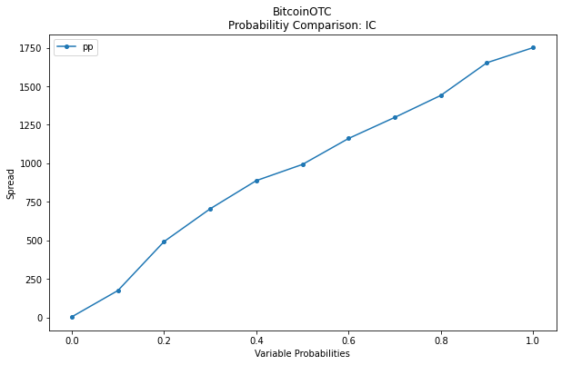
Propagation probability – all propagation models:
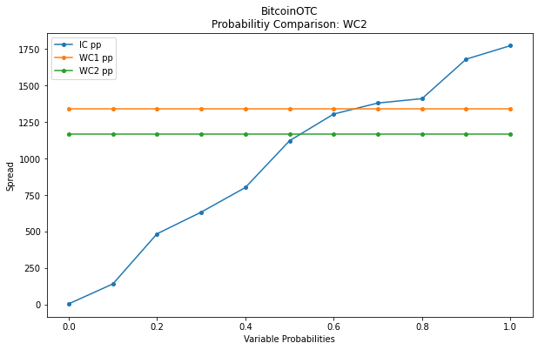

Evaluation
Propagation probability (pp) has a strong positive correlation with influence spread in the independent cascade model – increasing pp from 0 to 1 increased spread from 0 to ~1750. The weighted cascade models do not incorporate pp so remain constant throughout.

Quality factor – independent cascade:
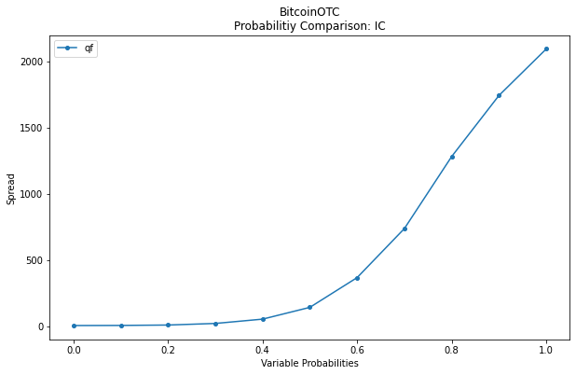
Quality factor – all propagation models:
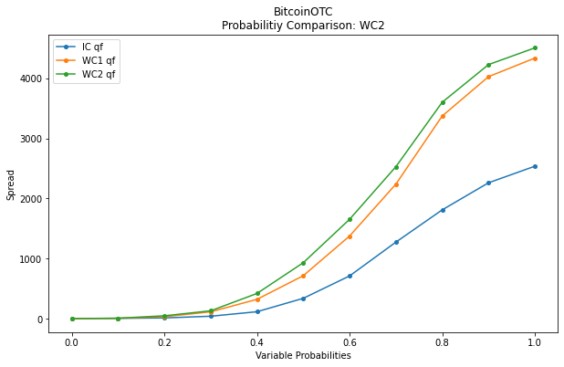

Evaluation
Quality factor (qf) has an increasingly positive correlation with influence spread – increasing qf from 0 to 0.5 increases spread from 0 to ~200, but increasing qf from 0.5 to 1 shows a rapid increase of spread from ~200 to ~2000 with the independent cascade model. The increasingly positive correlation is stronger with the weighted cascade models.

Switch factor – independent cascade:
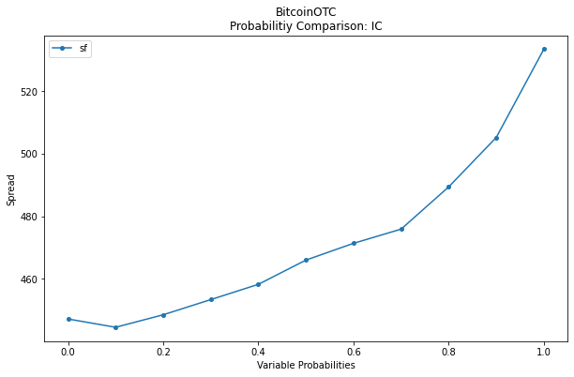
Switch factor – all propagation models:
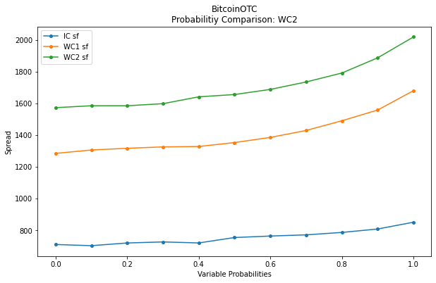

Evaluation
Switch factor (sf) has a very gradual positive correlation with influence spread, much lower than that of pp or qf, achieving a ~20% increase in spread over the full distribution of inputs with the independent cascade model. With the weighted cascade models, the correlation is more significant, but still quite gradual.

Time factor – independent cascade:
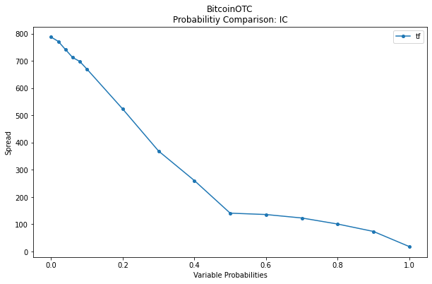
Time factor – all propagation models:
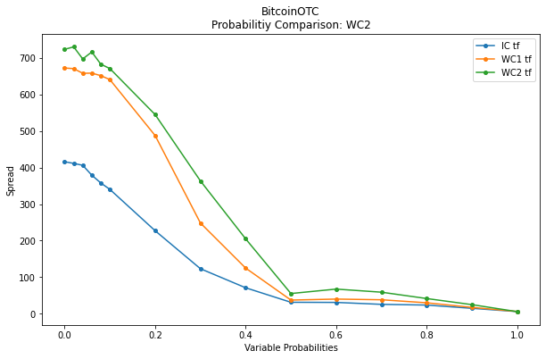

Evaluation
Time factor (tf) has a negative correlation with influence spread – increasing tf from 0.01 to 0.1 results in a decrease in influence spread from 800 to ~670 , increasing from 0.1 to 0.5 shows a drastic drop off in influence spread from 670 to 100, and increasing from 0.5 to 1 shows a steady decline from 100 to 0. The correlation follows a similar trend with the weighted cascade models, beginning with higher spreads but dropping to the same lows by tf = 0.5.
All parameters – independent cascade
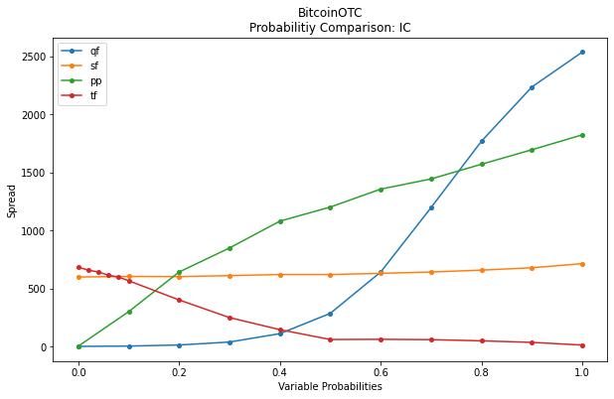

Evaluation
When all parameters are compared, propagation probability and quality factor are the most impactful on spread, with pp = 0.7 and qf = 0.7 returning very high spreads. Switch factor has a weak correlation in comparison, being more significant with the weighted cascade models. Time factor, when compared to the others, has a relatively small effect, affecting spread by less than 750 nodes. In contrast, quality factor can increase spread by +2000 nodes from qf = 0.5 to qf = 1.

Chapter 6 Conclusion
This chapter concludes the research undertaken, discusses the results, revisits the objectives and proposes future work that could be done in this field.

6.1 Objectives Revisited

6.1.1 Main Objectives
The first main objective of the project was to experiment with seed selection models and develop an original model that outperforms existing models. This objective was met as described in sections 5.4 and 5.6, where multiple seed selection models were implemented and experimented with. The new models that were implemented all outperformed the original greedy, CELF and improved greedy models when time is taken into consideration, and the custom heuristic model was second only to the out-degree centrality and degree discount models. However, the new models created were not as original as initially intended, instead creating new models by augmenting and combining elements of existing models.
The second main objective of the project was to analyse and evaluate propagation parameters, their correlations and the insights they provide into real social networks, culminating in the implementation of an original parameter. This objective was definitely achieved, as laid out in section 5.7 where experiments took place. Parameters from existing models – quality factor, time factor – were implemented and their effects on influence spread analysed, as well as a completely original parameter the switch factor. This was an entirely original contribution, and the results from the switch factor provided unexpected insight into negativity bias and its effect on influence when influences can switch.

6.1.2 Sub Objectives
- Implement a general method for generating network graphs from datasets and different models to simulate influence propagation through them.
-Satisfied. See sections 4.4, 4.5, 5.1 and 5.2 for proof of successful network generation and various propagation models. Also, see section 5.3.1 for proof of probability analysis and normalization to ensure multiple models could be used throughout.
- Ensure network generation is generalised for reproducibility, and easy extension to other network graphs using other dataset files.
-Satisfied. See section 5.5 and appendix B.2 for proof of completely generalized network generation that allows for easy additional datasets to be studied.
- Analyse propagation parameters and implement some original ones, to better simulate social networks.
-Satisfied. See sections 5.2, 5.5 and 5.7 for proof of propagation parameters being implemented and analysed.
- Analyse and implement different seed selection models.
-Satisfied. See section 5.6 for proof of multiple implemented seed selection models.
- Perform statistical data analysis on networks, comparing their properties to influence spreads.
-Semi-satisfied. See section 5.3 for proof of extensive statistical network analysis, but these analyses were not applied to influence spreads for comparison.
- Implement a method of comparing propagation spreads and times with different networks, parameters and seed sets.
-Satisfied. See section 5.7 for proof of comparing propagation spreads and times with different parameters and section 5.6 for comparison of different seed sets and networks.
- Plot different types of graphs, to analyse and present different propagation models, propagation parameters and seed selection models, in regard to spread and time.
-Satisfied. See sections 5.6 and 5.7 for proof of various graphs used in analysis and experimentation.
- Using established literature, evaluate and interpret the results, providing insight into social interaction, and discuss accompanying implications.
-Discussed in upcoming section 6.2. Chen’s use of negativity bias alongside quality factor was referenced throughout, however.
- Gain a deeper understanding of Python’s research capabilities, and software regarding network graphs, using NetworkX.
-Satisfied. I have learnt a great deal about using NetworkX and more broadly about researching and plotting graphs using Python.

6.1.3 Research Questions
- What parameters affect the spread of influence most in simulations and do these translate to real-life?
-Quality factor, propagation probability, time factor and switch factor, in that order of significance. See section 5.7 for proof. Furthermore, all of these parameters can be directly translated to real-life phenomena.
- What are the best approximation strategies for IM?
-Degree discount and out-degree centrality if efficiency is considered, CELF or original greedy if not. See section 5.6 for proof.
- How could propagation models better reflect real social networks, and what limitations restrict them?
-Further propagation parameters in keeping with real human social phenomena. There are limitations regarding the datasets and how truly accurate they are, described in section 1.5.
- How accurately can simulations reflect real-life networks, and how could irrationality be introduced to a model?
-More real-world experiments would have to be undertaken to confirm any suspicions. Perhaps irrationality could be introduced through some ongoing random manipulation of probabilities throughout propagation, but again, real-world experiments would be necessary to substantiate any abstraction.

6.1.4 Research Hypotheses
- Networks with more nodes will take longer to perform propagation on, accounting for the spread.
-Proven false, as the Facebook graph consistently took longer to process and it had less nodes than the BitcoinOTC graph. It seems number of edges is much more significant than number of nodes.
- In a model where positive and negative influences occur and can ‘steal’ influence from the other, the more likely nodes are to switch influence, the influence with the higher general probability will increase.
-Proven false. Regardless of which influence was more likely, positive influence always benefited from a higher switch factor, probably due to it alleviating the effect of negativity bias within the model. See section 5.5.1 for proof.
- New seed selection models based solely on network analysis metrics will outperform existing research models.
-Proven true. The out-degree centrality model performed better than many existing models. When time was considered, it outperformed every single seed selection model except sometimes degree discount, vote rank or custom heuristic.

6.2 Discussion

6.2.1 Seed selection
In terms of seed selection models, this project was an overwhelming success. In section 5.6 all models were experimented and compared, and it was seen that the customHeuristic model and out-degree centrality models outperformed the outstanding past models like improved greedy and CELF. Only degree-discount consistently beat the original models. This seems like an overwhelming success. Linking back to Leskovec (Leskovec et al., 2007) or (Kempe, Kleinberg and Tardos, 2003) who set the very foundations of this task, to outdo their model is impressive.

6.2.2 Propagation parameters
The analysis, experimentation and implementation of propagation parameters was an overall success. The results from section 5.7 capture the exact effects of the parameters on the simulation – quality factor and propagation probability having huge effects, time factor and switch factor having more minor effect, and the insights gained from the switch factor regarding how it counteracts negativity bias is truly a significant, original contribution. As discussed by Chen (Chen et al., 2011) with the negativity bias and their quality factor, incorporating human nature into these simulations is beneficial in producing more meaningful results, and switch factor accomplished just that. Replicating a real human trait – changing one’s mind – has been implemented and improved the realism of the model.

6.3 Future Work
There’s a great deal of potential for future work in this field. Firstly, in the way of improving approximative solutions. As Chen stated (Chen, Wang and Yang, 2009), research should be focused on ‘more effective heuristics’ approaching the accuracy of greedy solutions, considering their extremely fast speeds. The heuristic models proposed so far have all used degree in quite simplistic ways, so there are undoubtedly better heuristic solutions to be found.
Another way in which future work could contribute to the field would be by way of expanding the realms of the problem to improve realism – formulating new propagation methods which more accurately represent human influence, implementing new propagation parameters which make existing propagation models more realistic or any other method of expanding the problem as is. There seems to be a distinct gap in how computer scientists and sociologists approach social network analysis and IM, and bridging that gap may produce opportunities for more practical applications.

Glossary
Network Graphs | Network-like graphs of nodes and edges (edges can be weighted), used to represent social networks. They can be directed or undirected, and weighted or unweighted.
Influence Propagation | The diffusion of influence through a network. Starting with a source of seed nodes, each node will attempt to influence its neighbours (connected nodes), and any influenced nodes will attempt to influence theirs, and so on.
Seed Selection | Selecting a specific number of optimal seed nodes from a graph, to maximise influence propagation.

References
Blower, S. and Go, M.-H. (2011) ‘The importance of including dynamic social networks when modeling epidemics of airborne infections: does increasing complexity increase accuracy?’, BMC Medicine, 9(1), p. 88. doi: 10.1186/1741-7015-9-88.
Borgatti, S. P. et al. (2009) ‘Network Analysis in the Social Sciences’, Science, 323(5916), pp. 892–895. doi: 10.1126/science.1165821.
Brownlee, J. (2020) How to Scale Data With Outliers for Machine Learning, Machine Learning Mastery. Available at: https://machinelearningmastery.com/robust-scaler-transforms-for-machine-learning/#:~:text=One%20approach%20to%20standardizing%20input,standardization%20or%20robust%20data%20scaling. (Accessed: 21 April 2021).
Chen, W. et al. (2011) ‘Influence Maximization in Social Networks When Negative Opinions May Emerge and Propagate’, in Proceedings of the 2011 SIAM International Conference on Data Mining. The 2011 SIAM International Conference on Data Mining, Mesa, AZ, USA: Society for Industrial and Applied Mathematics, pp. 379–390. doi: 10.1137/1.9781611972818.33.
Chen, W., Wang, Y. and Yang, S. (2009) ‘Efficient influence maximization in social networks’, in Proceedings of the 15th ACM SIGKDD international conference on Knowledge discovery and data mining - KDD ’09. The 15th ACM SIGKDD international conference on Knowledge discovery and data mining, Paris, France: ACM Press, pp. 199–208. doi: 10.1145/1557019.1557047.
Data Preparation and Feature Engineering for Machine Learning: Normalization (2020) Developers Google. Available at: https://developers.google.com/machine-learning/data-prep/transform/normalization (Accessed: 21 April 2021).
Domingos, P. and Richardson, M. (2001) ‘Mining the network value of customers’, in Proceedings of the seventh ACM SIGKDD international conference on Knowledge discovery and data mining - KDD ’01. The seventh ACM SIGKDD international conference on Knowledge discovery and data mining, San Francisco, CA, USA: ACM Press, pp. 57–66. doi: 10.1145/502512.502525.
ecampver (2013) Best and/or fastest way to create lists in python, Stack Overflow. Available at: https://stackoverflow.com/questions/20816600/best-and-or-fastest-way-to-create-lists-in-python (Accessed: 20 April 2021).
Hong, T. and Liu, Q. (2019) ‘Seeds selection for spreading in a weighted cascade model’, Physica A: Statistical Mechanics and its Applications, 526, p. 120943. doi: 10.1016/j.physa.2019.04.179.
Kempe, D., Kleinberg, J. and Tardos, E. (2003) ‘Maximizing the Spread of Influence through a Social Network’, in KDD ’03: Proceedings of the ninth ACM SIGKDD international conference on Knowledge discovery and data mining. The ninth ACM SIGKDD international conference on Knowledge discovery and data mining, Washington, DC, USA: ACM, pp. 137–146. doi: 10.1145/956750.956769.
King, H. (2018) ‘Influence Maximization in Python - Greedy vs CELF’, 7 September. Available at: https://hautahi.com/im_greedycelf (Accessed: 20 April 2021).
Leskovec, J. et al. (2007) ‘Cost-effective outbreak detection in networks’, in Proceedings of the 13th ACM SIGKDD international conference on Knowledge discovery and data mining - KDD ’07. The 13th ACM SIGKDD international conference on Knowledge discovery and data mining, San Jose, CA, USA: ACM Press, pp. 420–429. doi: 10.1145/1281192.1281239.
Liu, B. et al. (2014) ‘Influence Spreading Path and Its Application to the Time Constrained Social Influence Maximization Problem and Beyond’, IEEE Transactions on Knowledge and Data Engineering, 26(8), pp. 1904–1917. doi: 10.1109/TKDE.2013.106.
Mantas Vidutis (2010) Python Sets vs Lists, Stack Overflow. Available at: https://stackoverflow.com/questions/2831212/python-sets-vs-lists (Accessed: 20 April 2021).
Mrvar, A. and Batagelj, V. (2016) ‘Analysis and visualization of large networks with program package Pajek’, Complex Adaptive Systems Modeling, 4(1), p. 6. doi: 10.1186/s40294-016-0017-8.
Normalization (2020) CodeAcademy. Available at: https://www.codecademy.com/articles/normalization#:~:text=Min%2Dmax%20normalization%20is%20one,decimal%20between%200%20and%201. (Accessed: 21 April 2021).
Richardson, M. and Domingos, P. (2002) ‘Mining Knowledge-Sharing Sites for Viral Marketing’, in Proceedings of the eighth ACM SIGKDD international conference on Knowledge discovery and data mining. The eighth ACM SIGKDD international conference on Knowledge discovery and data mining, Edmonton, Alberta, Canada: ACM Press, pp. 61–70. doi: 10.1145/775047.
Tichy, N. M., Tushman, M. L. and Fombrun, C. (1979) ‘Social Network Analysis for Organizations’, The Academy of Management Review, 4(4), p. 507. doi: 10.2307/257851.

Appendices

Appendix A: Project Definition Document

Sean Sullivan

Course Title: IN3007
Consultant: Constantino Carlos Reyes-Aldasoro

Network Analysis and Competitive Influence Maximization within a Dynamic Directed Network, with Ethical Considerations

Proposal

Problems to be Solved:
How does information propagate throughout social networks? Social networks play an increasingly important role as a means to spread ideas, influence, and information among its users, and I plan to study in detail how we can understand and best utilise them to maximise this information propagation.
The problem I will be solving in my project is to find out and understand where within a social network original ads and ideas (seed nodes) would be best placed to maximise their spread and influence. The exact problem is as follows: given a number k, find within a network (nodes adjoined by edges) a k set of nodes which will result in the largest possible set of activated nodes, once a propagation method has been continuously applied to the network until no further nodes may be reached.
I will be doing this by generating and visualising a variety of network graphs from matrix-adjacency tables which I will generate based on publicly available datasets, performing network analysis, and implementing and experimenting with multiple different propagation methods (including one I will make myself) to maximise success, while also optimizing for efficiency.
This is a well-studied topic, given its rising relevance and importance in recent decades, and I will be building on the related work done over past years by many others whilst still ensuring I am making original and valuable contributions. One aspect that has not been studied thus far, is to explore the consequences of multiple competing influences within a dynamic (nodes appearing/disappearing) directed network graph, where both positive and negative influence may propagate. This will improve upon the so far mainly theoretical research, providing results which would be more applicable in the real world, where such aspects of the problem will always exist in tandem. Furthermore, I plan to invent and implement an entirely original propagation method (algorithm), to ensure I can contribute additional value to the topic.
Finally, due to the unavoidable prevalence of social networks and advertising in our lives I will use my findings to investigate the moral and ethical considerations of such technology and research, as well as how and why they may be used for malicious purposes. The ethics of advertising is not often considered by the public, despite the fact it pervades all of our lives constantly. I will explore ways in which we can safeguard ourselves and others from such malice, including technological safeguards and making the public more aware of the impact advertising and social networks – and potentially bad actors using them – could and will affect our lives.

Project Objectives:

Primary Objectives:
- Implement a way to visualise large-scale (10,000+ nodes) social networks using network graphs.
- Create a new propagation algorithm that improves upon its predecessors in success and/or efficiency and prove such with robust experimentation.
- Explore the moral and ethical considerations of such technology.

Sub-Objectives:
- Implement a way of representing network graphs visually from datasets.
- Optimise this so it can be used for large-scale datasets and still provide insight.
- Implement working propagation methods on small-scale custom datasets and test they work as expected.
- Create and implement my own propagation methods, testing it works and improves upon others.
- Experiment with all these methods on multiple datasets and collate my results.
- Explore the morals and ethics of advertising and influence maximisation.

Project Beneficiaries:
Viral marketing is of great importance to advertisers in the modern age, and as such my results will be of great benefit to them, and many others who seek to spread information through a social network, including but not limited to: politicians running online campaign strategies, social media influencers, religious missionaries, etc. Of course, interest in my work will not be limited to those who would gain from it, but also include anyone who is interested in the algorithmic problem of Influence Maximization and the related field of network analysis.

Work Plan:
I understand I am extremely behind where I should be at this stage, but as you may or may not know I was extremely ill for almost the entirety of February, but I have applied and been granted a 2 week extension through EC. Nevertheless, I believe I will be able to finish this project to a high standard in that space of time, and have detailed my work plan from this day forward below:
- Provide a literature review which studies previous related work and highlights how I can effectively and originally build on that and contribute further value. Tues 23/03/21
- Write code to implement and compare multiple ways of representing large datasets with network graphs using Python. Also, compare the many large datasets applicable to this project and decide which few I use. Fri 26/03/21
- Write code to implement various propagation methods (independent cascade, linear threshold, etc.) and verify they work successfully on very small custom-made network graphs. Fri 2/04/21
- Optimise and improve until they are sufficient for the large-scale network graphs I will be using. Tues 6/04/21
- Studying and comparing the various methods mentioned above, as well as different techniques used by many researchers over the past 18 years, create a completely original propagation method algorithm, and implement it in Python. Sun 11/04/21
- Experiment with all of the implemented methods to collect and present results. Sun 18/04/21
- Draft report and show to consultant. Fri 23/04/21
- Research the ethical and moral considerations of social networks and influence maximization and add to the report. Weds 28/04/21
- Draft final report, including references and appendices. Thu 13/05/21
- Submit final project and report. Tue 18/5/21

Project Risks:
- Being delayed and missing deadlines. This would be disastrous for me, due to my already delayed situation.
Solution: Avoid procrastination and break every task into subtasks with manageable deadlines.
- I spend too much time on visualising large network graphs and don’t leave enough time for experimenting.
Solution: Prioritise implementation and results over visualisation, treat visualisation as an added extra if it takes up too much time.
- My propagation method does not meet the standards I am attaining for.
Solution: Leave a significant amount of time for implementing and testing propagation methods.
- Living alone adds stress and subtracts time away from my situation.
Solution: when I am able on March 29th, I will return to stay with my mother to keep on track.

Appendix B: Installation Guide

B.1 Files & Capabilities
This project is made up of 4 files:
- cascade_final.py
  - Generate networks from datasets
  - Generate some user-defined graphs
  - Perform propagation on a network with multiple optional parameters such as propagation probability, quality factor, propagation model, switch factor, time factor and more.
  - Plot line graphs to compare the influence spreads of different models and different parameters.
- network_analysis_final.py
  - Generate networks from datasets
  - Generate some user-defined graphs
  - Calculate various network properties such as mutuality, density and more
  - Create a list of degree reciprocals and relational degrees from a network
  - Normalize those lists with various techniques
  - Plot bar charts to compare network properties of networks
  - Plot pie charts to represent probability distributions
  - Plot histograms to represent probability distributions with various normalization techniques applied
- seed_selection_final.py
  - Generate networks from datasets
  - Generate some user-defined graphs
  - Fine-tune NetworkX seed selection models (run NetworkX seed selection models multiple times with a range of different parameter values, printing the resulting spreads of each, to compare and find the optimal values)
  - Seed selection models – select seed nodes from a network with various different techniques such as original greedy, degree centrality, VoteRank and others.
  - Plot horizontal bar charts to compare different seed selection models in terms of spread or spread divided by a tenth of time taken to select seeds.
- upgrades.py – This file is not necessary in order to run the code and test out the project, but instead is where old and new methods of code components are stored, as well as the functionality and efficiency tests that were ran to build the model.

B.2 New Dataset(s)
To successfully run the program with the datasets used in this project, the file-paths will have to be redefined to wherever they are in your local files.
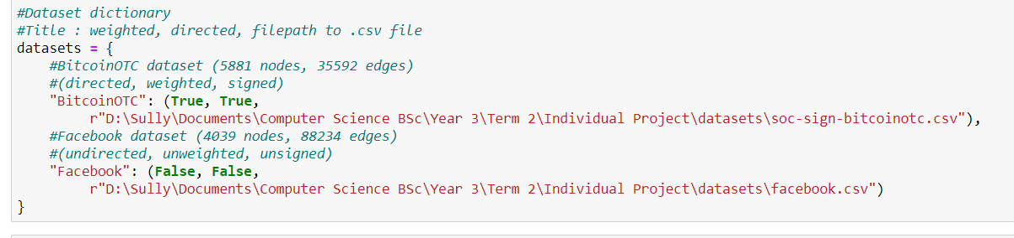
These lines must be changed.
New datasets can also be added to the program, and functionality is generalized so that you can apply the software to this new dataset with ease. Steps needed to implement new dataset:
- Have the dataset in .csv file format, and make sure each row contains a target node (column1), a targeting node (column2) and an optional weight (column3).
- Enter in a new element in the dataset dictionary (seen above) in the format:
“Name”: (directed, weighted, file-path)
where directed and weighted are boolean values indicating whether the network you’re implementing is directed and/or weighted, and where file-path is the path to the file in your local files.

Appendix C: Source Code

C.1 cascade_final.py
#!/usr/bin/env python
# coding: utf-8

# In[1]:

# ALL NECESSARY IMPORTS ::

# In[2]:

#product for generating all permutations for seed selection parameter fine-tuning
from itertools import product
#itemgetter for sorting lists of tuples / dicts by their second element / value
from operator import itemgetter
#math.log for calculating logs of probabilities in WC1 and WC2
from math import log
#copy.deepcopy for deepcopying graphs in seed selection models
from copy import deepcopy
#numpy to manipulate lists, calculate means, etc.
import numpy as np
#
import pandas as pd
#time.time to calculate and compare running time and efficiency
from time import time
#Counter to count frequencies in lists, for averaging edges in seed selection models
from collections import Counter
#networkx to generate and handle networks from data
import networkx as nx
#csv to extract network data from .csv files
import csv
#winsound to alert me when propagation is complete for long proccessing periods
import winsound
#matplotlib.pyplot for plotting graphs and charts
import matplotlib.pyplot as plt
import matplotlib.cm
#matplotlib.offsetbox.AnchoredText for anchored textboxes on plotted figures
from matplotlib.offsetbox import AnchoredText

#Dataset dictionary
#Title : weighted, directed, filepath to .csv file
datasets = {
#BitcoinOTC dataset (5881 nodes, 35592 edges)
#(directed, weighted, signed)
"BitcoinOTC": (True, True,
r"D:\Sully\Documents\Computer Science BSc\Year 3\Term 2\Individual Project\datasets\soc-sign-bitcoinotc.csv"),
#Facebook dataset (4039 nodes, 88234 edges)
#(undirected, unweighted, unsigned)
"Facebook": (False, False,
r"D:\Sully\Documents\Computer Science BSc\Year 3\Term 2\Individual Project\datasets\facebook.csv")
}

# In[3]:

# CASCADE, ITERATION, PROPAGATION & SUCCESS FUNCTIONS ::
#
# Functions to perform cascade & propagation on a given graph
# with a given seed set and a given number of iterations of a
# given cascade model.
#
# Functions included:
# 1. Model-specific success functions
# 2. Propagation function
# 3. Iteration function
# 4. Cascade (ties everything together) function

# In[4]:

#Determine propagation success for the various models
#(includes quality factor to differentiate positive/negative influence)
#(includes a switch penalty for nodes switching sign)

#Apply quality factor and switch factor variables
def successVars(sign, switch, qf, sf):
if not switch:
sf = 0
if not sign:
qf = (1-qf)
return qf*(1-sf)

#Calculate whether propagation is successful (model-specific)
def success(successModel, sign, switch, timeDelay, g, target, targeting, pp, qf, sf, a):
if successModel == 'ICu':
succ = (pp*successVars(sign, switch, qf, sf)*timeDelay)
elif successModel == 'IC':
succ = (pp*successVars(sign, switch, qf, sf)*g[targeting][target]['trust']*timeDelay)
elif successModel == 'WC1':
if a:
recip = g.nodes[target]['degRecip']
else:
recip = (1 / g.in_degree(target))
succ = (recip*successVars(sign, switch, qf, sf)*timeDelay*g[targeting][target]['trust'])
elif successModel == 'WC2':
if a:
relDeg = g[targeting][target]['relDeg']
else:
snd = sum([(g.out_degree(neighbour)) for neighbour in g.predecessors(target)])
relDeg = (g.out_degree(targeting) / snd)
#relDeg = mmNormalizeSingle(log(g.out_degree(targeting)/snd))
succ = (relDeg*successVars(sign, switch, qf, sf)*timeDelay*g[targeting][target]['trust'])
return np.random.uniform(0,1) < succ

#Returns probability with only the variables
#(no trust values, degree reciprocals or relational degrees)
def basicProb(weighted=False, *nodes):
return pp * successVars(True, False)

# In[5]:

#One complete turn of propagation from a given set of the newly
# activated (positive & negative) nodes from the last turn.
#(1. new negative nodes attempt to negatively influence their neighbours)
#(2. new positive nodes attempt to positively influence their neighbours)
#(3. new positive nodes attempt to negatively influence their neighbours)
def propagateTurn(g, pn, pos, nn, neg, trv, td, successMod, pp, qf, sf, a):
posCurrent, negCurrent = set(), set()
for node in nn:
for neighbour in g.neighbors(node):
if (node, neighbour) not in trv:
#Negative influence to neighbours of negative nodes
if success(successMod, False, (neighbour in pos), td, g, neighbour, node, pp, qf, sf, a):
negCurrent.add(neighbour)
trv.add((node, neighbour))
for node in pn:
for neighbour in g.neighbors(node):
if (node, neighbour) not in trv:
#Positive influence to neighbours of positive nodes
if neighbour not in negCurrent and success(successMod, True, (neighbour in neg), td, g, neighbour, node, pp, qf, sf, a):
posCurrent.add(neighbour)
#Negative influence to neighbours of positive nodes
elif neighbour not in negCurrent and neighbour not in posCurrent and success(successMod, False, (neighbour in pos), td, g, neighbour, node, pp, qf, sf, a):
negCurrent.add(neighbour)
trv.add((node, neighbour))
return(posCurrent, negCurrent, trv)

# In[6]:

#Calculate average positive spread over a given number of iterations
def iterate(g, s, its, successFunc, pp, qf, sf, tf, retNodes, a):
#If no number of iterations is given, one is calculated based on the
# ratio of nodes to edges within the graph, capped at 2000.
if not its:
neRatio = (len(g)/(g.size()))
if neRatio > 0.555:
its = 2000
else:
its = ((neRatio/0.165)**(1/1.75))*1000
influence = []
for i in range(its):
#Randomness seeded per iteration for repeatability & robustness
np.random.seed(i)
positive, posNew, negative, negNew, traversed, timeFactor = set(), set(s), set(), set(), set(), 1
#while there are newly influenced nodes from last turn...
while posNew or negNew:
#new nodes assigned to placeholder variables
posLastTurn, negLastTurn = posNew, negNew
#propagation turn is performed, returning positive&negative nodes and traversed edges
posNew, negNew, traversed = propagateTurn(g, posNew, positive, negNew, negative, traversed, timeFactor, successFunc, pp, qf, sf, a)
#Positive and negative nodes are recalculated
positive, negative = (positive.union(posNew, posLastTurn) - negNew), (negative.union(negNew, negLastTurn) - posNew)
#Time delay is taken away from the time factor
if timeFactor < 0:
timeFactor = 0
else:
timeFactor -= tf
if retNodes:
#Positive nodes added to list
for p in positive:
influence.append(p)
#Number of nodes added to list
infCount.append(len(positive))
else:
#Number of positive nodes added to list
influence.append(len(positive))
#If nodes are being returned
if retNodes:
#Average list of positive nodes are returned
counts = Counter(influence)
result = (sorted(counts, key=counts.get, reverse=True))[:int(np.mean(infCount))]
#If nodes aren't being returned
else:
#Mean is returned
result = np.mean(influence)
return result

# In[7]:

#Determine the cascade model and run the iteration function
# with the appropriate success function
def cascade(g, s, its=0,
model='IC', assign=1, ret=False,
pp=0.2, qf=0.6, sf=0.7, tf=0.04):
#g = graph, s = set of seed nodes, its = num of iterations
#model = cascade model, #assign model, #return nodes?
#pp = propagation probability, qf = quality factor
#sf = switch factor, tf = time factor
#Model is determined and appropriate success function is assigned
#print(f'model = {model}, assign = {assign} its = {its}\npp = {pp}, qf = {qf}, sf = {sf}, tf = {tf} \n')
if model != 'IC' and model != 'ICu' and assign:
assignSelect(g, model, assign)
success = model
return iterate(g, s, its, success, pp, qf, sf, tf, ret, assign)

#Propagation models and their names are compiled into a list
propMods = [('IC', "Independent Cascade"),
('WC1', "Weighted Cascade 1"),
('WC2', "Weighted Cascade 2")]

# In[8]:

# NETWORK GRAPH SETUP ::
#
# Functions to generate network graphs from various csv files,
# and assign meaningful attributes to the nodes/edges to save
# processing time during propagation.
#
# Real datasets/graphs included:
# 1. soc-BitcoinOTC
# 2. ego-Facebook

# In[9]:

#Removes any unconnected components of a given graph
def removeUnconnected(g):
components = sorted(list(nx.weakly_connected_components(g)), key=len)
while len(components)>1:
component = components[0]
for node in component:
g.remove_node(node)
components = components[1:]

# In[10]:

#Generates NetworkX graph from given file path:
def generateNetwork(name, weighted, directed, path):
#graph is initialized and named, dataframe is initialized
newG = nx.DiGraph(Graph = name)
data = pd.DataFrame()
#pandas dataframe is read from .csv file,
# with weight if weighted, without if not
if weighted:
data = pd.read_csv(path, header=None, usecols=[0,1,2],
names=['Node 1', 'Node 2', 'Weight'])
else:
data = pd.read_csv(path, header=None, usecols=[0,1],
names=['Node 1', 'Node 2'])
data['Weight'] = 1
#offset is calculated from minimum nodes
offset = min(data[['Node 1', 'Node 2']].min())
#each row of dataframe is added to graph as an edge
for row in data.itertuples(False, None):
#trust=weight, & distance=(1-trust)
trustval = row[2]
newG.add_edge(row[1]-offset, row[0]-offset,
trust=trustval, distance=(1-trustval))
#if graph is undirected, edges are added again in reverse
if not directed:
newG.add_edge(row[0]-offset, row[1]-offset,
trust=trustval, distance=(1-trustval))
#unconnected components are removed
if directed:
removeUnconnected(newG)
return newG

# In[11]:

#Generate graphs and compile into dictionaries:

#Dictionaries for groups of graphs are intialized
graphs, mockGraphs, rndmGraphs, diGraphs, allGraphs = {}, {}, {}, {}, {}

#Generate graphs from real datasets using the datasets dictionary
for g in datasets:
realGraph = generateNetwork((g + " Network"),
datasets[g][0], datasets[g][1],
datasets[g][2])
graphs[g], diGraphs[g], allGraphs[g] = realGraph, realGraph, realGraph

#Generate various mock graphs for testing and debugging:

#Custom, small directed, unweighted graph
mockG, name = nx.DiGraph(), "mock1: Custom, small"
testedges = [(1,2), (2,4), (2,5), (2,6), (3,5), (4,5), (5,9), (5,10), (6,8),
(7,8), (8,9)]
mockG.add_edges_from(testedges)
nx.set_edge_attributes(mockG, 1, 'trust')
mockGraphs[name], diGraphs[name], allGraphs[name] = mockG, mockG, mockG

#Medium-sized path graph
#(each node only has edges to the node before and/or after it)
mockG, name = nx.path_graph(100), "mock2: Path graph, 100 nodes"
nx.set_edge_attributes(mockG, 1, 'trust')
mockGraphs[name], allGraphs[name] = mockG, mockG

#Medium-sized, randomly generated directed, unweighted graph
mockG, name = nx.DiGraph(), "mock3: Random, trustvals=1"
for i in range(50):
for j in range(10):
targ = np.random.randint(-40,50)
if targ > -1:
mockG.add_edge(i, targ)
mockGraphs[name], rndmGraphs[name], diGraphs[name], allGraphs[name] = mockG, mockG, mockG, mockG

#Medium-sized, randomly generated directed, randomly-weighted graph
mockG, name = nx.DiGraph(), "mock4: Random, trustvals=random"
for i in range(50):
for j in range(10):
targ = np.random.randint(-40,50)
if targ > -1:
tru = np.random.uniform(0,1)
mockG.add_edge(i, targ, trust=tru)
mockGraphs[name], rndmGraphs[name], diGraphs[name], allGraphs[name] = mockG, mockG, mockG, mockG

#Functional testing for new graphing method
"""
for gl in [realGraphs, mockGraphs]:
for g in gl:
print(g + ": " + str(gl[g].size()))
print(g + ": " + str(len(gl[g])) + "\n")
#"""
print("")

# In[12]:

#Normalize (Min-Max) every value in a given dictionary (method 2 & 3)
def mmNormalizeDict(dic, elMax, elMin):
#for key, value in dic.items():
# dic[key] = ((value - elMin) / (elMax - elMin))
#printResults("Assigned", dic.values())
#print("Assigned normalization:\nMax = " + str(elMax) + "\nMin = "
# + str(elMin) + "\nMean = "
# + str(np.mean(list(dic.values()))))
#return dic
return {key: ((val - elMin)/(elMax - elMin)) for key,val in dic.items()}

#Min-Max Normalize a given list (method 1)
def mmNormalizeLis(lis):
elMax, elMin = max(lis), min(lis)
return list(map(lambda x : ((x - elMin)/(elMax - elMin)), lis))

# In[13]:

#Assign method 1 - manual

#Calculate all relational degrees for a graph
def allRelDegs1(g):
allRds = []
for target in g:
if not g.in_degree(target):
continue
snd = 0
for neighbour in g.predecessors(target):
snd += g.out_degree(neighbour)
for targeting in g.predecessors(target):
allRds.append(log(g.out_degree(targeting) / snd))
return allRds

"""
relDegsTest1 = allRelDegs(graphs['Facebook'])

elMax, elMin = max(relDegsTest1), min(relDegsTest1)
relDegsTest2 = mmNormalizeLis(relDegsTest1)

#Min-max normalize a single value, given the needed max & min
def mmNormalizeSingle(val, elMax, elMin):
return ((val - elMin)/(elMax - elMin))
"""
print("")

# In[14]:

"""

#AllRelDegs for dictionary, to check functionality after finding
# errors -
#Normalizes return dict and compares it to dict from assign method 3.
def allRelDegs2(g):
allRdsDict = {}
for target in g:
if not g.in_degree(target):
continue
snd = 0
for neighbour in g.predecessors(target):
snd += g.out_degree(neighbour)
for targeting in g.predecessors(target):
rdval = log(g[targeting][target]['trust']*(g.out_degree(targeting) / snd))
allRdsDict[(targeting, target)] = log((g.out_degree(targeting) / snd))
return allRdsDict

#relDegsTest1 = allRelDegs(graphs['Facebook'])
relDegsTest1, relDegsTestDict = allRelDegs(graphs['Facebook'])
elMax, elMin = max(relDegsTest1), min(relDegsTest1)
relDegsTest2 = mmNormalizeLis(relDegsTest1)
#relDegsTest3 = mmNormalizeDict(relDegsTestDict,
# max(relDegsTestDict.values()),
# min(relDegsTestDict.values()))

#Printing averages, maximums & minimums to find the
# error from the initial erroneous results
printResults("Test list: ", relDegsTest1)
printResults("Test normalized list: ", relDegsTest2)
printResults("Test normalized dict v1: ", list(relDegsTestDict.values()))
printResults("Test normalized dict v2: ", list(relDegsTest3)
"""
print("")

# In[15]:

#Methods that assign probabilities for WC1 & WC2 to nodes or edges

#Calculate manipulated degree-reciprocals for all nodes in a graph, and
# assign them as node attributes for the Weighted Cascade 1 model

#Log-scaling method - default if not specified
def assignRecips1(g):
drs = {}
for target in g:
if not g.in_degree(target):
continue
drs[target] = log(1 / g.in_degree(target))
elMax = drs[max(drs, key=drs.get)]
elMin = drs[min(drs, key=drs.get)]
drs = mmNormalizeDict(drs, elMax, elMin)
nx.set_node_attributes(g, drs, "degRecip")

#Square-rooting method
def assignRecips2(g):
drs = {}
for target in g:
if not g.in_degree(target):
continue
drs[target] = ((1 / g.in_degree(target)) ** (1/2))
nx.set_node_attributes(g, drs, "degRecip")

#Cube-rooting method
def assignRecips3(g):
drs = {}
for target in g:
if not g.in_degree(target):
continue
drs[target] = ((1 / g.in_degree(target)) ** (1/3))
nx.set_node_attributes(g, drs, "degRecip")

#Calculate manipulated relational-degrees for all edges in a graph, and
# assign them as edge attributes for the Weighted Cascade 2 model

#Log-scaling method
def assignRelDegs1(g):
rds = {}
for target in g:
if not g.in_degree(target):
continue
snd = 0
for targeting in g.predecessors(target):
snd += g.out_degree(targeting)
for targeting in g.predecessors(target):
rds[(targeting, target)] = log(g.out_degree(targeting) / snd)
#elMax = rds[max(rds, key=rds.get)]
#elMin = rds[min(rds, key=rds.get)]
rds = mmNormalizeDict(rds, max(rds.values()), min(rds.values()))
nx.set_edge_attributes(g, rds, "relDeg")

#Square-rooting method
def assignRelDegs2(g):
rds = {}
for target in g:
if not g.in_degree(target):
continue
snd = 0
for targeting in g.predecessors(target):
snd += g.out_degree(targeting)
for targeting in g.predecessors(target):
rds[(targeting, target)] = (((g.out_degree(targeting)) / snd) ** (1/2))
nx.set_edge_attributes(g, rds, "relDeg")

#Cube-rooting method
def assignRelDegs3(g):
rds = {}
for target in g:
if not g.in_degree(target):
continue
snd = sum([(g.out_degree(neighbour))
for neighbour in g.predecessors(target)])
for targeting in g.predecessors(target):
rds[(targeting, target)] = (((g.out_degree(targeting)) / snd) ** (1/3))
nx.set_edge_attributes(g, rds, "relDeg")

#Assign method dictionary for selection depending on parameters
assignMods = {'WC1': {1: assignRecips1, 2: assignRecips2, 3: assignRecips3},
'WC2': {1: assignRelDegs1, 2: assignRelDegs2, 3:assignRelDegs3}}

#Selects and runs appropriate assigning method
def assignSelect(g, propMod, assignMod):
if assignMod:
assignMods[propMod][assignMod](g)

# In[16]:

#Assign method 1 - manual

#Calculate all relational degrees
def allRelDegs(g):
#allRds = []
allRds, allRdsDict = [], {}
for target in g:
if not g.in_degree(target):
continue
snd = sum([g.out_degree(neighbour)
for neighbour in g.predecessors(target)])
#print("\nSND = " + str(snd) + "\n")
for targeting in g.predecessors(target):
rdval = log(g[targeting][target]['trust']*(g.out_degree(targeting) / snd))
allRds.append(rdval)
allRdsDict[(targeting, target)] = log((g.out_degree(targeting) / snd))
return allRds, allRdsDict

#Functionality & quality testing of assignment functions
"""
for assignTest in [0,1]:
print('assign method: ' + str(assignTest))
measureTime1(cascade, graphs['Facebook'], [1], 15, 'WC2', assignTest,
0.5, 0.7, 0.7, 0.08)
print("")
#"""
print("")

#Results: (S=[1], 75its, pp=0.5, qf=0.7, sf=0.7, tf=0.04)
#Manual log-scaling----------1.427 spread, 0.368secs
#Pre-assigned log-scaling----888.773 spread, 77.491secs
#Initially not equal --> typo in allRelDegs (return line indented so no loop)
#Due to the typo these results are erroneous

#Lowered iterations due to it taking so long to process the manual method
#Results: (S=[1], 75its, pp=0.5, qf=0.7, sf=0.7, tf=0.04)
#Manual log-scaling---------1188.533 spread, 328.085secs
#Pre-assigned log-scaling---1188.533 spread, 13.405secs

# In[17]:

# MISCALLANEOUS & UTILITY METHODS/FUNCTIONS ::
#
# Methods & functions for various purposes, that are either required
# in other sections of the program or optimize their performance.
#
# Methods/Functions included:
# 1. Measure time/speed of a given function
# 2. Min-max normalize a given dictionary, scaling between 0 and 1.
# 3. Draw a histogram from a given dictionary of probabilities

# In[18]:

#Time measuring functions

#Measure the time taken to perform a given function
def measureTime1(func, *pars):
startT = time()
print(func(*pars))
print(str(time() - startT) + "\n")

#Same as measureTime, but also returns the result from the given function
def measureTimeRet(func, *pars):
startT = time()
return func(*pars), round((time() - startT), 3)

#Same as measureTime1, but prints a given message initially
def measureTime2(msg, func, *pars):
print(msg + ":")
startT = time()
print(func(*pars))
print(str(time() - startT) + " secs\n")

#Given a seed selection model, and can also take parameters for that, selects a seed set and
# measures the time taken to do so. Checks this seed set hasn't already been propagated to,
# and if it hasnt't performs a given propagation model on it and measures the time it took.
#Also returns the seed set, so that it can be added to the set of propagated-to seed sets.
def measureTime3(seedSel, propMod, oldSeeds, g, qty, its, *params):
print(seedSel[1] + " Seed Selection:")
startT = time()
S = set(seedSel[0](g, qty, *params))
print(str(S) + "\n" + str(time() - startT) + "\n")
found = False
for oldSeedSet in oldSeeds:
if S in oldSeedSet:
found = True
print(seedSel[1] + "has the same seed set as " + oldSeedSet[1] +
". No need for propagation, check previous results.\n")
if found:
return S
print(propMod[1] + ": (" + str(its) + " iterations)")
startT = time()
print(str(cascade(g, S, its, propMod[0])))
print(str(time() - startT) + "\n\n")
return S

#Same as measureTime3 without the old seed checking
def measureTime4(seedSel, propMod, oldSeeds, g, qty, its, *params):
print(seedSel[1] + " Seed Selection:")
startT = time()
S = set(seedSel[0](g, qty, *params))
print(str(S) + "\n" + str(time() - startT) + "\n")
print(propMod[1] + ": (" + str(its) + " iterations)")
startT = time()
print(str(cascade(g, S, its, propMod[0])))
print(str(time() - startT) + "\n\n")

#switch factor testing against quality factor
for q in [0.2, 0.8]:
for sw in [0, 0.2, 0.4, 0.6, 0.8, 1]:
print("QualityFactor = " + str(q) + "\nSwitch factor = " + str(sw))
print(cascade(graphs['BitcoinOTC'], [1], 25, qf=q, sf=sw))
print("")

# In[19]:

# TIME-TESTING METHODS/FUNCTIONS ::
#
# Methods & functions for testing processing times for cascade functions,
# varying the number of iterations, variables used and the variables' values.

# In[20]:

#Random seed selection model for functionality
# testing & variable comparison testing
def randomSeeds(g, k):
return set(np.random.choice(g, k, replace=False))

# In[21]:

#Compare positive influence spreads for a given list of graphs with
# a range of different parameter values, and plot a line graph to show.
def compareVars(g, gs, S, its, model, vss):
values = []
order = 0
for c, vs in enumerate(vss):
if vs[0] == 'pp':
startTime = time()
values.append([cascade(gs[g], S, its, model, pp=v) for v in vs[2]])
print("Variable: " + vs[0] + "\n" + str(values[order]) + "\n" +
str(round((time() - startTime), 5)) + " secs\n")
vs[1] = order
order += 1
elif vs[0] == 'qf':
startTime = time()
values.append([cascade(gs[g], S, its, model, qf=v) for v in vs[2]])
print("Variable: " + vs[0] + "\n" + str(values[order]) + "\n" +
str(round((time() - startTime), 5)) + " secs\n")
vs[1] = order
order += 1
elif vs[0] == 'sf':
startTime = time()
values.append([cascade(gs[g], S, its, model, sf=v) for v in vs[2]])
print("Variable: " + vs[0] + "\n" + str(values[order]) + "\n" +
str(round((time() - startTime), 5)) + " secs\n")
vs[1] = order
order += 1
else:
startTime = time()
values.append([cascade(gs[g], S, its, model, tf=v) for v in vs[2]])
print("Variable: " + vs[0] + "\n" + str(values[order]) + "\n" +
str(round((time() - startTime), 5)) + " secs\n")
vs[1] = order
order += 1
figs, axs = plt.subplots(figsize=(10,6))
axs.set_xlabel("Variable Probabilities")
axs.set_ylabel("Spread")
axs.set_title(g + "\n" +
"Probabilitiy Comparison: " + model)
for c, vs in enumerate(vss):
axs.plot(vs[2], values[vs[1]], label=vs[0], marker='o', markersize=4)
axs.legend()
plt.show()

# In[22]:

#Compare positive influence spreads for a given list of graphs with
# a range of different models, and plot a line graph to show.
def compareVars2(g, gs, S, its, models, vss):
values = []
order = 0
for model in models:
for c, vs in enumerate(vss):
if vs[0] == 'pp':
startTime = time()
values.append([cascade(gs[g], S, its, model, pp=v) for v in vs[2]])
print("Variable: " + vs[0] + "\n" + str(values[order]) + "\n" +
str(round((time() - startTime), 5)) + " secs\n")
vs[1] = order
order += 1
elif vs[0] == 'qf':
startTime = time()
values.append([cascade(gs[g], S, its, model, qf=v) for v in vs[2]])
print("Variable: " + vs[0] + "\n" + str(values[order]) + "\n" +
str(round((time() - startTime), 5)) + " secs\n")
vs[1] = order
order += 1
elif vs[0] == 'sf':
startTime = time()
values.append([cascade(gs[g], S, its, model, sf=v) for v in vs[2]])
print("Variable: " + vs[0] + "\n" + str(values[order]) + "\n" +
str(round((time() - startTime), 5)) + " secs\n")
vs[1] = order
order += 1
else:
startTime = time()
values.append([cascade(gs[g], S, its, model, tf=v) for v in vs[2]])
print("Variable: " + vs[0] + "\n" + str(values[order]) + "\n" +
str(round((time() - startTime), 5)) + " secs\n")
vs[1] = order
order += 1
figs, axs = plt.subplots(figsize=(10,6))
axs.set_xlabel("Variable Probabilities")
axs.set_ylabel("Spread")
axs.set_title(g + "\n" +
"Probabilitiy Comparison: " + model)
for c, vs in enumerate(values):
axs.plot(vss[0][2], vs, label=(models[c] + " " + vss[0][0]), marker='o', markersize=4)
axs.legend()
plt.show()

# In[22]:

#pp experiment for IC
qty, its, model, gs = 5, 200, 'IC', [graphs]
vss = [['pp', 0, [x*0.1 for x in range(11)]]]
startTime = time()
s = randomSeeds(graphs['BitcoinOTC'], qty)
print(g + "\nseed set: " + str(s) + "\n" +
str(round((time() - startTime), 5)) + " secs\n")
compareVars('BitcoinOTC', graphs, s, its, model, vss)
print(str(round((startTime - time()), 4)) + " secs")

#306 secs

# In[34]:

#pp experiment for all models
qty, its, models, gs = 5, 50, ['IC','WC1','WC2'], [graphs]
vss = [['pp', 0, [x*0.1 for x in range(11)]]]
startTime = time()
s = randomSeeds(graphs['BitcoinOTC'], qty)
print(g + "\nseed set: " + str(s) + "\n" +
str(round((time() - startTime), 5)) + " secs\n")
compareVars2('BitcoinOTC', graphs, s, its, models, vss)
print(str(round((startTime - time()), 4)) + " secs")

#306 secs

# In[23]:

#qf experiment for IC
qty, its, model, gs = 5, 200, 'IC', [graphs]
vss = [['qf', 0, [x*0.1 for x in range(11)]]]
startTime = time()
s = randomSeeds(graphs['BitcoinOTC'], qty)
print(g + "\nseed set: " + str(s) + "\n" +
str(round((time() - startTime), 5)) + " secs\n")
compareVars('BitcoinOTC', graphs, s, its, model, vss)
print(str(round((startTime - time()), 4)) + " secs")

#300 secs

# In[23]:

#qf experiment for all models
qty, its, model, gs = 5, 50, ['IC','WC1','WC2'], [graphs]
vss = [['qf', 0, [x*0.1 for x in range(11)]]]
startTime = time()
s = randomSeeds(graphs['BitcoinOTC'], qty)
print(g + "\nseed set: " + str(s) + "\n" +
str(round((time() - startTime), 5)) + " secs\n")
compareVars2('BitcoinOTC', graphs, s, its, model, vss)
print(str(round((startTime - time()), 4)) + " secs")

#300 secs

# In[24]:

#switch factor experiment for IC
qty, its, model, gs = 5, 200, 'IC', [graphs]
vss = [['sf', 0, [x*0.1 for x in range(11)]]]

startTime = time()
s = randomSeeds(graphs['BitcoinOTC'], qty)
print(g + "\nseed set: " + str(s) + "\n" +
str(round((time() - startTime), 5)) + " secs\n")
compareVars('BitcoinOTC', graphs, s, its, model, vss)
print(str(round((startTime - time()), 4)) + " secs")

#290 secs

# In[24]:

#switch factor experiment for all models
qty, its, model, gs = 5, 50, ['IC','WC1','WC2'], [graphs]
vss = [['sf', 0, [x*0.1 for x in range(11)]]]

startTime = time()
s = randomSeeds(graphs['BitcoinOTC'], qty)
print(g + "\nseed set: " + str(s) + "\n" +
str(round((time() - startTime), 5)) + " secs\n")
compareVars2('BitcoinOTC', graphs, s, its, model, vss)
print(str(round((startTime - time()), 4)) + " secs")

#290 secs

# In[22]:

#time factor experiment for IC
qty, its, model, gs = 5, 200, 'IC', [graphs]
vss = [['tf', 0, [x*0.02 for x in range(5)] + [y*0.1 for y in range(1,11)]]]
startTime = time()
s = randomSeeds(graphs['BitcoinOTC'], qty)
print(g + "\nseed set: " + str(s) + "\n" +
str(round((time() - startTime), 5)) + " secs\n")
compareVars('BitcoinOTC', graphs, s, its, model, vss)
print(str(round((startTime - time()), 4)) + " secs")

#280 secs

# In[25]:

#time factor experiment for all models
qty, its, model, gs = 5, 50, ['IC','WC1','WC2'], [graphs]
vss = [['tf', 0, [x*0.02 for x in range(5)] + [y*0.1 for y in range(1,11)]]]
startTime = time()
s = randomSeeds(graphs['BitcoinOTC'], qty)
print(g + "\nseed set: " + str(s) + "\n" +
str(round((time() - startTime), 5)) + " secs\n")
compareVars2('BitcoinOTC', graphs, s, its, model, vss)
print(str(round((startTime - time()), 4)) + " secs")

#280 secs

# In[23]:

#all parameters experiment
qty, its, model = 5, 200, 'IC'
vss = [['qf', 0, [x*0.1 for x in range(11)]],
['sf', 0, [x*0.1 for x in range(11)]],
['pp', 0, [x*0.1 for x in range(11)]],
['tf', 0, [x*0.02 for x in range(5)] + [y*0.1 for y in range(1,11)]]]
startTime = time()
s = randomSeeds(graphs['BitcoinOTC'], qty)
print('BitcoinOTC' + "\nseed set: " + str(s) + "\n" +
str(round((time() - startTime), 5)) + " secs\n")
compareVars('BitcoinOTC', graphs, s, its, model, vss)
print(str(round((startTime - time()), 4)) + " secs")

# In[23]:

#Basic propagation probability & quality factor test
g, s, its = graphs['BitcoinOTC'], {1}, 10
def TestRun(g, s, its, p=0.2, q=0.6):
t = time()
print("Test IC " + str(cascade(g, s, its, pp=p, qf=q))) #Independent Cascade is default
print(str(round((time()-t),5)) + " secs\n")
t = time()
print("Test WC1 " + str(cascade(g, s, its, model='WC1', pp=p, qf=q))) #Weighted Cascade 1
print(str(round((time()-t),5)) + " secs\n")
t = time()
print("Test WC2 " + str(cascade(g, s, its, model='WC2', pp=p, qf=q))) #Weighted Cascade 2
print(str(round((time()-t),5)) + " secs\n")

#TestRun(g, s, its)

for vals in [(0.2, 0.2), (0.2, 0.8), (0.8, 0.2), (0.8, 0.8)]:
print("PP = " + str(vals[0]) + "\nQF = " + str(vals[1]))
TestRun(g, s, its, vals[0], vals[1])

C.2 network_analysis_final.py
#!/usr/bin/env python
# coding: utf-8

# In[ ]:

# ALL NECESSARY IMPORTS ::

# In[ ]:

#product for generating all permutations for seed selection parameter fine-tuning
from itertools import product
#itemgetter for sorting lists of tuples / dicts by their second element / value
from operator import itemgetter
#math.log for calculating logs of probabilities in WC1 and WC2
from math import log
#copy.deepcopy for deepcopying graphs in seed selection models
from copy import deepcopy
#numpy to manipulate lists, calculate means, etc.
import numpy as np
#
import pandas as pd
#time.time to calculate and compare running time and efficiency
from time import time
#Counter to count frequencies in lists, for averaging edges in seed selection models
from collections import Counter
#networkx to generate and handle networks from data
import networkx as nx
#csv to extract network data from .csv files
import csv
#winsound to alert me when propagation is complete for long proccessing periods
import winsound
#matplotlib.pyplot for plotting graphs and charts
import matplotlib.pyplot as plt
#matplotlib.offsetbox.AnchoredText for anchored textboxes on plotted figures
from matplotlib.offsetbox import AnchoredText

#Dataset dictionary
#Title : weighted, directed, filepath to .csv file
datasets = {
#BitcoinOTC dataset (5881 nodes, 35592 edges)
#(directed, weighted, signed)
"BitcoinOTC": (True, True,
r"D:\Sully\Documents\Computer Science BSc\Year 3\Term 2\Individual Project\datasets\soc-sign-bitcoinotc.csv"),
#Facebook dataset (4039 nodes, 88234 edges)
#(undirected, unweighted, unsigned)
"Facebook": (False, False,
r"D:\Sully\Documents\Computer Science BSc\Year 3\Term 2\Individual Project\datasets\facebook.csv")
}

# In[ ]:

# NETWORK GRAPH SETUP ::
#
# Functions to generate network graphs from various csv files,
# and assign meaningful attributes to the nodes/edges to save
# processing time during propagation.
#
# Datasets/graphs included:
# 1. soc-BitcoinOTC
# 2. ego-Facebook

# In[ ]:

#Removes any unconnected components of a given graph
def removeUnconnected(g):
components = sorted(list(nx.weakly_connected_components(g)), key=len)
while len(components)>1:
component = components[0]
for node in component:
g.remove_node(node)
components = components[1:]

# In[ ]:

#Generates NetworkX graph from given file path:
def generateNetwork(name, weighted, directed, path):
#graph is initialized and named, dataframe is initialized
newG = nx.DiGraph(Graph = name)
data = pd.DataFrame()
#pandas dataframe is read from .csv file,
# with weight if weighted, without if not
if weighted:
data = pd.read_csv(path, header=None, usecols=[0,1,2],
names=['Node 1', 'Node 2', 'Weight'])
wMax, wMin = data[['Weight']].max().item(), data[['Weight']].min().item()
else:
data = pd.read_csv(path, header=None, usecols=[0,1],
names=['Node 1', 'Node 2'])
#offset is calculated from minimum nodes
nodeOffset = min(data[['Node 1', 'Node 2']].min())
#each row of dataframe is added to graph as an edge
for row in data.itertuples(False, None):
#trust=weight, & distance=(1-trust)
if weighted:
trustval = ((row[2]-wMin)/(wMax-wMin))
else:
trustval = 1
newG.add_edge(row[1]-nodeOffset, row[0]-nodeOffset,
trust=trustval, distance=(1-trustval))
#if graph is undirected, edges are added again in reverse
if not directed:
newG.add_edge(row[0]-nodeOffset, row[1]-nodeOffset,
trust=trustval, distance=(1-trustval))
#unconnected components are removed
if directed:
removeUnconnected(newG)
return newG

# In[ ]:

#Generate graphs and compile into dictionaries:

#Dictionaries for groups of graphs are intialized
graphs, mockGraphs, rndmGraphs, diGraphs, allGraphs = {}, {}, {}, {}, {}

#Generate graphs from real datasets using the datasets dictionary
for g in datasets:
realGraph = generateNetwork((g + " Network"),
datasets[g][0], datasets[g][1],
datasets[g][2])
graphs[g], diGraphs[g], allGraphs[g] = realGraph, realGraph, realGraph

#Generate various mock graphs for testing and debugging:

#Custom, small directed, unweighted graph
mockG, name = nx.DiGraph(), "mock1"
testedges = [(1,2), (2,4), (2,5), (2,6), (3,5), (4,5), (5,9), (5,10), (6,8),
(7,8), (8,9)]
mockG.add_edges_from(testedges)
nx.set_edge_attributes(mockG, 1, 'trust')
mockGraphs[name], diGraphs[name] = mockG, mockG

#Medium-sized, randomly generated directed, unweighted graph
mockG, name = nx.DiGraph(), "mock2"
for i in range(50):
for j in range(10):
targ = np.random.randint(-40,50)
if targ > -1:
mockG.add_edge(i, targ, trust=1)
mockGraphs[name], rndmGraphs[name], diGraphs[name] = mockG, mockG, mockG

#Medium-sized, randomly generated directed, randomly-weighted graph
mockG, name = nx.DiGraph(), "mock3"
for i in range(50):
for j in range(10):
targ = np.random.randint(-40,50)
if targ > -1:
tru = np.random.uniform(0,1)
mockG.add_edge(i, targ, trust=tru)
mockGraphs[name], rndmGraphs[name], diGraphs[name] = mockG, mockG, mockG

#Functional testing for new graphing method
"""
for gl in [realGraphs, mockGraphs]:
for g in gl:
print(g + ": " + str(gl[g].size()))
print(g + ": " + str(len(gl[g])) + "\n")
#"""
print("")

# In[ ]:

#Calculate the logs of the degree-reciprocals for all nodes in a graph,
# and assign them as node attributes to that graph (WC1)
def assignRecips(g):
drs = {}
for target in g:
if not g.in_degree(target):
continue
drs[target] = log(1 / g.in_degree(target))
elMax = drs[max(drs, key=drs.get)]
elMin = drs[min(drs, key=drs.get)]
drs = mmNormalizeDict(drs, elMax, elMin)
nx.set_node_attributes(g, drs, "degRecip")

def assignRecips2(g):
drs = {}
for target in g:
if not g.in_degree(target):
continue
drs[target] = ((1 / g.in_degree(target)) ** (1/2))
nx.set_node_attributes(g, drs, "degRecip")

def assignRecips3(g):
drs = {}
for target in g:
if not g.in_degree(target):
continue
drs[target] = ((1 / g.in_degree(target)) ** (1/3))
nx.set_node_attributes(g, drs, "degRecip")

#Calculate the logs of the relational-degrees for all edges in a graph,
# and assign them as edge attributes to that graph (WC2)
def assignRelDegs(g):
rds = {}
for target in g:
if not g.in_degree(target):
continue
snd = 0
for targeting in g.predecessors(target):
snd += g.out_degree(targeting)
for targeting in g.predecessors(target):
rds[(targeting, target)] = log(g.out_degree(targeting) / snd)
elMax = rds[max(rds, key=rds.get)]
elMin = rds[min(rds, key=rds.get)]
rds = mmNormalizeDict(rds, elMax, elMin)
nx.set_edge_attributes(g, rds, "relDeg")

def assignRelDegs2(g):
rds = {}
for target in g:
if not g.in_degree(target):
continue
snd = 0
for targeting in g.predecessors(target):
snd += g.out_degree(targeting)
for targeting in g.predecessors(target):
rds[(targeting, target)] = ((g.out_degree(targeting) / snd) ** (1/2))
nx.set_edge_attributes(g, rds, "relDeg")

def assignRelDegs3(g):
rds = {}
for target in g:
if not g.in_degree(target):
continue
snd = 0
for targeting in g.predecessors(target):
snd += g.out_degree(targeting)
for targeting in g.predecessors(target):
rds[(targeting, target)] = ((g.out_degree(targeting) / snd) ** (1/3))
nx.set_edge_attributes(g, rds, "relDeg")

# In[ ]:

# MISCALLANEOUS & UTILITY METHODS/FUNCTIONS ::
#
# Functions for printing some/all of the maximum, minimum, mean,
# median and range of a given list. For comparison of normalization
# techniques.

# In[ ]:

#Print the mean, median, maximum and minimum of a given list
def printResults(lis, msg, space):
print(msg)
print("Mean = " + str(round(np.mean(lis), 5)))
print("Median = " + str(round(np.median(lis), 5)))
print("Max = " + str(round(max(lis), 5)))
print("Min = " + str(round(min(lis), 5)))
print("Range = " + str(round((max(lis)-min(lis)), 5)))
if space:
print("")

#Print the maximum, minimum and averages of a given list
#(more concisely; for larger comparisons)
def printResults1(lis, msg, space):
print(msg)
print("Mean = " + str(round(np.mean(lis), 5))
+ ". Median = " + str(round(np.median(lis), 5))
+ "\nMax = " + str(round(max(lis), 5)) + ". Min = "
+ str(round(min(lis), 5)) + ". Range = "
+ str(round((max(lis)-min(lis)), 5))
+ "\n---------------------------------")
if space:
print("")

#Print the mean and median of a given list
#(more concisely; for more specific, larger comparisons)
def printResults2(lis, msg, space):
print(msg)
print("Mean = " + str(round(np.mean(lis), 5))
+ ". Median = " + str(round(np.median(lis), 5)))
if space:
print("")

# In[ ]:

# NETWORK-WIDE ANALYSIS ::
#
# Analyses:
# 1. Strongly/Weakly Connected components - these are subgraphs or sections of the network where:
# -every node can reach every other node (strongly connected)
# -every node is reachable from some other node (weakly connected)
# 2. Mutuality percentage (fraction of edges that are bidirectional)
# 3. Density percentage (actual edges / possible edges)
# 4. Percentage of nodes with no incoming/outgoing edges

# In[ ]:

#Returns the mutuality-percentage of a given graph
#(how many of the edges are parallel/bi-directional)
def strongWeak(g):
weak = len(list(nx.weakly_connected_components(g)))
strong = len(list(nx.strongly_connected_components(g)))
return round((weak/strong)*100, 5)

#Results are printed and compared for every directed graph
"""
for g in diGraphs:
print(g + "\n# of weak components / # of weak components:\n"
+ str(strongWeak(diGraphs[g])) + "%\n")
#"""
print("")

# In[ ]:

#Returns the mutuality-percentage of a given graph
#(how many of the edges are parallel/bi-directional)
def mutuality(g):
edgeSet = set(g.edges)
count = 0
for (u,v) in edgeSet:
if (v,u) in edgeSet:
count += 1
return round((count/g.size())*100, 5)

#Results are printed and compared for every directed graph
"""
for g in diGraphs:
print(g + ": mutuality: " + str(mutuality(diGraphs[g])) + "%")
#"""
print("")

# In[ ]:

#Returns the density-percentage of a given graph
#(how many possible edges are actually present)
def density(g):
nodeCount = len(g)
return round((g.size()/((nodeCount*(nodeCount-1))/2))*100, 5)

#Results are printed and compared for every graph
"""
for g in allGraphs:
print(g + " density: " + str(density(allGraphs[g])) + "%")
#"""
print("")

# In[ ]:

#Returns percentage of nodes that have no incoming edges
def noIncoming(g):
return round((len([node for node in g if not g.in_degree(node)])/len(g))*100, 5)

#Returns percentage of nodes that have no outgoing edges
def noOutgoing(g):
return round((len([node for node in g if not g.out_degree(node)])/len(g))*100, 5)

#Results are printed and compared for every directed graph
"""
for g in diGraphs:
print(g + " nodes with no incoming edges: "
+ str(noIncoming(diGraphs[g])) + "%")
print("")
for g in diGraphs:
print(g + " nodes with no outgoing edges: "
+ str(noOutgoing(diGraphs[g])) + "%")
#"""
print("")

# In[ ]:

# DEGREE-RELATED ANALYSIS FUNCTIONS ::
#
# These tests specifically analyse the networks' degrees, degree reciprocals
# and relational degrees (used to calculate certain propagation probabilities),
# as well as various normalization or scaling techniques applied to them.
#
# This was to rectify the issue I encountered with my WC1 & WC2 models,
# that the propagation probabilities were too low across the whole dataset,
# due to the high number of edges and the wide range of nodes' degrees.
#
# My aim was to find a spread of the probabilities whereby:
# the mean falls between 0.25-0.75, but the key relationships are kept intact.
#
# The key relationships being between the propagation probability and:
# -the in_degree of the target node (WC1).
# -the out_degree of the targeting node, relative to the out_degrees of all of the target node's neighbours (WC2).
#
# Functions:
# 1. In-degrees & Out-degrees
# 2. Degree reciprocals for WC1
# 3. Relational degrees for WC2 (incl. sum of all neighbours' degrees)
# 4. Incorporating propagation variables (pp & qf)
# 5. Root normalization/scaling
# 6. Min-Max normalization/scaling
# 7. Max-normalization/scaling
# 8. Z-score normalizations (incl. adjust-scaling)
# 9. Robust/interquartile normalization
# 10. Log-scaling

# In[ ]:

#Return the in_degrees and out_degrees for all nodes in a graph:
def degsList(g, weighted=False):
inDegs = []
outDegs = []
for node in g:
if weighted:
inDegs.append(g.in_degree(node, weight='trust'))
outDegs.append(g.out_degree(node, weight='trust'))
else:
inDegs.append(g.in_degree(node))
outDegs.append(g.out_degree(node))
return (inDegs, outDegs)

#Calculate and return the degree-reciprocals for all nodes in a graph (WC1):
def calcRecips(g):
recips = []
for node in g:
if not g.in_degree(node):
continue
recips.append(1/(g.in_degree(node)))
return recips

#Calculate and return the relational-degrees for all edges in a graph (WC2):
def calcRelDegs(g, weighted=False):
relDegs = []
for target in g:
if not g.in_degree(target):
continue
#sum of target's neighbours' out_degrees
snd = 0
for neighbour in g.predecessors(target):
snd += g.out_degree(neighbour)
#relational degrees calculated
for targeting in g.predecessors(target):
if weighted:
relDegs.append((g.out_degree(targeting)/snd)*g[targeting][target]['trust'])
else:
relDegs.append(g.out_degree(targeting)/snd)
return relDegs

#Probability calculating functions are compiled into a list
probFuncs = [(calcRecips, "Degree Reciprocals"), (calcRelDegs, "Relational Degrees")]

#Averages, maximums and minimums are printed
#"""
for g in graphs:
print(str(g))
#indegs, outdegs = degsList(diGraphs[g])
#printResults1(indegs, "Unweighted in-degrees", False)
#printResults1(outdegs, "Unweighted out-degrees", False)
#indegs, outdegs = degsList(diGraphs[g], True)
#printResults1(indegs, "Weighted in-degrees", False)
#printResults1(outdegs, "Weighted out-degrees", False)
printResults1(calcRecips(diGraphs[g]), "Degree reciprocals", False)
printResults1(calcRelDegs(diGraphs[g]), "Unweighted relational degrees", False)
printResults1(calcRelDegs(diGraphs[g], True), "Weighted relational degrees", True)
print("")
#"""
print("")

# In[ ]:

#Multiply all values in a list by a quality factor qf
def varsList(lis, qf=0.7):
return list(map(lambda x : x*qf, lis))

#Returns a list of all the trust values from all edges of a given graph,
# multiplied by pp.
#For comparison with Independent Cascade probabilities
def icProb(g, pp=0.2):
icprobs = []
for (u,v,t) in g.edges.data('trust'):
if not t:
continue
icprobs.append(t * pp)
return icprobs

# In[ ]:

#Convert all elements in a list to a given root
def rootList(lis, root):
return list(map(lambda x : x**root, lis))

#Direct rooting of degree-reciprocals in a given graph, up to a given number k:
def recipsRoots(g, k):
recips = calcRecips(g)
probs = []
for i in range(1, k+1):
probs.append(round(np.mean(rootList(recips, (1/i))), 5))
#print("Average degRecip prob to the power of " + str(i) + " = " + str(prob))
return probs

#Direcct rooting of relational-degrees in a given graph, up to a given number k:
def relDegsRoots(g, k):
relDegs = calcRelDegs(g)
probs = []
for i in range(1, k+1):
probs.append(round(np.mean(rootList(relDegs, (1/i))), 5))
#print("Average RelDeg prob to the power of " + str(i) + " = " + str(prob))
return probs

#Averages, maximums and minimums are printed
"""
for probFunc in probFuncs:
print(probFunc[1] + ":\n")
for g in diGraphs:
print(g)
probs = probFunc[0](diGraphs[g])
for i in range(1,5):
printResults1(rootList(probs, 1/i), ("Rooted by " + str(i)), True)
print("")
"""
print("")

# In[ ]:

#Min-max normalization of a given list
#(a normalization technique itself, but can also be combined with
# other techniques to scale the values between 0 and 1.)
def mmNormalize(lis):
elMax = max(lis)
elMin = min(lis)
return list(map(lambda x : ((x - elMin) / (elMax - elMin)), lis))

#Direct min-max normalization of degree-reciprocals:
def mmNormalizeDegRec(g):
degRecs = calcRecips(g)
norDegRecs = []
for dr in degRecs:
norDegRecs.append((dr - min(degRecs)) / (max(degRecs) - min(degRecs)))
return (degRecs, norDegRecs)

#Direct min-max normalization of relational-degrees:
def mmNormalizeRelDeg(g):
relDegs = calcRelDegs(g)
norRelDegs = []
for rd in relDegs:
norRelDegs.append((rd - min(relDegs)) / (max(relDegs) - min(relDegs)))
return (relDegs, norRelDegs)

#Averages, maximums and minimums are printed
"""
for probFunc in probFuncs:
print(probFunc[1] + ":\n")
for g in diGraphs:
print(g)
printResults1(mmNormalize(probFunc[0](diGraphs[g])), "Min-max normalized", True)
print("")
"""
print("")

# In[ ]:

#Normalization by dividing every element in a given list by the maximum value
def maxNormalize(lis):
elMax = max(lis)
if not elMax:
elMax = 0.000000001
return list(map(lambda x : x/elMax, lis))

#Averages, maximums and minimums are printed
"""
for probFunc in probFuncs:
print(probFunc[1] + ":\n")
for g in diGraphs:
print(g)
printResults1(maxNormalize(probFunc[0](diGraphs[g])),
"Max normalized", True)
print("")
"""
print("")

# In[ ]:

#Z-score normalization of a given list
def zNormalize(lis):
mean = np.mean(lis)
meanSqs = list(map(lambda x : ((x - mean) ** 2), lis))
stanDev = np.mean(meanSqs) ** (1/2)
zScores = list(map(lambda x : ((x - mean) / stanDev), lis))
return zScores

#Returns mean and standard deviation of a given list
def standardDev(lis):
mean = np.mean(lis)
meanSqs = list(map(lambda x : ((x - mean) ** 2), lis))
stanDev = np.mean(meanSqs) ** (1/2)
return mean, stanDev

#Scale a given list to between 0 and 1
def adjust(lis):
elMax = max(lis)
elMin = abs(min(lis))
return list(map(lambda x : ((x + elMin) / (elMax + elMin)), lis))

#Averages, maximums and minimums are printed
"""
for probFunc in probFuncs:
print(probFunc[1] + ":\n")
for g in diGraphs:
print(g)
printResults1(zNormalize(probFunc[0](diGraphs[g])), "Z-score normalized", True)
print("")
"""
print("")

# In[ ]:

#Robust normalization using interquartile range
def robustNormalize(lis):
median = np.median(lis)
q75, q25 = np.percentile(lis, [75, 25])
iqr = q75 - q25
return list(map(lambda x : ((x - median) / iqr), lis))

#Averages, maximums and minimums are printed
"""
for probFunc in probFuncs:
print(probFunc[1] + ":\n")
for g in graphs:
print(g)
printResults1(robustNormalize(probFunc[0](diGraphs[g])), "Robust normalized", True)
print("")
#"""
print("")

# In[ ]:

#Log-scale a given list
def logList(lis):
return list(map(lambda x : log(x), lis))

#Averages, maximums and minimums are printed
"""
for probFunc in probFuncs:
print(probFunc[1] + ":\n")
for g in diGraphs:
print(g)
printResults1(logList(probFunc[0](diGraphs[g])), "Log-scaled", True)
print("")
"""
print("")

# In[ ]:

# GRAPHING & COMPAING NETWORK-WIDE PROBABILITIES ::
#
# Functions:
# 1. Plot pie chart
# 2. Plot histograms comparing probabilities from normalization techniques
# for a single graph.
# 3. Plot histograms comparing probabilities for a given list of graphs,
# comparing at each normalization technique.
# 4. Plot histograms comparing probabilities for a given list of graphs,
# comparing at each normalization technique, with a given list of
# normalization functions.

# In[ ]:

#Plot pie chart for probability distribution
def compareNetworksPie1(g, gname, func):
probs, frac, explode = func[0](g), [[], [], [], [], []], (0.1, 0.1, 0.1, 0.1, 0.1)
for prob in probs:
if prob < 0.2:
frac[0].append(round(prob, 1))
elif prob < 0.4:
frac[1].append(round(prob, 1))
elif prob < 0.6:
frac[2].append(round(prob, 1))
elif prob < 0.8:
frac[3].append(round(prob, 1))
else:
frac[4].append(round(prob, 1))
fracnames, values = [(str(round(i*0.2, 1)) + " -- " + str((round(((i*0.2)+0.2), 1)))) for i in range(5)], [len(p) for p in frac]
fig, ax = plt.subplots(1, 1, figsize=(10, 6))
ax.grid(zorder=0)
ax.pie(values, labels=fracnames, explode=explode, autopct='%1f%%')
fig.suptitle(gname + " - " + func[1] + " Probability Distribution:", fontsize=20, fontweight='bold')
fig.subplots_adjust(top=0.88)

#"""
for gs in [graphs]:
for g in gs:
for probFunc in probFuncs:
compareNetworksPie1(gs[g], g, probFunc)
#"""
print("")

# In[ ]:

#Plot pie chart for probability distribution #2
def compareNetworksPie2(g, gname, func):
probs, frac, explode = func[0](g), [[], [], [], [], []], (0.1, 0.1, 0.1, 0.1, 0.1)
for prob in probs:
if prob < 0.2:
frac[0].append(round(prob, 1))
elif prob < 0.4:
frac[1].append(round(prob, 1))
elif prob < 0.6:
frac[2].append(round(prob, 1))
elif prob < 0.8:
frac[3].append(round(prob, 1))
else:
frac[4].append(round(prob, 1))
fracnames, values = [(str(round(i*0.2, 1)) + " -- " + str((round(((i*0.2)+0.2), 1)))) for i in range(5)], [len(p) for p in frac]
fig, ax = plt.subplots(figsize=(10, 6))
ax.grid(zorder=0)
wedges = ax.pie(values, labels=fracnames,
wedgeprops=dict(width=0.5),
autopct='%1f%%', startangle=-30)
#
bbox_props = dict(boxstyle="square,pad=0.3",
fc="w", ec="k", lw=0.72)
kw = dict(arrowprops=dict(arrowstyle="-"),
bbox=bbox_props, zorder=0, va='center')

ax.legend(wedges, ingredients)

for i, p in enumerate(wedges):
ang = (p.theta2 - p.theta1)/2. + p.theta1
y = np.sin(np.deg2rad(ang))
x = np.cos(np.deg2rad(ang))
horizontalalignment = {-1: "right", 1: "left"}[int(np.sign(x))]
connectionstyle = "angle,angleA=0,angleB={}".format(ang)
kw["arrowprops"].update({"connectionstyle": connectionstyle})
ax.annotate(recipe[i], xy=(x, y), xytext=(1.35*np.sign(x), 1.4*y),
horizontalalignment=horizontalalignment, **kw)

fig.suptitle(gname + " - " + func[1] + " Probability Distribution:", fontsize=16, fontweight='bold')
fig.subplots_adjust(top=0.88)

#"""
for gs in [graphs]:
for g in gs:
for probFunc in probFuncs:
compareNetworksPie2(gs[g], g, probFunc)
#"""
print("")

# In[ ]:

#General function to plot a bar chart for a
# list of names against a list of values
def generalBar(lis, vals):
if len(lis[1]) != len(vals[1]):
print("Error, not the same size")
return
fig, ax = plt.subplots(1, 1, figsize=((len(lis[1])*2.5),6))
ax.grid(zorder=0)
topVal = max(vals[1])
ax.set_ylim([0, topVal*1.25])
ax.bar(lis[1], vals[1], width=0.4, facecolor=colors,
edgecolor='black', linewidth=2.5, zorder=3)
for v in range(len(vals[1])):
if vals[1][v] == max(vals[1]):
try:
label = AnchoredText(("Maximum = " + lis[1][v]) +
"\nMean = " + str(round(np.mean(vals[1]), 3)))
ax.add_artist(label)
except Exception as e:
print(e)
for count, (xbar,ybar) in enumerate(zip(lis[1], vals[1])):
if ybar/topVal < 0.3:
y = ybar + (max(values) * 0.05)
else:
y = ybar*0.5
ax.annotate(ybar, xy=((0.5)*(2*count), y),
rotation=90, ha='center', fontsize=16)
#Subtitle, x-labels & y-labels are set for each axis
ax.set_xlabel(lis[0], fontsize=15)
ax.set_ylabel(func[0] + " (%)", fontsize=15)
#Titles are set and the layout (incl. padding/gaps) is set and adjusted
fig.tight_layout(pad=5)
fig.suptitle(func[1] + " Comparison:", fontsize=24, fontweight='bold')
fig.subplots_adjust(top=0.88)

# In[ ]:

#Plot bar charts for every metric for one list of graphs
def compareNetworksBar1(graphlist, func):
#
labels, values = [], []
for g in graphlist:
labels.append(g)
values.append(func[0](graphlist[g]))
fig, ax = plt.subplots(1, 1, figsize=(8,5))
ax.grid(zorder=0)
topVal = max(values)
ax.set_ylim([0, topVal*1.38])
ax.bar(labels, values, width=0.3,
facecolor='lightsteelblue', edgecolor='black',
linewidth=2.5, zorder=3)
label = AnchoredText(("Mean = " + str(round(np.mean(values), 3)) +
"\nMedian = " + str(round(np.median(values), 3))),
loc=1, prop=dict(size=10))
ax.add_artist(label)
#An annotation displaying each bar's value is created and
# relatively positioned in each column
for count, (xbar,ybar) in enumerate(zip(labels, values)):
if ybar/topVal < 0.3:
y = ybar + (max(values) * 0.05)
else:
y = ybar*0.5
ax.annotate(round(ybar, 2), xy=((0.5)*(2*count), ybar+(topVal*0.05)),
#rotation=90,
ha='center', fontsize=14)
#Subtitle, x-labels & y-labels are set for each axis
ax.set_xlabel('Graphs', fontsize=15)
ax.set_ylabel(func[1] + " (%)", fontsize=15)
#Titles are set and the layout (incl. padding/gaps) is set and adjusted
fig.tight_layout(pad=5)
fig.suptitle(func[1] + " Comparison:", fontsize=20, fontweight='bold')
fig.subplots_adjust(top=0.88)

#List of lists of graphs with labels are compiled
glistlist = [graphs, diGraphs]
#Lists of functions with labels are compiled
fs = [(mutuality, "Mutuality"), (density, "Density"),
(strongWeak, "# of weak comps / # of strong comps"),
(noIncoming, "Nodes with no incoming edges"),
(noOutgoing, "Nodes with no outgoing edges")]

#Plotting graphs to compare network-wide metrics of all graphs
#"""
for gs in glistlist:
for f in fs:
compareNetworksBar1(gs, f)
#"""
print("")

# In[ ]:

#Plot and display bar charts of given network-wide metrics,
# comparing a given list of lists of graphs
def compareNetworksBar2(graphlistlist, funclist):
#Network metric values and labels are calculated for every graph in a given
# list of lists of graphs and compiled into 2 lists
labels, values = [[g for g in graphlist] for graphlist in graphlistlist], []
for graphlist in graphlistlist:
values.append([[func[0](graphlist[g]) for g in graphlist] for func in funclist])
#Subplots are created, as wide as the number of metrics and as tall as
# the number of different lists of graphs
figs, axs = plt.subplots(len(funclist), len(graphlistlist), figsize=(15,30), sharey=False)
for f in range(len(funclist)):
for g in range(len(graphlistlist)):
#Gridlines are drawn behind the graph
axs[f, g].grid(zorder=0)
#Width of bars is adjusted based on the length of the current graph list
barwidth = (len(graphlistlist[g]))*0.1
while barwidth > 1:
barwidth *= 0.5
#Values are assigned from the array to prevent repetitive nested array access
vals = values[g][f]
#Maximum value is calculated and y-limits are adjusted to more than that,
# to reserve space for a text boxt in the upper-right
topVal = max(vals)
axs[f, g].set_ylim([0, topVal*1.38])
#Bar chart is plotted with customised visual settings
axs[f, g].bar(labels[g], vals, width=(barwidth),
facecolor='lightsteelblue', edgecolor='black',
linewidth=2.5, zorder=3)
#Mean and median are calculated and displayed in a text-box
label = AnchoredText(("Mean = " + str(round(np.mean(vals), 3)) +
"\nMedian = " + str(round(np.median(vals), 3))),
loc=1, prop=dict(size=10))
axs[f, g].add_artist(label)
#An annotation displaying each bar's value is created and
# relatively positioned in each column
for count, (xbar,ybar) in enumerate(zip(labels[g], vals)):
if ybar/topVal < 0.3:
y = ybar + (max(vals) * 0.05)
else:
y = ybar*0.5
axs[f, g].annotate(round(ybar, 2), xy=((0.5)*(2*count), ybar+(topVal*0.05)),
ha='center', fontsize=12)
#Subtitle, x-labels & y-labels are set for each axis
axs[f, g].set_title((funclist[f][1] + ": "), fontsize=20)
axs[f, g].set_xlabel('Graphs', fontsize=15)
axs[f, g].set_ylabel("Metric (%)", fontsize=15)
#Titles are set and the layout (incl. padding/gaps) is set and adjusted
figs.tight_layout(pad=5)
figs.suptitle("Network-wide metrics", fontsize=24, fontweight='bold')
figs.subplots_adjust(top=0.95)

#List of lists of graphs with labels are compiled
gs = [diGraphs, graphs]
#Lists of functions with labels are compiled
fs = [(mutuality, "Mutuality"), (density, "Density"),
(strongWeak, "# of weak comps / # of strong comps"),
(noIncoming, "Nodes with no incoming edges"),
(noOutgoing, "Nodes with no outgoing edges")]

#Plotting graphs to compare network-wide metrics of all graphs
#"""
compareNetworksBar2(gs, fs)
#"""
print("")

# In[ ]:

rooted = []
for g in graphs:
rooted.append(rootList(calcRelDegs(graphs[g], (1/2))))

# In[ ]:

#Histograms of probabilties & normalization techniques #1
#Every normalization technique for one graph
def compareProbsHist1(g, gs, baseFunc):
#Probabilities are calculated with every technique and compiled into a list
baseProbs = baseFunc[0](gs[g])
probs = [(baseProbs, "Base values"),
(rootList(baseProbs, (1/2)), "Square rooted"),
(rootList(baseProbs, (1/3)), "Cube rooted"),
(rootList(baseProbs, (1/4)), "Fourth root"),
(mmNormalize(baseProbs), "Min-Max normalized"),
(maxNormalize(baseProbs), "Max normalized"),
(zNormalize(baseProbs), "Z-score normalized"),
(robustNormalize(baseProbs), "Interquartile normalized"),
(logList(baseProbs), "Log-scaled")]
#Subplots are created, 2 wide and as tall as the number of different probabilities
figs, axs = plt.subplots(len(probs), 2, figsize=(15, 50), sharey=False)
for f in range(len(probs)):
#Values are scaled to within 0 and 1, if they are not already
if max(probs[f][0]) > 1 or min(probs[f][0]) < 0:
probs[f] = (mmNormalize(probs[f][0]), probs[f][1])
for i in range(2):
#Values and label are assigned from the array to prevent repetitive nested array access
#Axes are plotted with two sets of probabilities - once for these values and then
# these values multiplied by a quality factor, alternatively.
if not i:
vals, title = probs[f]
axs[f, i].set_title(g + ": " + title, fontsize=20)
else:
vals, title = varsList(probs[f][0]), probs[f][1]
axs[f, i].set_title(g + ": " + title +
" (multiplied by qf)", fontsize=20)
#Gridlines are drawn behind the graph
axs[f, i].grid(zorder=0)
#Histogram is plotted with customised visual settings
bars, bins, _ = axs[f, i].hist(vals, bins=[num*0.1 for num in range(11)],
facecolor='lightsteelblue', edgecolor='dimgrey',
linewidth=2.5, rwidth=0.75, zorder=3)
#Maximum y-value is calculated and y-limits are adjusted to more than that,
# to reserve space for a text boxt in the upper-right
maxBar = max(bars)
axs[f, i].set_ylim([0, maxBar*1.25])
#Mean and median are calculated and displayed in a text-box
label = AnchoredText(("Mean = " + str(round(np.mean(vals), 3)) +
"\nMedian = " + str(round(np.median(vals), 3))),
loc=1, prop=dict(size=10))
axs[f, i].add_artist(label)
#An annotation displaying each histogram bar's value is created and
# relatively positioned in each column
for count, (xbar,ybar) in enumerate(zip(bins, bars)):
if ybar/maxBar < 0.3:
y = ybar + (maxBar * 0.05)
elif ybar/maxBar > 0.7:
y = ybar*0.75
else:
y = ybar*0.5
axs[f, i].annotate(round(ybar, 0), xy=(xbar+0.05, y),
rotation=90, ha='center', fontsize=12)
#Histogram bins, x-labels & y-labels are set for each axis
axs[f, i].set_xticks([num*0.1 for num in range(11)])
axs[f, i].set_xlabel("Probabilities", fontsize=15)
axs[f, i].set_ylabel("Frequencies", fontsize=15)
#Titles are set and the layout (incl. padding/gaps) is set and adjusted
figs.tight_layout(pad=5)
figs.subplots_adjust(top=0.96, bottom=0.02)
figs.suptitle(baseFunc[1] + ": Various Normalization Techniques",
fontsize=24, fontweight='bold')

#Plotting histograms to compare probabilities with various
# normalization techniques for one graph
#"""
for gs in [graphs]:
for g in gs:
for probFunc in probFuncs:
compareProbsHist1(g, gs, probFunc)
#compareProbsHist1(namedGraphs[0], probFuncs[0])
#"""
print("")

# In[ ]:

#Histograms of probabilities & normalization techniques #2a
#Every graph in list, one-after-another
def compareProbsHist2(graphlist, baseFunc):
#Probabilities are calculated with every technique and compiled into a list
probs = []
for g in graphlist:
baseProbs = baseFunc[0](graphlist[g])
probs.append([(baseProbs, "Base values"),
(rootList(baseProbs, (1/2)), "Square rooted"),
(rootList(baseProbs, (1/3)), "Cube rooted"),
(rootList(baseProbs, (1/4)), "Fourth root"),
(mmNormalize(baseProbs), "Min-Max normalized"),
(maxNormalize(baseProbs), "Max normalized"),
(zNormalize(baseProbs), "Z-score normalized"),
(robustNormalize(baseProbs), "Interquartile normalized"),
(logList(baseProbs), "Log-scaled")])
#Subplots are created, 2 wide and as tall as the number of different probabilities
figs, axs = plt.subplots(len(probs)*len(probs[0]), 2, figsize=(15, 130), sharey=False)
for f in range(len(probs[0])):
for gc, g in enumerate(graphlist):
index = (f*len(probs))+gc
#Values are scaled to within 0 and 1, if they are not already
if max(probs[gc][f][0]) > 1 or min(probs[gc][f][0]) < 0:
probs[gc][f] = (mmNormalize(probs[gc][f][0]), (probs[gc][f][1] + " (adjusted)"))
#Values and label are assigned from the array to prevent repetitive nested array access
vals, title = probs[gc][f]
#Axes are plotted twice - once for these values and then these values
# multiplied by a quality factor, alternatively.
for i in range(2):
if not i:
axs[index, i].set_title(g + ": " + title, fontsize=20)
else:
vals = varsList(vals)
axs[index, i].set_title(g + ": " + title +
" multiplied by qf", fontsize=20)
#Gridlines are drawn behind the graph
axs[index, i].grid(zorder=0)
#Histogram is plotted with customised visual settings
bars, bins, _ = axs[index, i].hist(vals, bins=[num*0.1 for num in range(11)],
facecolor='lightsteelblue', edgecolor='dimgrey',
linewidth=2.5, rwidth=0.75, zorder=3)
#Maximum y-value is calculated and y-limits are adjusted to more than that,
# to reserve space for a text boxt in the upper-right
maxBar = max(bars)
axs[index, i].set_ylim([0, maxBar*1.25])
#Mean and median are calculated and displayed in a text-box
label = AnchoredText(("Mean probability = " + str(round(np.mean(vals), 3)) +
"\nMedian probability = " + str(round(np.median(vals), 3))),
loc=1, prop=dict(size=10))
axs[index, i].add_artist(label)
#An annotation displaying each histogram bar's value is created and
# relatively positioned in each column
for count, (xbar,ybar) in enumerate(zip(bins, bars)):
frac = ybar/maxBar
if frac < 0.3:
y = ybar + (maxBar * 0.05)
elif frac > 0.7:
y = ybar*0.75
else:
y = ybar*(frac)
axs[index, i].annotate(ybar, xy=(xbar+0.05, y),
rotation=90, ha='center', fontsize=12)
#Histogram bins, x-labels & y-labels are set for each axis
axs[index, i].set_xticks([num*0.1 for num in range(11)])
axs[index, i].set_xlabel("Probabilities", fontsize=15)
axs[index, i].set_ylabel("Frequencies", fontsize=15)
#Titles are set and the layout (incl. padding/gaps) is set and adjusted
figs.tight_layout(pad=5)
figs.subplots_adjust(top=0.97, bottom=0.3)
figs.suptitle(baseFunc[1] + ": Various Normalization Techniques",
fontsize=24, fontweight='bold')

#Plotting histograms to compare probabilities with various
# normalization techniques of all graphs
#"""
for probFunc in probFuncs:
compareProbsHist2(graphs, probFunc)
#"""
print("")

# In[ ]:

#Histograms of probabilities & normalization techniques #2b
#Graphs alternating
def compareProbsHist2Alternate(graphlist, baseFunc, funclist):
#Probabilities are calculated with every technique from a given list
# and compiled into a list
probs = []
for g in graphlist:
graphProbs = []
baseProbs = baseFunc[0](graphlist[g])
graphProbs.append((baseProbs, "Base values"))
for func in funclist:
if len(func) > 2:
graphProbs.append((func[0](baseProbs, func[1]), func[2]))
else:
graphProbs.append((func[0](baseProbs), func[1]))
probs.append(graphProbs)

#Subplots are created, 2 wide and as tall as the number of different probabilities
figs, axs = plt.subplots(len(probs)*len(probs[0]), 2, figsize=(15, 130), sharey=False)
for f in range(len(probs[0])):
for g, graph in enumerate(graphlist):
index = (f*len(probs))+g
#Values are scaled to within 0 and 1, if they are not already
if max(probs[g][f][0]) > 1 or min(probs[g][f][0]) < 0:
probs[g][f] = (mmNormalize(probs[g][f][0]), (probs[g][f][1] + " (adjusted)"))
#Values and label are assigned from the array to prevent repetitive nested array access
vals, title = probs[g][f]
#Axes are plotted with two sets of probabilities - once for these values and then
# these values multiplied by a quality factor, alternatively.
for i in range(2):
if not i:
axs[index, i].set_title(graph + ": " + title, fontsize=20)
else:
vals = varsList(vals)
axs[index, i].set_title(graph + ": " + title +
" multiplied by qf", fontsize=20)
#Gridlines are drawn behind the graph
axs[index, i].grid(zorder=0)
#Histogram is plotted with customised visual settings
bars, bins, _ = axs[index, i].hist(vals, bins=[num*0.1 for num in range(11)],
facecolor='lightsteelblue', edgecolor='dimgrey',
linewidth=2.5, rwidth=0.75, zorder=3)
#Maximum y-value is calculated and y-limits are adjusted to more than that,
# to reserve space for a text boxt in the upper-right
maxBar = max(bars)
axs[index, i].set_ylim([0, maxBar*1.25])
#Mean and median are calculated and displayed in a text-box
label = AnchoredText(("Mean probability = " + str(round(np.mean(vals), 3)) +
"\nMedian probability = " + str(round(np.median(vals), 3))),
loc=1, prop=dict(size=10))
axs[index, i].add_artist(label)
#An annotation displaying each histogram bar's value is created and
# relatively positioned in each column
for count, (xbar,ybar) in enumerate(zip(bins, bars)):
frac = ybar/maxBar
if frac < 0.3:
y = ybar + (maxBar * 0.05)
elif frac > 0.7:
y = ybar*0.8
else:
y = ybar*(frac)
axs[index, i].annotate(ybar, xy=(xbar+0.05, y),
rotation=90, ha='center', fontsize=12)
#Histogram bins, x-labels & y-labels are set for each axis
axs[index, i].set_xticks([num*0.1 for num in range(11)])
axs[index, i].set_xlabel("Probabilities", fontsize=15)
axs[index, i].set_ylabel("Frequencies", fontsize=15)
#Titles are set and the layout (incl. padding/gaps) is set and adjusted
figs.tight_layout(pad=5)
figs.subplots_adjust(top=0.97, bottom=0.3)
figs.suptitle(baseFunc[1] + ": Various Normalization Techniques",
fontsize=24, fontweight='bold')

#List of functions with labels are compiled
fs = [(rootList, (1/2), "Square rooted"),
(rootList, (1/3), "Cube rooted"),
(rootList, (1/4), "Fourth root"),
(mmNormalize, "Min-Max normalized"),
(zNormalize, "Z-score normalized"),
(robustNormalize, "Interquartile normalized"),
(logList, "Log-scaled")]

#Plotting histograms of probabilities with various given
# normalization techniques alternating between graphs
#"""
for probFunc in probFuncs:
compareProbsHist2Alternate(graphs, probFunc, fs)
#"""
print("")

# In[ ]:

#Line-graphs of probabilty spreads & normalization techniques #3
#
def compareProbsLine1(g, gs, baseFunc, funclist, colours):
#
probs, ind = [(baseFunc[0](gs[g]), "Base values")], 0
for c, func in enumerate(funclist):
if len(func) > 2:
for par in range(len(func[1])):
probs.append((func[0](probs[0][0], func[1][par]), func[2][par]))
ind += 1
else:
probs.append((func[0](probs[0][0]), func[1]))
ind += 1
#
if max(probs[ind][0]) > 1 or min(probs[ind][0]) < 0:
probs[ind] = (mmNormalize(probs[ind][0]),
(probs[ind][1] + " (adjusted)"))
#
fracs = [[[] for _ in range(12)] for _ in range(len(probs))]
for f in range(len(probs)):
for prob in probs[f][0]:
added, i = False, 0
while added == False:
if prob <= i*0.1:
#try:
fracs[f][i].append(prob)
added = True
else:
i+=1
#
for frac in range(len(fracs[f])):
fracs[f][frac] = len(fracs[f][frac])
#
fig, ax = plt.subplots(1, 1, figsize=(10, 5), sharey=False)
#
ax.grid(zorder=0)
xlabels = [i*0.1 for i in range(12)]
#
for i in range(len(probs)):
ax.plot(xlabels, fracs[i], label=probs[i][1], marker='o',
color=colours[i], linewidth=4, zorder=3)
#
ax.legend()
fig.suptitle(g + " " + probFunc[1] +
" Probability Normalization Comparisons:",
fontsize=20, fontweight='bold')

#
fs = [(rootList, [(1/2), (1/3), (1/4)],
["Square rooted", "Cube rooted", "Fourth root"]),
(mmNormalize, "Min-Max normalized"),
(zNormalize, "Z-score normalized"),
(robustNormalize, "Interquartile normalized"),
(logList, "Log-scaled")]
cs = ['red', 'orange', 'lawngreen', 'green', 'aqua',
'lightskyblue', 'blue', 'magenta', 'mediumpurple', 'darkkhaki']

#
#"""
for g in graphs:
for probFunc in probFuncs:
compareProbsLine1(g, graphs, probFunc, fs, cs)
#"""
print("")

# In[ ]:

def compareProbsLine2(graphlist, baseFunc, funclist, colours, lines):
#
allProbs = []
for g in graphlist:
gProbs, ind = [(baseFunc[0](graphlist[g]), "Base Values")], 0
for func in funclist:
if len(func) > 2:
for par in range(len(func[1])):
gProbs.append((func[0](gProbs[0][0], func[1][par]), func[2][par]))
ind += 1
else:
gProbs.append((func[0](gProbs[0][0]), func[1]))
ind += 1
#
if max(gProbs[ind][0]) > 1 or min(gProbs[ind][0]) < 0:
gProbs[ind] = (mmNormalize(gProbs[ind][0]),
(gProbs[ind][1] + " (adjusted)"))
allProbs.append(gProbs)
#
fracs = [[[[] for _ in range(11)] for _ in range(len(allProbs[g]))]
for g in range(len(allProbs))]
for g in range(len(allProbs)):
for f in range(len(allProbs[g])):
for prob in allProbs[g][f][0]:
added, i = False, 0
while added == False:
if prob < 0 or prob > 1:
print("Error encountered with " + allProbs[g][f][1] + "!")
return
elif prob <= i*0.1:
fracs[g][f][i].append(prob)
added = True
else:
i+=1
#
for frac in range(len(fracs[g][f])):
fracs[g][f][frac] = len(fracs[g][f][frac])
#
figs, axs = plt.subplots(len(allProbs), 1, figsize=(10, 8), sharey=False)
xlabels = [i*0.1 for i in range(11)]
for c, g in enumerate(graphlist):
#
axs[c].grid(zorder=0, which='both')
#
maxProbFreq = 0
for f in range(len(allProbs[c])):
if maxProbFreq < max(fracs[c][f]):
maxProbFreq = max(fracs[c][f])
lstyle = f
while lstyle > 2:
lstyle -= 3
axs[c].plot(xlabels, fracs[c][f], label=allProbs[c][f][1],
linestyle=lines[f], marker='o', markersize=7.5,
alpha=0.7, color=colours[f], linewidth=4, zorder=3)
#
axs[c].set_ylim([0, maxProbFreq*1.25])
axs[c].set_title(probFunc[1] + " Comparisons:")
axs[c].legend(ncol=2)
figs.suptitle(g + " " + probFunc[1] + ":",
fontsize=20, fontweight='bold')

#
fs = [(rootList, [(1/2), (1/3), (1/4)],
["Square rooted", "Cube rooted", "Fourth root"]),
(mmNormalize, "Min-Max normalized"),
(zNormalize, "Z-score normalized"),
(robustNormalize, "Interquartile normalized"),
(logList, "Log-scaled")]
cs = ['red', 'orange', 'lawngreen', 'green', 'aqua',
'lightskyblue', 'blue', 'magenta', 'mediumpurple', 'darkkhaki']
ls = ['-', (0, (5, 5)), (0, (5, 5)), (0, (5, 5)), '--', 'dotted', (0, (5, 10)), (0, (5, 5)),]

#
#"""
for gs in [graphs]:
for probFunc in probFuncs:
compareProbsLine2(gs, probFunc, fs, cs, ls)
#"""
print("")

# In[ ]:

def compareProbsLine3(graphlist, baseFunc, funclist, colours, lines):
#
allProbs = []
for g in graphlist:
gProbs, ind = [(baseFunc[0](graphlist[g]), "Base Values")], 0
for func in funclist:
if len(func) > 2:
for par in range(len(func[1])):
gProbs.append((func[0](gProbs[0][0], func[1][par]), func[2][par]))
ind += 1
else:
gProbs.append((func[0](gProbs[0][0]), func[1]))
ind += 1
#
if max(gProbs[ind][0]) > 1 or min(gProbs[ind][0]) < 0:
gProbs[ind] = (mmNormalize(gProbs[ind][0]),
(gProbs[ind][1] + " (adjusted)"))
allProbs.append(gProbs)
#
fracs = [[[[] for _ in range(11)] for _ in range(len(allProbs[g]))]
for g in range(len(allProbs))]
for g in range(len(allProbs)):
for f in range(len(allProbs[g])):
for prob in allProbs[g][f][0]:
added, i = False, 0
while added == False:
if prob < 0 or prob > 1:
print("Error encountered with " + allProbs[g][f][1] + "!")
return
elif prob <= i*0.1:
fracs[g][f][i].append(prob)
added = True
else:
i+=1
#
for frac in range(len(fracs[g][f])):
fracs[g][f][frac] = len(fracs[g][f][frac])
#
figs, axs = plt.subplots(len(allProbs), 1, figsize=(10, 8), sharey=False)
xlabels = [i*0.1 for i in range(11)]
for c, g in enumerate(graphlist):
#
axs[c].grid(zorder=0, which='both')
#
maxProbFreq = 0
for f in range(len(allProbs[c])):
if maxProbFreq < max(fracs[c][f]):
maxProbFreq = max(fracs[c][f])
lstyle = f
while lstyle > 2:
lstyle -= 3
axs[c].plot(xlabels, fracs[c][f], label=allProbs[c][f][1],
linestyle=lines[f], marker='o', markersize=7.5,
alpha=0.7, color=colours[f], linewidth=4, zorder=3)
#
axs[c].set_ylim([0, maxProbFreq*1.25])
axs[c].set_title(probFunc[1] + " Comparisons:")
axs[c].legend(ncol=2)
figs.suptitle(g + " " + probFunc[1] + ":",
fontsize=20, fontweight='bold')

#
fs = [(rootList, [(1/2), (1/3), (1/4)],
["Square rooted", "Cube rooted", "Fourth root"]),
(mmNormalize, "Min-Max normalized"),
(zNormalize, "Z-score normalized"),
(robustNormalize, "Interquartile normalized"),
(logList, "Log-scaled")]
cs = ['red', 'orange', 'lawngreen', 'green', 'aqua',
'lightskyblue', 'blue', 'magenta', 'mediumpurple', 'darkkhaki']
ls = ['-', (0, (5, 5)), (0, (5, 5)), (0, (5, 5)), '-', '-', (0, (5, 5)), (0, (5, 5)),]

#
#"""
for gs in [graphs]:
for probFunc in probFuncs:
compareProbsLine3(gs, probFunc, fs, cs, ls)
#"""
print("")

C.3 seed_selection_final.py
#!/usr/bin/env python
# coding: utf-8

# In[1]:

# ALL NECESSARY IMPORTS ::

# In[2]:

#product for generating all permutations for seed selection parameter fine-tuning
from itertools import product
#itemgetter for sorting lists of tuples / dicts by their second element / value
from operator import itemgetter
#math.log for calculating logs of probabilities in WC1 and WC2
from math import log
#copy.deepcopy for deepcopying graphs in seed selection models
from copy import deepcopy
#numpy to manipulate lists, calculate means, etc.
import numpy as np
#
import pandas as pd
#time.time to calculate and compare running time and efficiency
from time import time
#Counter to count frequencies in lists, for averaging edges in seed selection models
from collections import Counter
#networkx to generate and handle networks from data
import networkx as nx
#csv to extract network data from .csv files
import csv
#winsound to alert me when propagation is complete for long proccessing periods
import winsound
#matplotlib.pyplot for plotting graphs and charts
import matplotlib.pyplot as plt
#matplotlib.offsetbox.AnchoredText for anchored textboxes on plotted figures
from matplotlib.offsetbox import AnchoredText

#Dataset dictionary
#Title : weighted, directed, filepath to .csv file
datasets = {
#BitcoinOTC dataset (5875 nodes, 35592 edges)
#(directed, weighted, signed)
"BitcoinOTC": (True, True,
r"D:\Sully\Documents\Computer Science BSc\Year 3\Term 2\Individual Project\datasets\soc-sign-bitcoinotc.csv"),
#Facebook dataset (4039 nodes, 88234 edges)
#(undirected, unweighted, unsigned)
"Facebook": (False, False,
r"D:\Sully\Documents\Computer Science BSc\Year 3\Term 2\Individual Project\datasets\facebook.csv")
}

# In[3]:

# CASCADE, ITERATION, PROPAGATION & SUCCESS FUNCTIONS ::
#
# Functions to perform cascade & propagation on a given graph
# with a given seed set and a given number of iterations of a
# given cascade model.
#
# Functions included:
# 1. Model-specific success functions
# 2. Propagation function
# 3. Iteration function
# 4. Cascade (ties everything together) function

# In[4]:

#Determine propagation success for the various models
#(includes quality factor to differentiate positive/negative influence)
#(includes a switch penalty for nodes switching sign)

#Apply quality factor and switch factor variables
def successVars(sign, switch, qf=1, sf=1):
if not sign:
qf = (1-qf)
if not switch:
sf = 0
return qf*(1-sf)

#Calculate whether propagation is successful (model-specific)
def success(successModel, sign, switch, timeDelay, g, target, targeting, pp, qf, sf, a):
if successModel == 'IC':
succ = (pp*successVars(sign, switch, qf, sf)*g[targeting][target]['trust']*timeDelay)
elif successModel == 'WC1':
if a:
recip = g.nodes[target]['degRecip']
else:
recip = (1 / g.in_degree(target))
succ = (recip*successVars(sign, switch, qf, sf)*g[targeting][target]['trust']*timeDelay)
elif successModel == 'WC2':
if a:
relDeg = g[targeting][target]['relDeg']
else:
snd = sum([(g.out_degree(neighbour)) for neighbour in g.predecessors(target)])
relDeg = (g.out_degree(targeting) / snd)
succ = (relDeg*successVars(sign, switch, qf, sf)*timeDelay*g[targeting][target]['trust'])
return np.random.uniform(0,1) < succ

#Returns probability with only the variables
#(no trust values, degree reciprocals or relational degrees)
def basicProb(weighted=False, *nodes):
return pp * successVars(True, False)

# In[5]:

#One complete turn of propagation from a given set of the newly
# activated (positive & negative) nodes from the last turn.
#(1. new negative nodes attempt to negatively influence their neighbours)
#(2. new positive nodes attempt to positively influence their neighbours)
#(3. new positive nodes attempt to negatively influence their neighbours)
def propagateTurn(g, pn, pos, nn, neg, trv, td, successMod, pp, qf, sf, a):
posCurrent, negCurrent = set(), set()
for node in nn:
for neighbour in g.neighbors(node):
if (node, neighbour) not in trv:
#Negative influence to neighbours of negative nodes
if success(successMod, False, (neighbour in pos), td, g, neighbour, node, pp, qf, sf, a):
negCurrent.add(neighbour)
trv.add((neighbour, node))
trv.add((node, neighbour))

for node in pn:
for neighbour in g.neighbors(node):
if (node, neighbour) not in trv:
#Positive influence to neighbours of positive nodes
if neighbour not in negCurrent and success(successMod, True, (neighbour in neg), td, g, neighbour, node, pp, qf, sf, a):
posCurrent.add(neighbour)
#Negative influence to neighbours of positive nodes
elif neighbour not in negCurrent and neighbour not in posCurrent and success(successMod, False, (neighbour in pos), td, g, neighbour, node, pp, qf, sf, a):
negCurrent.add(neighbour)
trv.add((neighbour, node))
trv.add((node, neighbour))
return(posCurrent, negCurrent, trv)

# In[6]:

#Calculate average positive spread over a given number of iterations
def iterate(g, s, it, successFunc, pp, qf, sf, tf, ret, a):
#If no number of iterations is given, one is calculated based on the
# ratio of nodes to edges within the graph, capped at 2000.
if not it:
neRatio = (len(g)/(g.size()))
if neRatio > 0.555:
it = 2000
else:
it = ((neRatio/0.165)**(1/1.75))*1000
influence = []
if ret:
infCount = []
for i in range(it):
#Randomness seeded for repeatability & robustness
np.random.seed(i)
positive, posNew, negative, negNew, traversed, timeFactor = set(), set(s), set(), set(), set(), 1
#while there are newly influenced nodes from last turn...
while posNew or negNew:
#new nodes assigned to placeholder variables
posLastTurn, negLastTurn = posNew, negNew
#propagation turn is performed, returning positive&negative nodes and traversed edges
posNew, negNew, traversed = propagateTurn(g, posNew, positive, negNew, negative, traversed, timeFactor, successFunc, pp, qf, sf, a)
#Positive and negative nodes are recalculated
positive, negative = (positive.union(posNew, posLastTurn) - negNew), (negative.union(negNew, negLastTurn) - posNew)
#Time delay is taken away from the time factor
timeFactor -= tf
if ret:
#Positive nodes added to list
for p in positive:
influence.append(p)
#Number of nodes added to list
infCount.append(len(positive))
else:
#Number of positive nodes added to list
influence.append(len(positive))
#If nodes are being returned
if ret:
#Average list of positive nodes are returned
counts = Counter(influence)
result = (sorted(counts, key=counts.get, reverse=True))[:int(np.mean(infCount))]
#If nodes aren't being returned
else:
#Mean is returned
result = np.mean(influence)
return result

# In[7]:

#Propagation probability declared outside the function, because
# some seed selection models use it without the cascade function.
pp = 0.2
#Determine the cascade model and run the iteration function
# with the appropriate success function
def cascade(g, s, its=0,
model='IC', assign=1, ret=False,
p=pp, qf=0.7, sf=0.8, tf=0.04):
#g = graph, s = set of seed nodes, its = num of iterations
#model = cascade model, #assign model, #return nodes?
#p = propagation probability, qf = quality factor
#sf = switch factor, tf = time factor
#Model is determined and appropriate success function is assigned
#print(f'model = {model}, assign = {assign} its = {its}\npp = {p}, qf = {qf}, sf = {sf}, tf = {tf} \n')
if model != 'IC' and assign:
assignSelect(g, model, assign)
success = model
return iterate(g, s, its, success, p, qf, sf, tf, ret, assign)

#Propagation models and their names are compiled into a list
propMods = [('IC', "Independent Cascade"),
('WC1', "Weighted Cascade 1"),
('WC2', "Weighted Cascade 2")]

# In[8]:

#Return a set of all reachable nodes from a given node or set of nodes,
# by recursive depth-first traversal.
#Used in improved greedy & mixed greedy seed selection models
def reach(g, node, reached, traversed):
for neighbour in g.neighbors(node):
if (node,neighbour) not in traversed and neighbour not in reached:
reached.add(neighbour)
traversed.add((node, neighbour))
reached, traversed = reach(g, neighbour, reached, traversed)
return reached, traversed

def reachable(g, s):
reached, traversed = set(), set()
for node in s:
if node not in g:
continue
else:
reached.add(node)
reached, traversed = reach(g, node, reached, traversed)
return reached

# In[9]:

# NETWORK GRAPH SETUP ::
#
# Functions to generate network graphs from various csv files,
# and assign meaningful attributes to the nodes/edges to save
# processing time during propagation.
#
# Datasets/graphs included:
# 1. soc-BitcoinOTC
# 2. ego-Facebook

# In[10]:

#Removes any unconnected components of a given graph
def removeUnconnected(g):
components = sorted(list(nx.weakly_connected_components(g)), key=len)
while len(components)>1:
component = components[0]
for node in component:
g.remove_node(node)
components = components[1:]

# In[11]:

#Generates NetworkX graph from given file path:
def generateNetwork(name, weighted, directed, path):
#graph is initialized and named, dataframe is initialized
newG = nx.DiGraph(Graph = name)
data = pd.DataFrame()
#pandas dataframe is read from .csv file,
# with weight if weighted, without if not
if weighted:
data = pd.read_csv(path, header=None, usecols=[0,1,2],
names=['Node 1', 'Node 2', 'Weight'])
wMax, wMin = data[['Weight']].max().item(), data[['Weight']].min().item()
else:
data = pd.read_csv(path, header=None, usecols=[0,1],
names=['Node 1', 'Node 2'])
#offset is calculated from minimum nodes
nodeOffset = min(data[['Node 1', 'Node 2']].min())
#each row of dataframe is added to graph as an edge
for row in data.itertuples(False, None):
#trust=weight, & distance=(1-trust)
if weighted:
trustval = ((row[2]-wMin)/(wMax-wMin))
else:
trustval = 1
newG.add_edge(row[1]-nodeOffset, row[0]-nodeOffset,
trust=trustval, distance=(1-trustval))
#if graph is undirected, edges are added again in reverse
if not directed:
newG.add_edge(row[0]-nodeOffset, row[1]-nodeOffset,
trust=trustval, distance=(1-trustval))
#unconnected components are removed
if directed:
removeUnconnected(newG)
return newG

# In[12]:

#Generate graphs and compile into dictionaries:

#Dictionaries for groups of graphs are intialized
graphs, mockGraphs, rndmGraphs, diGraphs, allGraphs = {}, {}, {}, {}, {}

#Generate graphs from real datasets using the datasets dictionary
for g in datasets:
realGraph = generateNetwork((g + " Network"),
datasets[g][0], datasets[g][1],
datasets[g][2])
graphs[g], diGraphs[g], allGraphs[g] = realGraph, realGraph, realGraph

#Generate various mock graphs for testing and debugging:

#Custom, small directed, unweighted graph
mockG, name = nx.DiGraph(), "mock-custom"
testedges = [(1,2), (2,4), (2,5), (2,6), (3,5), (4,5), (5,9), (5,10), (6,8),
(7,8), (8,9)]
mockG.add_edges_from(testedges)
nx.set_edge_attributes(mockG, 1, 'trust')
mockGraphs[name], diGraphs[name] = mockG, mockG

#Medium-sized path graph
#(each node only has edges to the node before and/or after it)
mockG, name = nx.path_graph(100), "mock-path"
nx.set_edge_attributes(mockG, 1, 'trust')
mockGraphs[name] = mockG

#Medium-sized, randomly generated directed, unweighted graph
mockG, name = nx.DiGraph(), "mock3-random1"
for i in range(50):
for j in range(10):
targ = np.random.randint(-40,50)
if targ > -1:
mockG.add_edge(i, targ, trust=1)
mockGraphs[name], rndmGraphs[name], diGraphs[name] = mockG, mockG, mockG

#Medium-sized, randomly generated directed, randomly-weighted graph
mockG, name = nx.DiGraph(), "mock4-random2"
for i in range(50):
for j in range(10):
targ = np.random.randint(-40,50)
if targ > -1:
tru = np.random.uniform(0,1)
mockG.add_edge(i, targ, trust=tru)
mockGraphs[name], rndmGraphs[name], diGraphs[name] = mockG, mockG, mockG

#Functional testing for new graphing method
"""
for gl in [realGraphs, mockGraphs]:
for g in gl:
print(g + ": " + str(gl[g].size()))
print(g + ": " + str(len(gl[g])) + "\n")
#"""
print("")

# In[13]:

#Normalize (Min-Max) every value in a given dictionary
def mmNormalizeDict(dic, elMax, elMin):
#for key, value in dic.items():
# dic[key] = ((value - elMin) / (elMax - elMin))
#printResults("Assigned", dic.values())
#print("Assigned normalization:\nMax = " + str(elMax) + "\nMin = "
# + str(elMin) + "\nMean = "
# + str(np.mean(list(dic.values()))))
#return dic
return {key: ((val - elMin)/(elMax - elMin)) for key,val in dic.items()}

# In[14]:

#Methods that assign probabilities for WC1 & WC2 to nodes or edges

#Calculate manipulated degree-reciprocals for all nodes in a graph, and
# assign them as node attributes for the Weighted Cascade 1 model

#Log-scaling method - default if not specified
def assignRecips1(g):
drs = {}
for target in g:
if not g.in_degree(target):
continue
drs[target] = log(1 / g.in_degree(target))
elMax = drs[max(drs, key=drs.get)]
elMin = drs[min(drs, key=drs.get)]
drs = mmNormalizeDict(drs, elMax, elMin)
nx.set_node_attributes(g, drs, "degRecip")

#Square-rooting method
def assignRecips2(g):
drs = {}
for target in g:
if not g.in_degree(target):
continue
drs[target] = ((1 / g.in_degree(target)) ** (1/2))
nx.set_node_attributes(g, drs, "degRecip")

#Cube-rooting method
def assignRecips3(g):
drs = {}
for target in g:
if not g.in_degree(target):
continue
drs[target] = ((1 / g.in_degree(target)) ** (1/3))
nx.set_node_attributes(g, drs, "degRecip")

#Calculate manipulated relational-degrees for all edges in a graph, and
# assign them as edge attributes for the Weighted Cascade 2 model

#Log-scaling method
def assignRelDegs1(g):
rds = {}
for target in g:
if not g.in_degree(target):
continue
snd = 0
for targeting in g.predecessors(target):
snd += g.out_degree(targeting)
for targeting in g.predecessors(target):
rds[(targeting, target)] = log((g.out_degree(targeting) / snd))
#elMax = rds[max(rds, key=rds.get)]
#elMin = rds[min(rds, key=rds.get)]
rds = mmNormalizeDict(rds, max(rds.values()), min(rds.values()))
nx.set_edge_attributes(g, rds, "relDeg")

#Square-rooting method
def assignRelDegs2(g):
rds = {}
for target in g:
if not g.in_degree(target):
continue
snd = sum([(g.out_degree(neighbour))
for neighbour in g.predecessors(target)])
for targeting in g.predecessors(target):
rds[(targeting, target)] = (((g.out_degree(targeting)) / snd) ** (1/2))
nx.set_edge_attributes(g, rds, "relDeg")

#Cube-rooting method
def assignRelDegs3(g):
rds = {}
for target in g:
if not g.in_degree(target):
continue
snd = sum([(g.out_degree(neighbour))
for neighbour in g.predecessors(target)])
for targeting in g.predecessors(target):
rds[(targeting, target)] = (((g.out_degree(targeting)) / snd) ** (1/3))
nx.set_edge_attributes(g, rds, "relDeg")

#Assign method dictionary for selection depending on parameters
assignMods = {'WC1': {1: assignRecips1, 2: assignRecips2, 3: assignRecips3},
'WC2': {1: assignRelDegs1, 2: assignRelDegs2, 3:assignRelDegs3}}

#Selects and runs appropriate assigning method
def assignSelect(g, propMod, assignMod):
if assignMod:
assignMods[propMod][assignMod](g)

# In[15]:

#Manual method to assign relational degree for WC2 to edges

#Return list of relational degrees
def allRelDegs(g):
#allRds = []
allRds, allRdsDict = [], {}
for target in g:
if not g.in_degree(target):
continue
snd = sum([g.out_degree(neighbour)
for neighbour in g.predecessors(target)])
for targeting in g.predecessors(target):
rdval = log(g[targeting][target]['trust']*(g.out_degree(targeting) / snd))
allRds.append(rdval)
allRdsDict[(targeting, target)] = log((g.out_degree(targeting) / snd))
return allRds

#List of relational degrees, maximum & minimums are assigned
relDegsTest1 = allRelDegs(graphs['Facebook'])
elMax, elMin = max(relDegsTest1), min(relDegsTest1)

#Normalize a single element, given the max and min elements
def mmNormalizeSingle(val):
return ((val - elMin)/(elMax - elMin))

# In[16]:

# MISCALLANEOUS & UTILITY METHODS/FUNCTIONS ::
#
# Methods & functions for various purposes, that are either required
# in other sections of the program or optimize their performance.
#
# Methods/Functions included:
# 1. Measure time/speed of a given function
# 2. Min-max normalize a given dictionary, scaling between 0 and 1.
# 3. Draw a histogram from a given dictionary of probabilities

# In[17]:

#Normalize (Min-Max) every value in a given dictionary
def mmNormalizeDict(dic, elMax, elMin):
for key, value in dic.items():
dic[key] = ((value - elMin) / (elMax - elMin))
return dic

# In[18]:

#Time measuring functions

#Measure the time taken to perform a given function
def measureTime1(func, *pars):
startT = time()
print(func(*pars))
print(str(round((time() - startT), 3)) + "\n")

#MeasureTime1 with no printing of function
def measureTime1NoPrint(func, *pars):
startT = time()
func(*pars)
print(str(round((time() - startT), 3)) + " secs\n")

#Same as measureTime, but also returns the result from the given function
def measureTimeRet(func, *pars):
startT = time()
return func(*pars), round((time() - startT), 3)

#Same as measureTime1, but prints a given message initially
def measureTime2(msg, func, *pars):
print(msg + ":")
startT = time()
print(func(*pars))
print(str(round((time() - startT), 3)) + " secs\n")

#Given a seed selection model, and can also take parameters for that, selects a seed set and
# measures the time taken to do so. Checks this seed set hasn't already been propagated to,
# and if it hasnt't performs a given propagation model on it and measures the time it took.
#Also returns the seed set, so that it can be added to the set of propagated-to seed sets.
def measureTime3(seedSel, propMod, oldSeeds, g, qty, its, *params):
print(seedSel[1] + " Seed Selection:")
startT = time()
S = set(seedSel[0](g, qty, *params))
print(str(S) + "\n" + str(time() - startT) + "\n")
found = False
for oldSeedSet in oldSeeds:
if S in oldSeedSet:
found = True
print("Same seed set as " + oldSeedSet[1] +
".\nNo need for propagation, check previous results.\n")
if found:
return S
print(propMod[1] + ": (" + str(its) + " iterations)")
startT = time()
print(str(cascade(g, S, its, propMod[0])))
print(str(time() - startT) + "\n\n")
return S

#Same as measureTime3, but doesn't print strings and returns results
def measureTime3Ret(seedSel, propMod, vals, gname, g, qty, its, *params):
#found = False
startT = time()
Seed = (set(seedSel[0](g, qty, *params)), round((time()-startT), 5))
#endTime = time() - startT
#if vals and findNestedDictVal(vals, S):
# found = True
#vals[gname][seedSel[1]][params]['Seed'] = (S, endTime)
#if found:
# return vals

def measureRetTup1(func, g, qty, *params):
startT = time()
return (set(seedSel[0](g, qty, *params)), round((time()-startT), 5))

def measureRetTup2(func, g, S, its):
startT = time()
return (cascade(g, S, its, propMod[0]), round((time()-startT), 5))

#Same as measureTime3 without the old seed checking
def measureTime4(seedSel, propMod, oldSeeds, g, qty, its, *params):
print(seedSel[1] + " Seed Selection:")
startT = time()
S = set(seedSel[0](g, qty, *params))
print(str(S) + "\n" + str(time() - startT) + "\n")
print(propMod[1] + ": (" + str(its) + " iterations)")
startT = time()
print(str(cascade(g, S, its, propMod[0])))
print(str(time() - startT) + "\n\n")

# In[19]:

# SEED SELECTION MODEL PARAMETER FINE-TUNING ::
#
# Seed selection functions with variable parameters, and
# functions to compare the spreads of different parameter values.
#
# Sections:
# 1. Seed selection models with variable parameters
# -closeness centrality, -betweenness centrality,
# -approximate current flow betweenness centrality
# -load centrality, -eigenvector centrality,
# -katz centrality, -harmonic centrality, -page rank
# 2. Printing resultant spreads using different permutations of
# parameters to compare and choose the best.

# In[20]:

#Seed selection functions with variable parameters, for testing different
# value parameters and comparing their resultant spread.

#Closeness-centrality w/ variable parameters
def ccSeedsTune(g, qty, wf, dis=None):
ccs = nx.closeness_centrality(g, distance=dis, wf_improved=wf)
return sorted(ccs, key=ccs.get, reverse=True)[:qty]

#Betweenness-centrality w/ variable parameters
def btwnCSeedsTune(g, qty, kp, s, w=None):
btwns = nx.betweenness_centrality(g, k=kp, normalized=False, weight=w, seed=s)
return sorted(btwns, key=btwns.get, reverse=True)[:qty]

#Approximate current-flow Betweenness-centrality w/ variable parameters
def approxCfBtwnCSeedsTune(g, qty, p):
#A negative p indicates that k should be the graph's size
# divided by p, not p itself
if p < 0:
k = g.size()/abs(p)
else:
k = p
acfBtwns = nx.approximate_current_flow_betweenness_centrality(nx.to_undirected(g), normalized=False, kmax=k, seed=10)
return sorted(acfBtwns, key=acfBtwns.get, reverse=True)[:qty]

#Load-centrality w/ variable parameters
def loadCSeedsTune(g, qty, cut, w=None):
lcs = nx.load_centrality(g, normalized=False, weight=w, cutoff=cut)
return sorted(lcs, key=lcs.get, reverse=True)[:qty]

#Eigenvector-centrality w/ variable parameters
def evCSeedsTune(g, qty, mi, t, w=None):
evcs = nx.eigenvector_centrality(g, weight=w, tol=t, max_iter=mi)
return sorted(evcs, key=evcs.get, reverse=True)[:qty]

#Katz-centrality w/ variable parameters
def kCSeedsTune(g, qty, b, a, w=None):
kcs = nx.katz_centrality_numpy(g, alpha=a, beta=b, normalized=False, weight=w)
return sorted(kcs, key=kcs.get, reverse=True)[:qty]

#Harmonic-centrality w/ variable parameters
def harmCSeedsTune(g, qty, p=None):
hcs = nx.harmonic_centrality(g, distance=p)
return sorted(hcs, key=hcs.get, reverse=True)[:qty]

#PageRank w/ variable parameters
def pageRankSeedsTune(g, qty, al, w=None):
prs = nx.pagerank(g, alpha=al, weight=w)
return sorted(prs, key=prs.get, reverse=True)[:qty]

# In[21]:

#Seed selection model parameter fine-tuning

#Runs seed selection models that can take different parameter values, with
# every possible permutation of values and prints the results of each.
def paramFineTune(gs, qty, its, sModsParams):
for g in graphs:
print(g + ":\n")
#Set of tried seed sets is kept, to avoid unneccesary repeated propagations.
oldSeeds = set()
for seedSel in sModsTune:
#Generates tuples for every possible permutation from the given tuple of variables
#Special case for single parameters, as they need to be within an iterable
singleParam = False
if len(seedSel[2]) > 1:
params = list(product(*seedSel[2]))
else:
params = list(*seedSel[2])
singleParam = True
for paramPerm in params:
print(paramPerm)
if singleParam:
paramPerm = [paramPerm]
try:
currentSeeds = measureTime3(seedSel, propMods[0],
oldSeeds, graphs[g],
qty, its, *paramPerm)
#Seeds obtained are added as frozen set to a set of tried seeds,
# to avoid propagating the same seed set twice.
oldSeeds.add((frozenset(currentSeeds),
(seedSel[1] + ": " + str(paramPerm))))
except Exception as e:
print(e)

# In[22]:

#Seed selection models to be fine-tuned, with tuples
# for each parameter containing every value to be tried.
sModsTune = [(btwnCSeedsTune, "BetweennessCentrality", ((25,50,100,200), (10, None))),
(approxCfBtwnCSeedsTune, "ApproxCF-BetweennessCentrality", [(10000,500,-50,-200)]),
(loadCSeedsTune, "LoadCentrality", [(1,2,3,4)]),
(evCSeedsTune, "EigenvectorCentrality", ((100,500,1000), (0.001,0.0025,0.005))),
(kCSeedsTune, "KatzCentrality", ((0.75,1,1.25,1.5), (0.05,0.1,0.15,0.2))),
(harmCSeedsTune, "HarmonicCentrality", ([(None, 'trust')])),
(pageRankSeedsTune, "PageRank", [(0.65,0.75,0.85,0.95)]),
(ccSeedsTune, "ClosenessCentrality", [(True, False)])]
#Parameter fine-tuning
"""
paramFineTune(graphs, 8, 25, sModsTune)
#"""
print("")

# In[23]:

#Text output from above function:
"""
BitcoinOTC:

(25, 10)
BetweennessCentrality Seed Selection:
{0, 34, 6, 904, 2027, 4558, 2641, 1809}
0.9559996128082275

Independent Cascade: (25 iterations)
579.48
3.3419723510742188

(25, None)
BetweennessCentrality Seed Selection:
{34, 6, 1351, 904, 2124, 1809, 2387, 3128}
0.9119899272918701

Independent Cascade: (25 iterations)
543.6
2.987001419067383

(50, 10)
BetweennessCentrality Seed Selection:
{0, 34, 6, 904, 4171, 2027, 2641, 1809}
1.7610361576080322

Independent Cascade: (25 iterations)
579.08
2.9539971351623535

(50, None)
BetweennessCentrality Seed Selection:
{0, 34, 6, 904, 12, 2641, 1809, 3734}
1.7709946632385254

Independent Cascade: (25 iterations)
578.68
3.026970386505127

(100, 10)
BetweennessCentrality Seed Selection:
{0, 34, 6, 904, 4171, 2027, 2641, 1809}
3.460965156555176

Same seed set as BetweennessCentrality: (50, 10).
No need for propagation, check previous results.

(100, None)
BetweennessCentrality Seed Selection:
{0, 34, 6, 904, 4171, 2027, 2641, 1809}
3.956001043319702

Same seed set as BetweennessCentrality: (50, 10).
No need for propagation, check previous results.

Same seed set as BetweennessCentrality: (100, 10).
No need for propagation, check previous results.

(200, 10)
BetweennessCentrality Seed Selection:
{0, 34, 6, 904, 4171, 2027, 1809, 2641}
7.684998512268066

Same seed set as BetweennessCentrality: (50, 10).
No need for propagation, check previous results.

Same seed set as BetweennessCentrality: (100, None).
No need for propagation, check previous results.

Same seed set as BetweennessCentrality: (100, 10).
No need for propagation, check previous results.

(200, None)
BetweennessCentrality Seed Selection:
{0, 34, 6, 904, 4171, 2124, 2641, 1809}
8.950001239776611

Independent Cascade: (25 iterations)
579.64
2.987016439437866

10000
ApproxCF-BetweennessCentrality Seed Selection:
{1952, 34, 904, 4171, 2124, 2027, 1809, 5851}
15.70596981048584

Independent Cascade: (25 iterations)
563.44
3.250000238418579

500
ApproxCF-BetweennessCentrality Seed Selection:
{1952, 34, 904, 4171, 2124, 2027, 1809, 5851}
14.256999969482422

Same seed set as ApproxCF-BetweennessCentrality: [10000].
No need for propagation, check previous results.

-50
ApproxCF-BetweennessCentrality Seed Selection:
{1952, 34, 904, 4171, 2124, 2027, 1809, 5851}
15.11800241470337

Same seed set as ApproxCF-BetweennessCentrality: [10000].
No need for propagation, check previous results.

Same seed set as ApproxCF-BetweennessCentrality: [500].
No need for propagation, check previous results.

-200
ApproxCF-BetweennessCentrality Seed Selection:
{1952, 34, 904, 4171, 2124, 2027, 1809, 5851}
14.81799840927124

Same seed set as ApproxCF-BetweennessCentrality: [10000].
No need for propagation, check previous results.

Same seed set as ApproxCF-BetweennessCentrality: [-50].
No need for propagation, check previous results.

Same seed set as ApproxCF-BetweennessCentrality: [500].
No need for propagation, check previous results.

1
LoadCentrality Seed Selection:
{0, 1, 2, 3, 4, 5, 14, 15}
0.08399629592895508

Independent Cascade: (25 iterations)
494.44
2.95900297164917

2
LoadCentrality Seed Selection:
{34, 6, 904, 2027, 2124, 4171, 2641, 1809}
5.055690288543701

Independent Cascade: (25 iterations)
572.0
3.5680010318756104

3
LoadCentrality Seed Selection:
{0, 34, 6, 904, 2027, 2124, 2641, 1809}
52.553258419036865

Independent Cascade: (25 iterations)
587.44
3.2359983921051025
#"""
print("")

# In[24]:

# SEED SELECTION MODELS (post parameter fine-tuning)::
#
# Functions for selecting a seed set from a given graph, using
# various different strategies. Split into 4 sections.
#
# Sections:
# 1. Random seed selection model (for comparison)
# 2. Models from prior papers
# -random, -original greedy, -CELF,
# -improved greedy, degree discount
# 3. Models based on network analysis metrics
# -degree centrality, -out_degree centrality, -closeness centrality,
# -information centrality, -betweenness centrality,
# -approximate current flow betweenness centrality,
# -load centrality, -eigenvector centrality, -katz centrality
# -subgraph centrality, -harmonic centrality,
# -vote rank, -page rank, -HITS hubs, -HITS authorities
# 4. New models
# -Mixed greedy 1.1, 1.2, 2.1 & 2.2
# -customHeuristic
# -disconnect (DOESN'T WORK)

# In[ ]:

#Random seed selection model
def randomSeeds(g, qty, *other):
return set(np.random.choice(g, qty, replace=False))
randomTuple = (randomSeeds, 'random')

# In[ ]:

#Seed Selection Models from past research

#Original Greedy from Kempe et al 2003
#Calculates spread for every node not in the seed set, and adds the
# highest to the seed set. Repeat until seed set is full.
def ogGreedySeeds(g, qty, its, propFunc='IC'):
S = set()
for _ in range(qty):
inf = {node: cascade(g, S.union({node}), its, model=propFunc)
for node in g if node not in S}
S.add(max(inf, key=inf.get))
return S

#Cost-effective Lazy-forward (CELF) from Leskovec 2007
#Uses submodularity of propagation to optimize - spread of every node
# doesn't need to be calculated every time.
#Calculates the spread of every node and creates a sorted list,
# and extracts the highest to seed set. Then the new highest is
# recalculated and if it remains the highest is added to the
# seed set, otherwise the list is resorted.
def celfSeeds(g, qty, its, propFunc='IC'):
infs = sorted([(node, cascade(g, {node}, its, model=propFunc))
for node in g], key=itemgetter(1), reverse=True)
S = {infs[0][0]}
spread = infs[0][1]
infs = infs[1:]
for _ in range(qty-1):
sameTop = False
while not sameTop:
check = infs[0][0]
infs[0] = (check, cascade(g, S.union({check}), its,
model=propFunc)- spread)
infs = sorted(infs, key=itemgetter(1), reverse=True)
sameTop = (infs[0][0] == check)
S.add(infs[0][0])
spread += infs[0][1]
infs = infs[1:]
return S

#Improved Greedy from Chen 2009
#Creates a simulated copy of the graph, removing edges with the probability
# (1 - pp). Then the reach within that graph is calculated for each node,
# and the highest is added to the seed set.
def impGreedySeeds(g, qty, its):
S = set()
for _ in range(qty):
for i in range(its):
np.random.seed(i)
remove = [(u, v) for (u, v, t) in g.edges.data('trust')
if np.random.uniform(0, 1) > (pp*t)]
newG = deepcopy(g)
newG.remove_edges_from(remove)
rSnewG = reachable(newG, S)
infs = [(node, len(reachable(newG, {node}))) for node in newG
if node not in rSnewG]
#infs = sorted([(node, (val/its)) for (node, val) in infs],
# key=lambda x:x[1], reverse=True)
#S.add(infs[0][0])
infs = [(node, val/its) for (node, val) in infs]
S.add(max(infs, key=itemgetter(1))[0])
return S

#Degree Discount from Chen 2009
#Calculates degree 'score' of each node, adds highest to seed set,
# discounts score of every neighbour node of newly added seed,
# and repeats until seed set is filled.
def degDiscSeeds(g, qty, *other):
S = set()
nodes = {}
for node in g:
deg = g.degree(node)
nodes[node] = (deg, 0, deg)
for _ in range(qty):
ddvmax = 0
for node in nodes:
if node not in S:
if nodes[node][2] > ddvmax:
ddvmax = nodes[node][2]
u = node
S.add(u)
for neighbour in g.neighbors(u):
if neighbour not in S:
dv, tv, ddv = nodes[neighbour]
tv += 1
ddv = dv - (2*tv) - ((dv - tv)*tv*pp)
nodes[neighbour] = dv, tv, ddv
return S

#seeds compiled into list
priorSeeds = [(ogGreedySeeds, 'ogGreedy'), (celfSeeds, 'celf'),
(impGreedySeeds, 'impGreedy'), (degDiscSeeds,'degDisc'),
(randomSeeds, 'random')]

# In[ ]:

#Network-Analysis-metric-based Seed Selection Models

#Degree-centrality
def degCSeeds(g, qty):
dcs = nx.degree_centrality(g)
return sorted(dcs, key=dcs.get, reverse=True)[:qty]

#In-degree-centrality
def inDegCSeeds(g, qty):
dcs = nx.in_degree_centrality(g)
return sorted(dcs, key=dcs.get, reverse=True)[:qty]

#Out-degree-centrality
def outDegCSeeds(g, qty):
dcs = nx.out_degree_centrality(g)
return sorted(dcs, key=dcs.get, reverse=True)[:qty]

#Closeness-centrality
def ccSeeds(g, qty):
ccs = nx.closeness_centrality(g, wf_improved=True)
return sorted(ccs, key=ccs.get, reverse=True)[:qty]

#Information-centrality
#(a.k.a. current-flow closeness-centrality)
def infCSeeds(g, qty):
ics = nx.information_centrality(nx.to_undirected(g))
return sorted(ics, key=ics.get, reverse=True)[:qty]

#Betweenness-centrality
def btwnCSeeds(g, qty):
btwns = nx.betweenness_centrality(g, k=50, normalized=False, seed=10)
return sorted(btwns, key=btwns.get, reverse=True)[:qty]

#Approximate current-flow betweenness-centrality
def approxCfBtwnCSeeds(g, qty):
acfBtwns = nx.approximate_current_flow_betweenness_centrality(nx.to_undirected(g), normalized=False, kmax=200, seed=10)
return sorted(acfBtwns, key=acfBtwns.get, reverse=True)[:qty]

#Load-centrality
def loadCSeeds(g, qty):
lcs = nx.load_centrality(g, normalized=False, cutoff=2)
return sorted(lcs, key=lcs.get, reverse=True)[:qty]

#Eigenvector-centrality
def evCSeeds(g, qty):
evcs = nx.eigenvector_centrality(g, tol=0.005)
return sorted(evcs, key=evcs.get, reverse=True)[:qty]

#Katz-centrality
def kCSeeds(g, qty):
kcs = nx.katz_centrality_numpy(g, alpha=0.05, normalized=False)
return sorted(kcs, key=kcs.get, reverse=True)[:qty]

#Subgraph-centrality
def subgCSeeds(g, qty):
sgcs = nx.subgraph_centrality(nx.to_undirected(g))
return sorted(sgcs, key=sgcs.get, reverse=True)[:qty]

#Harmonic-centrality
def harmCSeeds(g, qty):
hcs = nx.harmonic_centrality(g, distance='distance')
return sorted(hcs, key=hcs.get, reverse=True)[:qty]

#VoteRank
def voteRankSeeds(g, qty):
return set(nx.voterank(nx.to_undirected(g), qty))

#PageRank
def pageRankSeeds(g, qty):
prs = nx.pagerank(g, alpha=0.95)
return sorted(prs, key=prs.get, reverse=True)[:qty]

#HITS Hubs
def hitsHubSeeds(g, qty):
hhs, has = nx.hits(g)
return sorted(hhs, key=hhs.get, reverse=True)[:qty]

#HITS Authorities
def hitsAuthSeeds(g, qty):
hhs, has = nx.hits(g)
return sorted(has, key=has.get, reverse=True)[:qty]

#NetworkX seeds compiled into list (w/ random)
netSeeds = [(degCSeeds, 'degC'), (inDegCSeeds, 'inDeg'),
(outDegCSeeds, 'outDeg'), (ccSeeds, 'closeC'),
(infCSeeds, 'info'), (btwnCSeeds, 'btwnC'),
(approxCfBtwnCSeeds, 'approxCfBtwnC'), (loadCSeeds, 'loadC'),
(subgCSeeds, 'subG'), (harmCSeeds, 'harmC'),
(voteRankSeeds, 'voteRank'), (pageRankSeeds, 'pageRank'),
(hitsHubSeeds, 'Hubs'), (hitsAuthSeeds, 'Auth'),
(randomSeeds, 'random')]

# In[ ]:

#Mixed greedy seed selection models
def mixedGreedy11(g, qty, its):
S = set()
for i in range(its):
np.random.seed(i)
remove = [(u, v) for (u, v, t) in g.edges.data('trust')
if np.random.uniform(0, 1) > (pp*t)]
newG = deepcopy(g)
newG.remove_edges_from(remove)
rSnewG = reachable(newG, S)
infs = [(node, len(reachable(newG, {node}))) for node in newG
if node not in rSnewG]
infs = sorted([(node, val/its) for (node, val) in infs],
key=itemgetter(1), reverse=True)
S.add(infs[0][0])
reach, infs = infs[0][1], infs[1:]
for _ in range(qty-1):
rSnewG = reachable(newG, S)
sameTop = False
while not sameTop:
check = infs[0][0]
if check in rSnewG:
infs = infs[1:]
continue
infs[0] = (check, len(reachable(newG, {check})) - reach)
infs = sorted(infs, key=itemgetter(1), reverse=True)
sameTop = (infs[0][0] == check)
S.add(infs[0][0])
reach += infs[0][1]
infs = infs[1:]
return S

def mixedGreedy12(g, qty, its):
S = set()
for i in range(its):
np.random.seed(i)
remove = [(u, v) for (u, v, t) in g.edges.data('trust')
if np.random.uniform(0, 1) > (pp*t)]
newG = deepcopy(g)
newG.remove_edges_from(remove)
rSnewG = reachable(newG, S)
infs = [(node, len(reachable(newG, {node}))) for node in newG
if node not in rSnewG]
infs = sorted([(node, val/its) for (node, val) in infs],
key=itemgetter(1), reverse=True)
S.add(infs[0][0])
reach, infs = infs[0][1], infs[1:]
firstrun = 1
for _ in range(qty-1):
if firstrun:
rSnewG = reachable(newG, S)
firstrun = 0
else:
rSnewG = reachable(newG, {Snew})
newG.remove_nodes_from(rSnewG)
sameTop = False
while not sameTop:
check = infs[0][0]
if check in rSnewG or check not in newG:
infs = infs[1:]
continue
infs[0] = (check, len(reachable(newG, {check})) - reach)
infs = sorted(infs, key=itemgetter(1), reverse=True)
sameTop = (infs[0][0] == check)
Snew = infs[0][0]
S.add(Snew)
reach += infs[0][1]
infs = infs[1:]
return S

def mixedGreedy21(g, qty, its):
S = set()
edges, edgeCount = [], []
for i in range(its):
np.random.seed(i)
newG = deepcopy(g)
newG.remove_edges_from([(u,v) for (u,v,t) in g.edges.data('trust')
if np.random.uniform(0,1) > (pp*t)])
newEdges = [e for e in newG.edges]
edgeCount.append(len(newEdges))
edges += newEdges
counts = Counter(edges)
finalEdges = (sorted(counts, key=counts.get, reverse=True))[:int(np.mean(edgeCount))]
newGfinal = nx.DiGraph(finalEdges)
rSnewG = reachable(newG, S)
infs = sorted([(node, len(reachable(newG, {node}))) for node in newGfinal
if node not in rSnewG], key=itemgetter(1), reverse=True)
S.add(infs[0][0])
reach, infs = infs[0][1], infs[1:]
for _ in range(qty-1):
rSnewG = reachable(newGfinal, S)
sameTop = False
while not sameTop:
check = infs[0][0]
if check in rSnewG:
infs = infs[1:]
continue
infs[0] = (check, len(reachable(newGfinal, {check})) - reach)
infs = sorted(infs, key=itemgetter(1), reverse=True)
sameTop = (infs[0][0] == check)
S.add(infs[0][0])
reach += infs[0][1]
infs = infs[1:]
return S

def mixedGreedy22(g, qty, its):
S = set()
edges, edgeCount = [], []
for i in range(its):
np.random.seed(i)
newG = deepcopy(g)
newG.remove_edges_from([(u,v) for (u,v,t) in g.edges.data('trust')
if np.random.uniform(0,1) > (pp*t)])
newEdges = [e for e in newG.edges]
edgeCount.append(len(newEdges))
edges += newEdges
counts = Counter(edges)
finalEdges = (sorted(counts, key=counts.get, reverse=True))[:int(np.mean(edgeCount))]
newGfinal = nx.DiGraph(finalEdges)
rSnewG = reachable(newG, S)
infs = sorted([(node, len(reachable(newG, {node}))) for node in newGfinal
if node not in rSnewG], key=itemgetter(1), reverse=True)
S.add(infs[0][0])
reach, infs = infs[0][1], infs[1:]
firstrun = 1
for _ in range(qty-1):
if firstrun:
rSnewG = reachable(newGfinal, S)
firstrun = 0
else:
rSnewG = reachable(newGfinal, {Snew})
newGfinal.remove_nodes_from(rSnewG)
sameTop = False
while not sameTop:
check = infs[0][0]
if check in rSnewG or check not in newGfinal:
infs = infs[1:]
continue
infs[0] = (check, len(reachable(newGfinal, {check})) - reach)
infs = sorted(infs, key=itemgetter(1), reverse=True)
sameTop = (infs[0][0] == check)
Snew = infs[0][0]
S.add(Snew)
reach += infs[0][1]
infs = infs[1:]
return S

#Custom Heuristic
def calculateRank(g, node, seeds):
seedProb, nonSeedProb = 1, 1
for neighbour in g.predecessors(node):
if neighbour in seeds:
seedProb *= (1 - (basicProb()*(g[neighbour][node]['trust'])))
for neighbour in g.successors(node):
if neighbour not in seeds:
nonSeedProb += (basicProb()*(g[node][neighbour]['trust']))
return seedProb * nonSeedProb

def customHeuristicSeeds(g, qty, *other):
S = set()
ranks = sorted({(node, calculateRank(g, node, S)) for node in g
if node not in S}, key=lambda x:x[1], reverse=True)
for _ in range(qty):
topNode = ranks[0][0]
S.add(topNode)
ranks = ranks[1:]
for neighbour in g.successors(topNode):
for pos,(node,rank) in enumerate(ranks):
if node == neighbour:
ranks[pos] = (node, calculateRank(g, node, S))
#changed.append(ranks[pos])
break
ranks = sorted(ranks, key=lambda x:x[1], reverse=True)
return S

#Disconnect Greedy
#Could not get it to work, so omitted from results
def disconnectSeeds(g, qty, its=500):
S, infs = set(), {}
for node in g:
reached = cascade(g, {node}, its, ret=True)
infs[node] = {'nodes': reached, 'inf': len(reached)}
maxSeed = max(infs, key=lambda x:infs[x]['inf'])
S.add(maxSeed)
Gx = deepcopy(g)
Gx.remove_nodes_from(infs[maxSeed]['nodes'])
del infs[maxSeed]
for _ in (range(qty - 1)):
for node in Gx:
newReach = cascade(Gx, {node}, its, ret=True)
infs[node] = {'nodes':newReach, 'inf':len(newReach)}
maxSeed = max(infs, key=lambda x:infs[x]['inf'])
S.add(maxSeed)
Gx.remove_nodes_from(infs[maxSeed]['nodes'])
del infs[maxSeed]
return S

ogSeeds = [(mixedGreedy11, 'mixedGreedy11'),
(mixedGreedy12, 'mixedGreedy12'),
(mixedGreedy21, 'mixedGreedy21'),
(mixedGreedy22, 'mixedGreedy22'),
(customHeuristicSeeds, 'customHeuristic'),
(randomSeeds, 'random')]

# In[ ]:

allSeeds1 = [(ogGreedySeeds, 'ogGreedy'),
(celfSeeds, 'celf'),
(impGreedySeeds, 'impGreedy'),
(degDiscSeeds,'degDisc'),
(inDegCSeeds, 'inDeg'),
(outDegCSeeds, 'outDeg'),
(ccSeeds, 'closeC'),
(infCSeeds, 'info'),
(btwnCSeeds, 'btwnC'),
(approxCfBtwnCSeeds, 'approxCfBtwnC'),
(loadCSeeds, 'loadC'),
(subgCSeeds, 'subG'),
(harmCSeeds, 'harmC'),
(voteRankSeeds, 'voteRank'),
(pageRankSeeds, 'pageRank'),
(hitsHubSeeds, 'Hubs'),
(hitsAuthSeeds, 'Auth'),
(mixedGreedy11, 'mixedGreedy11'),
(mixedGreedy12, 'mixedGreedy12'),
(mixedGreedy21, 'mixedGreedy21'),
(mixedGreedy22, 'mixedGreedy22'),
(customHeuristicSeeds, 'customHeuristic'),
(randomSeeds, 'random')]
allSeeds2 = [(degDiscSeeds, 'degreeDiscount'),
(inDegCSeeds, 'inDegree'),
(outDegCSeeds, 'outDegree'),
(mixedGreedy22, 'mixedGreedy22'),
(customHeuristicSeeds, 'customHeuristic'),
(randomSeeds, 'randomSeeds')]

# In[ ]:

# GRAPHING FUNCTIONS ::

# In[25]:

def horzBar(lis, vals, msg, topGap):
#return nothing if lists aren't same size
if len(lis[1]) != len(vals[1]) != len(vals[2]):
print("Error, not the same size")
return
lis[1], vals[1], vals[2] = lis[1][::-1], vals[1][::-1], vals[2][::-1]
#subplot set up, gridlines drawn, max value calculated and y-limits set
fig, ax = plt.subplots(2, 1, figsize=(12,2*len(vals[1])))
for g in range(2):
ax[g].grid(zorder=0)
height, pos = 0.4, np.arange(len(vals[1]))
#bar chart plotted
ax[g].barh(lis[1], vals[g+1], height=height,
facecolor='lightsteelblue', edgecolor='black',
linewidth=2.5, zorder=3)
#Subtitle, x-labels & y-labels are set for each axis
ax[g].set_ylabel(lis[0], fontsize=20)
ax[g].tick_params(axis='both', labelsize=15)
ax[g].set_xlabel(vals[0][g], fontsize=20)
#Titles are set and the layout (incl. padding/gaps) is set and adjusted
fig.tight_layout(pad=5)
fig.suptitle(msg + " Comparison:", fontsize=24, fontweight='bold')
fig.subplots_adjust(top=topGap)

# In[26]:

#Prepares values for comparing seed selection models, and plots bar chart
def prepareBar(seedMods, gs, qty=4, its=100, its2=100, topGap=0.92, gqty=0, model='IC', timeFactor=0.01):
if not gqty:
gqty=len(gs)
#Lists are intialized
x = ['Models', seedMods]
#Special cases where additional variables are required in
# seed selection are noted
fourParam = ['ogGreedy', 'celf']
threeParam = ['impGreedy', 'mixedGreedy11', 'mixedGreedy12',
'mixedGreedy21', 'mixedGreedy22']
#For every graph in the given list,
for gc, g in enumerate(gs):
if gc+1 != gqty:
continue
y, seedTimes = [['Spread', 'Spread by Time'], [], []], []
for c, seedSel in enumerate(x[1]):
#Every seed selection model is run, seeds and the time
# elapsed are added to a list
if seedSel[1] in threeParam:
t = time()
seeds = seedSel[0](gs[g], qty, its2)
t = time() - t
if t < 0.001:
t = 0.001
seedTimes.append(t)
elif seedSel[1] in fourParam:
t = time()
seeds = seedSel[0](gs[g], qty, its2, model)
t = time() - t
if t < 0.001:
t = 0.001
seedTimes.append(t)
else:
t = time()
seeds = seedSel[0](gs[g], qty)
t = time() - t
if t < 0.001:
t = 0.001
seedTimes.append(t)
casc = cascade(gs[g], seeds, its)
y[1].append(casc)
if seedTimes[c] > 1:
y[2].append(casc/(seedTimes[c]))
else:
y[2].append(casc)
#Seed selection labels are compiled and bar chart is plotted
xLabels = ['Models', [seedMod[1] for seedMod in x[1]]]
horzBar(xLabels, y, (g + " Seed Select Models:"), topGap)

# In[75]:

#Past models - printing
print("Past models time testing (5 seeds)::\n")
for rndmGraph in rndmGraphs:
print(rndmGraph + ":\n")
for seedSel in priorSeeds:
measureTime2(seedSel[1], seedSel[0], rndmGraphs[rndmGraph], 5)

# In[89]:

#Past models random graphs - bar charts for spread & spread/time
#"""
measureTime1NoPrint(prepareBar, priorSeeds, rndmGraphs, 5)
#"""

# In[91]:

#NetworkX models - printing
print("Past models time testing (5 seeds)::\n")
for rndmGraph in rndmGraphs:
print(rndmGraph + ":\n")
for seedSel in netSeeds:
measureTime2(seedSel[1], seedSel[0], rndmGraphs[rndmGraph], 5)

# In[95]:

#NetworkX models random graphs - bar charts for spread & spread/time
#"""
measureTime1NoPrint(prepareBar, netSeeds, rndmGraphs, 5, 100, 100, 0.96)
#"""

# In[30]:

#NetworkX models real graphs - bar charts for spread & spread/time
#"""
measureTime1NoPrint(prepareBar, netSeeds, graphs, 5, 1, 1, 0.96, 1)
#"""
print("")

# In[109]:

#New models - printing
print("New models time testing (5 seeds)::\n")
for rndmGraph in rndmGraphs:
print(rndmGraph + ":\n")
for seedSel in ogSeeds:
measureTime2(seedSel[1], seedSel[0], rndmGraphs[rndmGraph], 5, 500)

# In[113]:

#New models real graphs - printing
print("New models time testing (5 seeds)::\n")
for graph in graphs:
print(graph + ":\n")
for seedSel in ogSeeds:
measureTime2(seedSel[1], seedSel[0], graphs[graph], 5, 5)
print("")
break

# In[115]:

#New models random graphs - bar charts for spread & spread/time
#"""
measureTime1NoPrint(prepareBar, ogSeeds, rndmGraphs, 5, 100)
#"""
print("")

# In[35]:

#New models real graphs - bar charts for spread & spread/time
#"""
measureTime1NoPrint(prepareBar, ogSeeds, graphs, 5, 5, 5, 0.92)
#"""
print("")

# In[134]:

#All models random graphs - bar charts for spread & spread/time
#"""
measureTime1NoPrint(prepareBar, allSeeds1, rndmGraphs, 5, 100, 100, 0.96)
#"""
print("")

# In[139]:

#All models random graphs - bar charts for spread & spread/time
#"""
measureTime1NoPrint(prepareBar, allSeeds2, graphs, 5, 50, 50, 0.92, 1)
#"""
print("")

# In[34]:

#All models random graphs - bar charts for spread & spread/time
#"""
measureTime1NoPrint(prepareBar, allSeeds2, graphs, 5, 50, 50, 0.92, 2)
#"""
print("")

# In[34]:

g, qty, its = rndmGraphs['mock3-random1'], 4, 250
testSeeds = [(randomSeeds, 'random'),
(degDiscSeeds, 'degreeDiscount'),
(degCSeeds, 'degreeCentrality'),
(customHeuristicSeeds, 'customHeuristics')]
def testRun(g, qty, seedMod, its):
print("Seed selection model: " + seedMod[1])
s, t = measureTimeRet(seedMod[0], g, qty)
print("Seeds: " + str(s) + "\nTime taken: " + str(round(t, 3)))
inf, t = measureTimeRet(cascade, g, s, its)
print("Spread: " + str(inf) + "\nTime taken: " + str(round(t, 3)) + "\n")

for testSeed in testSeeds:
testRun(g, qty, testSeed, its)

# In[ ]:

C.4 Latex Algorithm Code
\title{AlgorithmTemplate}
\author{Sean}

\documentclass[12pt]{article}
\usepackage{fullpage}
\usepackage[T1]{fontenc}
\usepackage[linesnumbered,ruled,vlined]{algorithm2e}
\include{pythonlisting}

\begin{document}

\begin{algorithm}
\SetAlgorithmName{Propagation Model}
\SetAlgoLined
\DontPrintSemicolon
%\KwIn{\textit{Graph G, Seeds S, Iterations R, Probability P}}
%\KwOut{\textit{Mean spread of influence}}
$\textsf{totalSpread} \gets \textsf{0}$ \\
\For{$\textsf{iter} = \textsf{1 to R }$}{
$\textsf{tried} \gets \emptyset$ \\
$\textsf{newNodes} \gets \textsf{S}$ \\
\While{$\textsf{newNodes} \neq \emptyset $}{
$\textsf{currentNodes} \gets \textsf{newNodes} $\\
$\textsf{newNodes} \gets \emptyset $ \\
\For{$\textsf{each node x : x} \in \textsf{newNodes }$}{
\For{$\textsf{each node y : y} \in \bf N_x \textsf{ and y} \notin \textsf{S }$}{
%\tcc{\small{($\bf{N_x}$ = set of node x's neighbour nodes)}}
\If{$\textsf{Random(0, 1)} < \textsf{P}$}{
$\textsf{newNodes += node y}$ \\
}
$\textsf{tried += (node x, node y)}$ \\
\tcp{\small{(line 12 alternative: tried += node y)}}
}
}
$\textsf{S = S} \cup \textsf{currentNodes} \cup \textsf{newNodes}$}
$\textsf{totalSpread += Len(S)}$}
\Return $\textsf{(totalSpread / R)}$
\caption{{\bf Independent Cascade (G, S, R, P)} \label{Algorithm}}
\end{algorithm}

\begin{algorithm}
\SetAlgorithmName{Propagation Model}
\SetAlgoLined
\DontPrintSemicolon
%\KwIn{\textit{Graph G, Seeds S, Iterations R}}
%\KwOut{\textit{Mean spread of influence}}
$\textsf{totalSpread} \gets \textsf{0}$ \\
\For{$\textsf{iter} = \textsf{1 to R }$}{
$\textsf{tried} \gets \emptyset$ \\
$\textsf{newNodes} \gets \textsf{S}$ \\
\While{$\textsf{newNodes} \neq \emptyset $}{
$\textsf{currentNodes} \gets \textsf{newNodes} $\\
$\textsf{newNodes} \gets \emptyset $ \\
\For{$\textsf{each node x : x} \in \textsf{newNodes }$}{
\For{$\textsf{each node y : y} \in \bf N_x \textsf{ and y} \notin \textsf{S }$}{
%\tcp{\small{($\bf{N_x}$ = set of node x's neighbour nodes)}}
\If{$\textsf{Random(0, 1)} < \textsf{(1 / in-degree(y))}$}{
$\textsf{newNodes += node y}$ \\
}
$\textsf{tried += (node x, node y)}$ \\
\tcp{\small{(line 12 alternative: tried += node y)}}
} }
$\textsf{S = S} \cup \textsf{currentNodes} \cup \textsf{newNodes}$}
$\textsf{totalSpread += Len(S)}$}
\Return $\textsf{(totalSpread / R)}$
\caption{{\bf Weighted Cascade 1 (G, S, R)} \label{Algorithm}}
\end{algorithm}

\begin{algorithm}
\SetAlgorithmName{Propagation Model}
\SetAlgoLined
\DontPrintSemicolon
%\KwIn{\textit{Graph G, Seeds S, Iterations R}}
%\KwOut{\textit{Mean spread of influence}}
$\textsf{totalSpread} \gets \textsf{0}$ \\
\For{$\textsf{iter} = \textsf{1 to R }$}{
$\textsf{tried} \gets \emptyset$ \\
$\textsf{newNodes} \gets \textsf{S}$ \\
\While{$\textsf{newNodes} \neq \emptyset $}{
$\textsf{currentNodes} \gets \textsf{newNodes} $\\
$\textsf{newNodes} \gets \emptyset $ \\
\For{$\textsf{each node x : x} \in \textsf{newNodes }$}{
\For{$\textsf{each node y : y} \in \bf N_x \textsf{ and y} \notin \textsf{S }$}{
%\tcp{\small{($\bf{N_x}$ = set of node x's neighbour nodes)}}
$\textsf{SND} \gets 0 $ \\
\For{$\textsf{each node z : z} \in \bf N_y$}{
$\textsf{SND += out-degree(z)}$}
\If{$\textsf{Random(0, 1)} < \textsf{(out-degree(x) / SND)}$}{
$\textsf{newNodes += node y}$ \\
}
$\textsf{tried += (node x, node y)}$ \\
\tcp{\small{(line 12 alternative: tried += node y)}}
} }
$\textsf{S = S} \cup \textsf{currentNodes} \cup \textsf{newNodes}$}
$\textsf{totalSpread += Len(S)}$}
\Return $\textsf{(totalSpread / R)}$
\caption{{\bf Weighted Cascade 2 (G, S, R)} \label{Algorithm}}
\end{algorithm}

\end{document}

Appendix D: Testing Source Code & Further Results

D.1 upgrades.py

D.2 Probability Histograms
BitcoinOTC:
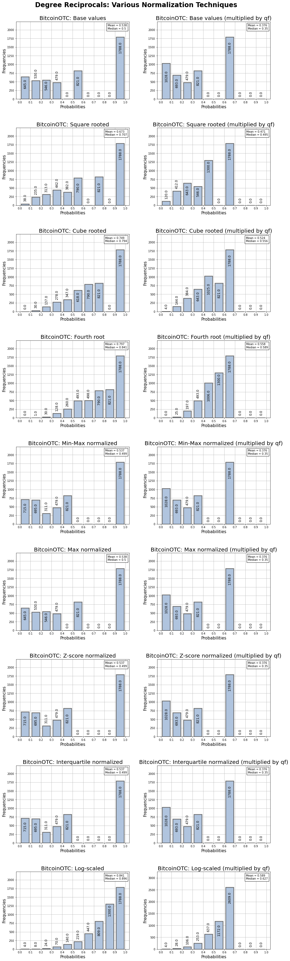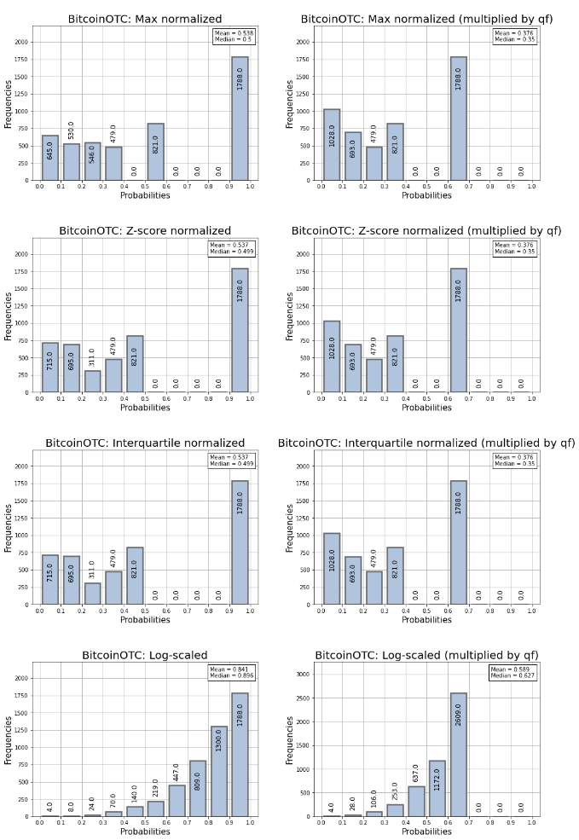
Facebook:
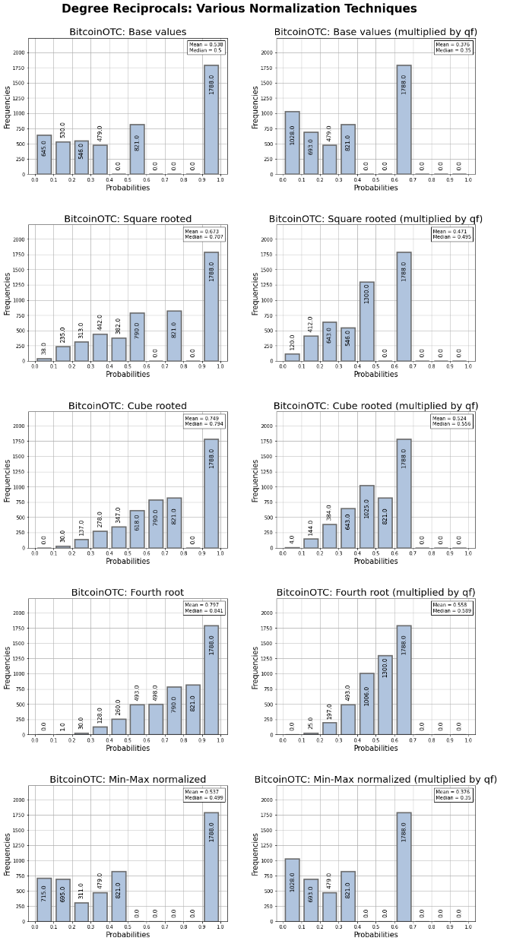

D.3 Network-wide Metric Bar Charts
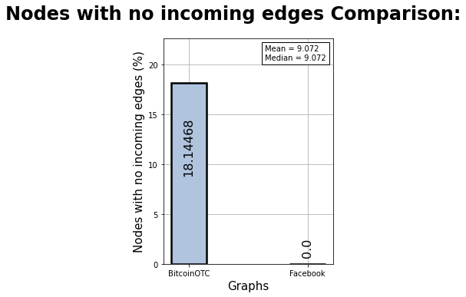
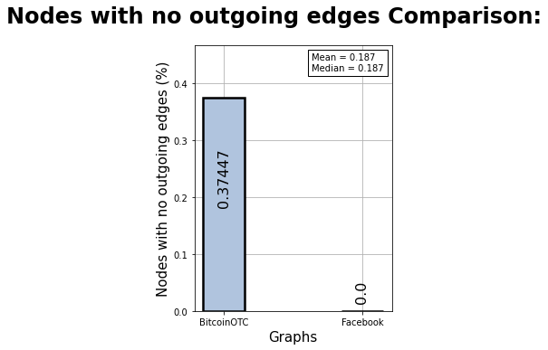
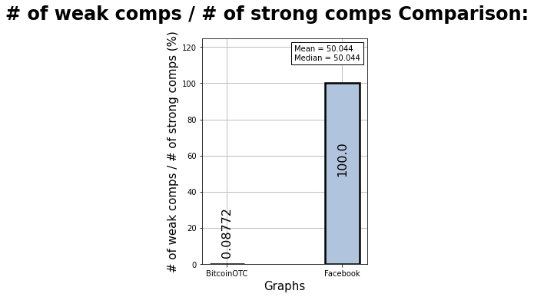

D.4 Seed Selection Parameter Fine-tuning Excel Spreadsheet

Appendix E: Repo URL
Github repo link: {https://github.com/ssulls/Influence-Maximization-project/blob/main/README.md. }

